UNITED STATES
SECURITIES AND EXCHANGE COMMISSION
Washington, D.C. 20549

FORM 8-K

CURRENT REPORT
Pursuant to Section 13 or 15(d)
of the Securities Exchange Act of 1934
Date of Report (Date of earliest event reported): July 20, 2026

SAGIMET BIOSCIENCES INC.
(Exact name of registrant as specified in its charter)

Delaware |  | 001-41742 |  | 20-5991472
(State or other jurisdiction  of incorporation) |  | (Commission  File Number) |  | (I.R.S. Employer  Identification No.)
Sagimet Biosciences Inc.
950 Tower Lane, Suite 1500,
Foster City, CA 94404
(Address of principal executive offices, including zip code)
(650) 561-8600
(Registrant’s telephone number, including area code)
155 Bovet Road, Suite 303,
San Mateo, California 94402
(Former Name or Former Address, if Changed Since Last Report)

Check the appropriate box below if the Form 8-K filing is intended to simultaneously satisfy the filing obligation of the registrant under any of the following provisions:

☐ | Written communications pursuant to Rule 425 under the Securities Act (17 CFR 230.425)

☐ | Soliciting material pursuant to Rule 14a-12 under the Exchange Act (17 CFR 240.14a-12)

☐ | Pre-commencement communications pursuant to Rule 14d-2(b) under the Exchange Act (17 CFR 240.14d-2(b))

☐ | Pre-commencement communications pursuant to Rule 13e-4(c) under the Exchange Act (17 CFR 240.13e-4(c))
Securities registered pursuant to Section 12(b) of the Act:

Title of each class |  | Trade  Symbol(s) |  | Name of each exchange  on which registered
Series A Common Stock, $0.0001 par value per share |  | SGMT |  | The Nasdaq Global Market
Indicate by check mark whether the registrant is an emerging growth company as defined in Rule 405 of the Securities Act of 1933 (§ 230.405 of this chapter) or Rule 12b-2 of the Securities Exchange Act of 1934 (§ 240.12b-2 of this chapter).
Emerging growth company ☒
If an emerging growth company, indicate by check mark if the registrant has elected not to use the extended transition period for complying with any new or revised financial accounting standards provided pursuant to Section 13(a) of the Exchange Act. ☐

Item 7.01 | Regulation FD Disclosure.
On July 20, 2026, Sagimet Biosciences Inc. (the “Company”) updated information reflected in a slide presentation, which is attached as Exhibit 99.1 to this Current Report on Form 8-K and is incorporated herein by reference. Representatives of the Company will use the updated presentation in various meetings with investors from time to time.
The information in Item 7.01 of this Current Report on Form 8-K, including the information set forth in Exhibit 99.1, is being furnished and shall not be deemed “filed” for purposes of Section 18 of the Securities Exchange Act of 1934, as amended (the “Exchange Act”), nor shall Exhibit 99.1 furnished herewith be deemed incorporated by reference in any filing under the Securities Act of 1933, as amended or the Exchange Act, except as shall be expressly set forth by specific reference in such a filing.

Item 9.01 | Financial Statements and Exhibits.
(d) Exhibits

Exhibit  No. |  | Document
99.1 |  | Investor Presentation of Sagimet Biosciences Inc., dated July 20, 2026.
104 |  | Cover Page Interactive Data File (embedded within the Inline XBRL document).

SIGNATURES
Pursuant to the requirements of the Securities Exchange Act of 1934, as amended, the registrant has duly caused this report to be signed on its behalf by the undersigned hereunto duly authorized.

 |  |  |  | Sagimet Biosciences Inc.
Date: July 20, 2026 |  |  |  | By: |  | /s/ David Happel
 |  |  |  |  |  | David Happel
 |  |  |  |  |  | Chief Executive Officer

Exhibit 99.1 Targeting Metabolic Dysfunction with Novel Therapeutics July 2026

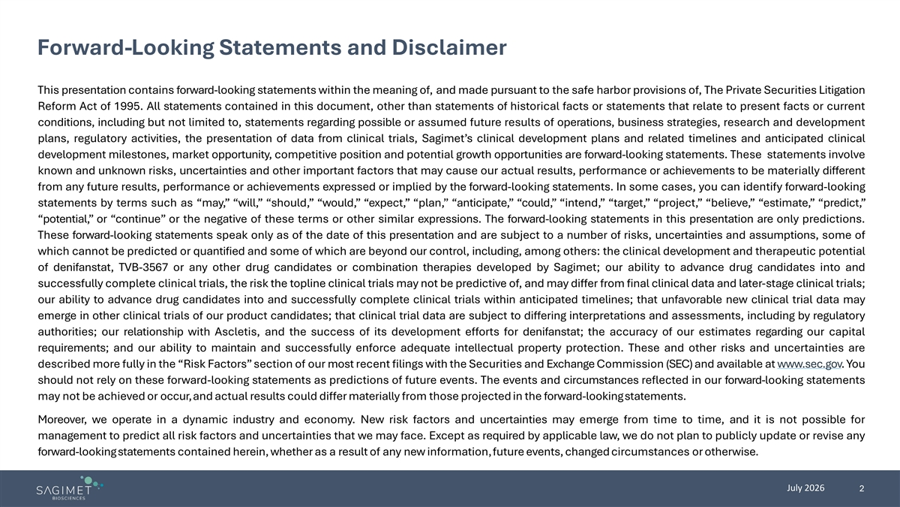
Forward-Looking Statements and Disclaimer This presentation contains forward-looking statements within the meaning of, and made pursuant to the safe harbor provisions of, The Private Securities Litigation Reform Act of 1995. All statements contained in this document, other than statements of historical facts or statements that relate to present facts or current conditions, including but not limited to, statements regarding possible or assumed future results of operations, business strategies, research and development plans, regulatory activities, the presentation of data from clinical trials, Sagimet’s clinical development plans and related timelines and anticipated clinical development milestones, market opportunity, competitive position and potential growth opportunities are forward-looking statements. These statements involve known and unknown risks, uncertainties and other important factors that may cause our actual results, performance or achievements to be materially different from any future results, performance or achievements expressed or implied by the forward-looking statements. In some cases, you can identify forward-looking statements by terms such as “may,” “will,” “should,” “would,” “expect,” “plan,” “anticipate,” “could,” “intend,” “target,” “project,” “believe,” “estimate,” “predict,” “potential,” or “continue” or the negative of these terms or other similar expressions. The forward-looking statements in this presentation are only predictions. These forward-looking statements speak only as of the date of this presentation and are subject to a number of risks, uncertainties and assumptions, some of which cannot be predicted or quantified and some of which are beyond our control, including, among others: the clinical development and therapeutic potential of denifanstat, TVB-3567 or any other drug candidates or combination therapies developed by Sagimet; our ability to advance drug candidates into and successfully complete clinical trials, the risk the topline clinical trials may not be predictive of, and may differ from final clinical data and later-stage clinical trials; our ability to advance drug candidates into and successfully complete clinical trials within anticipated timelines; that unfavorable new clinical trial data may emerge in other clinical trials of our product candidates; that clinical trial data are subject to differing interpretations and assessments, including by regulatory authorities; our relationship with Ascletis, and the success of its development efforts for denifanstat; the accuracy of our estimates regarding our capital requirements; and our ability to maintain and successfully enforce adequate intellectual property protection. These and other risks and uncertainties are described more fully in the “Risk Factors” section of our most recent filings with the Securities and Exchange Commission (SEC) and available at www.sec.gov. You should not rely on these forward-looking statements as predictions of future events. The events and circumstances reflected in our forward-looking statements may not be achieved or occur,and actual results could differ materially from those projected in the forward-lookingstatements. Moreover, we operate in a dynamic industry and economy. New risk factors and uncertainties may emerge from time to time, and it is not possible for management to predict all risk factors and uncertainties that we may face. Except as required by applicable law, we do not plan to publicly update or revise any forward-lookingstatements contained herein, whether as a result of any new information,future events, changed circumstances or otherwise. July 2026 2

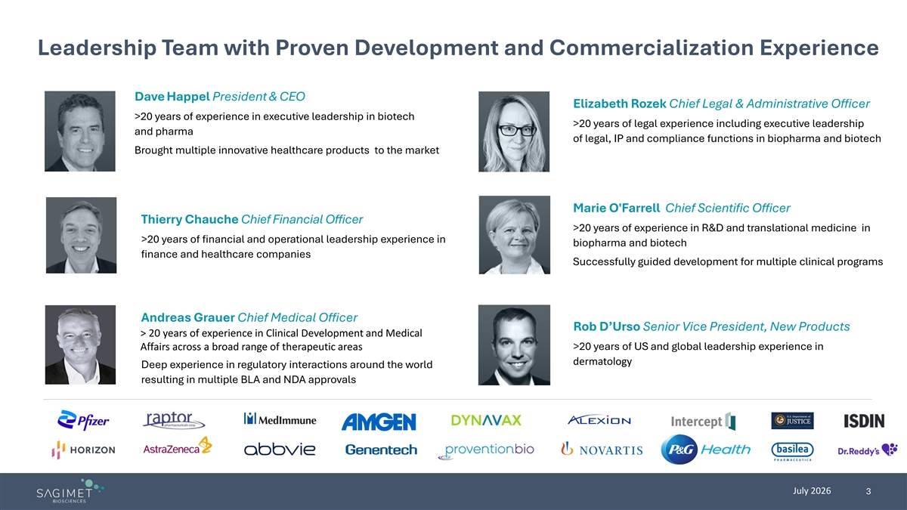
Leadership Team with Proven Development and Commercialization Experience Dave Happel President & CEO Elizabeth Rozek Chief Legal & Administrative Officer >20 years of experience in executive leadership in biotech >20 years of legal experience including executive leadership and pharma of legal, IP and compliance functions in biopharma and biotech Brought multiple innovative healthcare products to the market Marie O'Farrell Chief Scientific Officer Thierry Chauche Chief Financial Officer >20 years of experience in R&D and translational medicine in >20 years of financial and operational leadership experience in biopharma and biotech finance and healthcare companies Successfully guided development for multiple clinical programs Andreas Grauer Chief Medical Officer Rob D’Urso Senior Vice President, New Products > 20 years of experience in Clinical Development and Medical Affairs across a broad range of therapeutic areas >20 years of US and global leadership experience in dermatology Deep experience in regulatory interactions around the world resulting in multiple BLA and NDA approvals July 2026 3

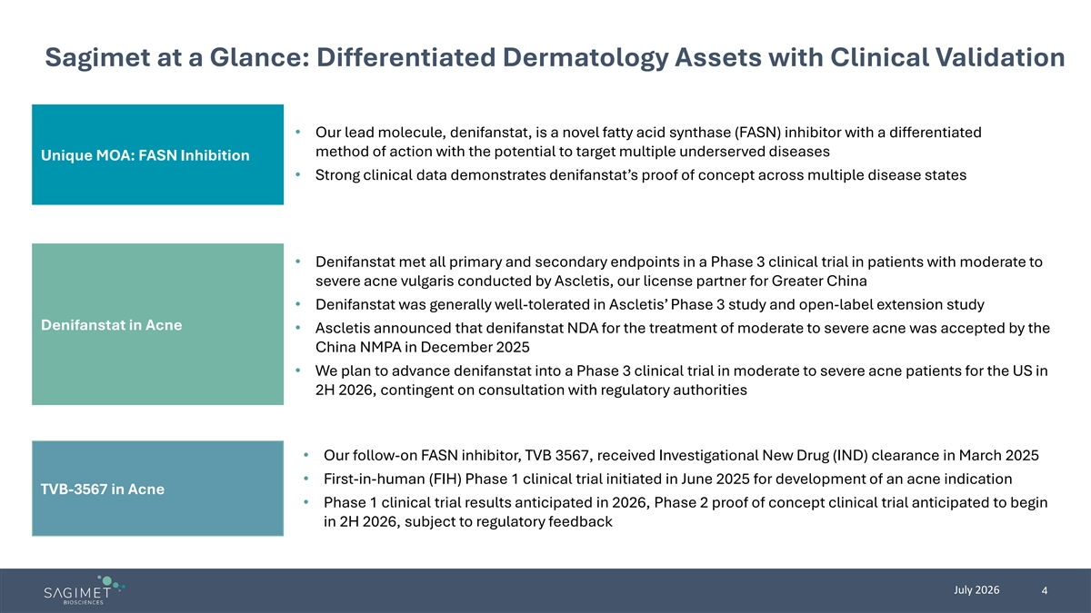
Sagimet at a Glance: Differentiated Dermatology Assets with Clinical Validation • Our lead molecule, denifanstat, is a novel fatty acid synthase (FASN) inhibitor with a differentiated method of action with the potential to target multiple underserved diseases Unique MOA: FASN Inhibition • Strong clinical data demonstrates denifanstat’s proof of concept across multiple disease states • Denifanstat met all primary and secondary endpoints in a Phase 3 clinical trial in patients with moderate to severe acne vulgaris conducted by Ascletis, our license partner for Greater China • Denifanstat was generally well-tolerated in Ascletis’ Phase 3 study and open-label extension study Denifanstat in Acne • Ascletis announced that denifanstat NDA for the treatment of moderate to severe acne was accepted by the China NMPA in December 2025 • We plan to advance denifanstat into a Phase 3 clinical trial in moderate to severe acne patients for the US in 2H 2026, contingent on consultation with regulatory authorities • Our follow-on FASN inhibitor, TVB 3567, received Investigational New Drug (IND) clearance in March 2025 • First-in-human (FIH) Phase 1 clinical trial initiated in June 2025 for development of an acne indication TVB-3567 in Acne • Phase 1 clinical trial results anticipated in 2026, Phase 2 proof of concept clinical trial anticipated to begin in 2H 2026, subject to regulatory feedback July 2026 4

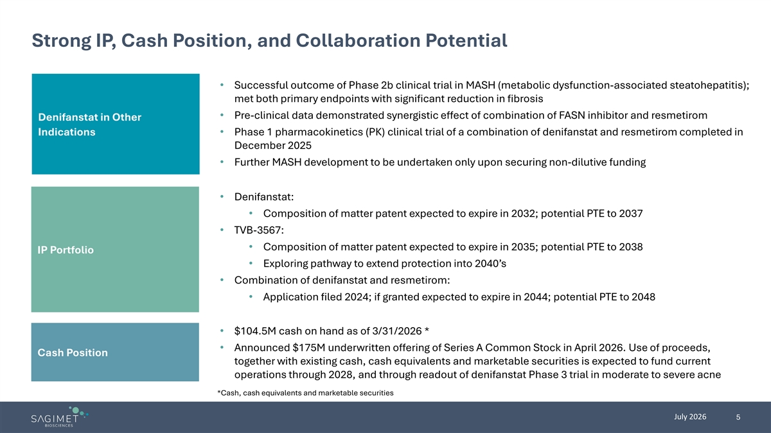
Strong IP, Cash Position, and Collaboration Potential • Successful outcome of Phase 2b clinical trial in MASH (metabolic dysfunction-associated steatohepatitis); met both primary endpoints with significant reduction in fibrosis • Pre-clinical data demonstrated synergistic effect of combination of FASN inhibitor and resmetirom Denifanstat in Other Indications • Phase 1 pharmacokinetics (PK) clinical trial of a combination of denifanstat and resmetirom completed in December 2025 • Further MASH development to be undertaken only upon securing non-dilutive funding • Denifanstat: • Composition of matter patent expected to expire in 2032; potential PTE to 2037 • TVB-3567: • Composition of matter patent expected to expire in 2035; potential PTE to 2038 IP Portfolio • Exploring pathway to extend protection into 2040’s • Combination of denifanstat and resmetirom: • Application filed 2024; if granted expected to expire in 2044; potential PTE to 2048 • $104.5M cash on hand as of 3/31/2026 * • Announced $175M underwritten offering of Series A Common Stock in April 2026. Use of proceeds, Cash Position together with existing cash, cash equivalents and marketable securities is expected to fund current operations through 2028, and through readout of denifanstat Phase 3 trial in moderate to severe acne *Cash, cash equivalents and marketable securities July 2026 5

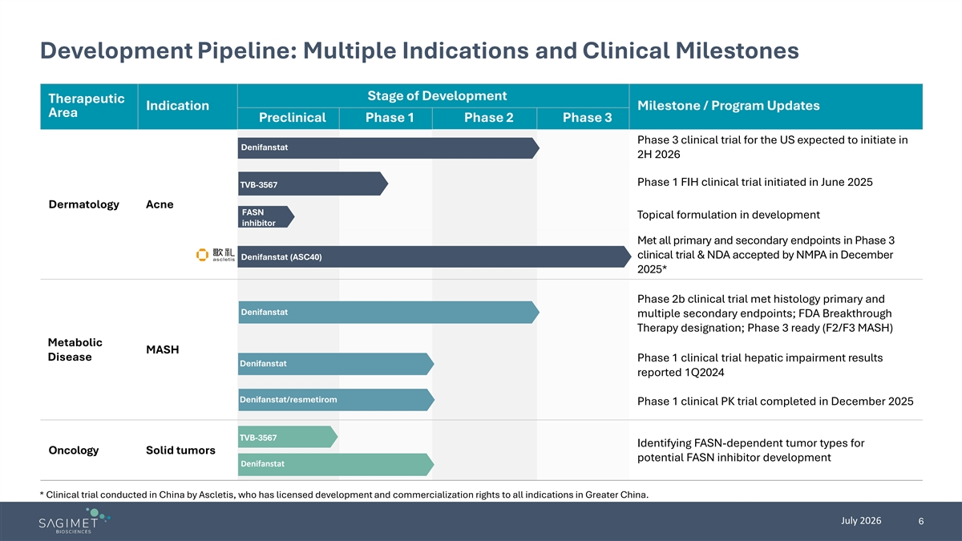
Development Pipeline: Multiple Indications and Clinical Milestones Stage of Development Therapeutic Indication Milestone / Program Updates Area Preclinical Phase 1 Phase 2 Phase 3 Phase 3 clinical trial for the US expected to initiate in Denifanstat 2H 2026 Phase 1 FIH clinical trial initiated in June 2025 TVB-3567 Dermatology Acne FASN Topical formulation in development inhibitor Met all primary and secondary endpoints in Phase 3 clinical trial & NDA accepted by NMPA in December Denifanstat (ASC40) 2025* Phase 2b clinical trial met histology primary and Denifanstat multiple secondary endpoints; FDA Breakthrough Therapy designation; Phase 3 ready (F2/F3 MASH) Metabolic MASH Disease Phase 1 clinical trial hepatic impairment results Denifanstat reported 1Q2024 Denifanstat/resmetirom Phase 1 clinical PK trial completed in December 2025 TVB-3567 Identifying FASN-dependent tumor types for Oncology Solid tumors potential FASN inhibitor development Denifanstat * Clinical trial conducted in China by Ascletis, who has licensed development and commercialization rights to all indications in Greater China. July 2026 6


FASN Inhibition Offers Differentiated MOA in Acne

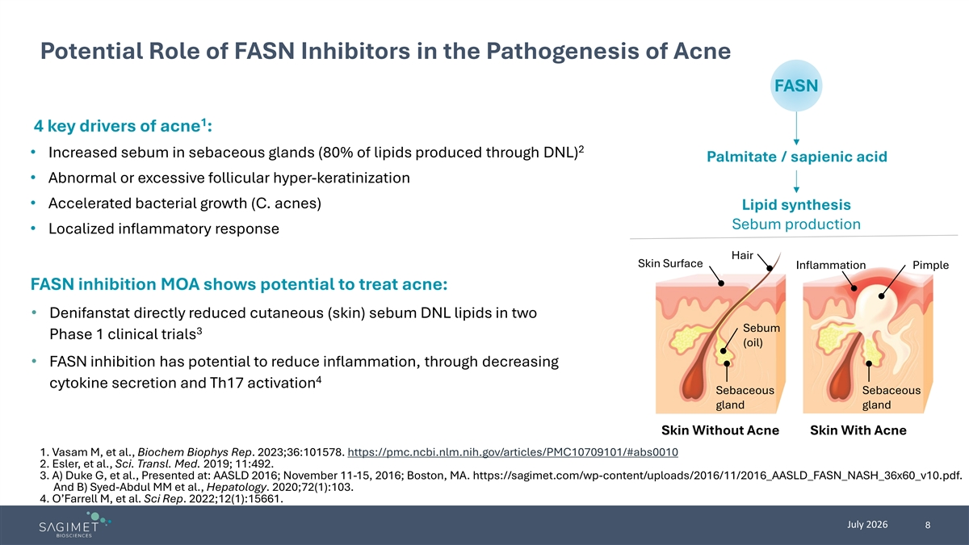
Potential Role of FASN Inhibitors in the Pathogenesis of Acne FASN 1 4 key drivers of acne : 2 • Increased sebum in sebaceous glands (80% of lipids produced through DNL) Palmitate / sapienic acid • Abnormal or excessive follicular hyper-keratinization • Accelerated bacterial growth (C. acnes) Lipid synthesis Sebum production • Localized inflammatory response Hair Skin Surface Inflammation Pimple FASN inhibition MOA shows potential to treat acne: • Denifanstat directly reduced cutaneous (skin) sebum DNL lipids in two Sebum 3 Phase 1 clinical trials (oil) • FASN inhibition has potential to reduce inflammation, through decreasing 4 cytokine secretion and Th17 activation Sebaceous Sebaceous gland gland Skin Without Acne Skin With Acne 1. Vasam M, et al., Biochem Biophys Rep. 2023;36:101578. https://pmc.ncbi.nlm.nih.gov/articles/PMC10709101/#abs0010 2. Esler, et al., Sci. Transl. Med. 2019; 11:492. 3. A) Duke G, et al., Presented at: AASLD 2016; November 11-15, 2016; Boston, MA. https://sagimet.com/wp-content/uploads/2016/11/2016_AASLD_FASN_NASH_36x60_v10.pdf. And B) Syed-Abdul MM et al., Hepatology. 2020;72(1):103. 4. O’Farrell M, et al. Sci Rep. 2022;12(1):15661. July 2026 8

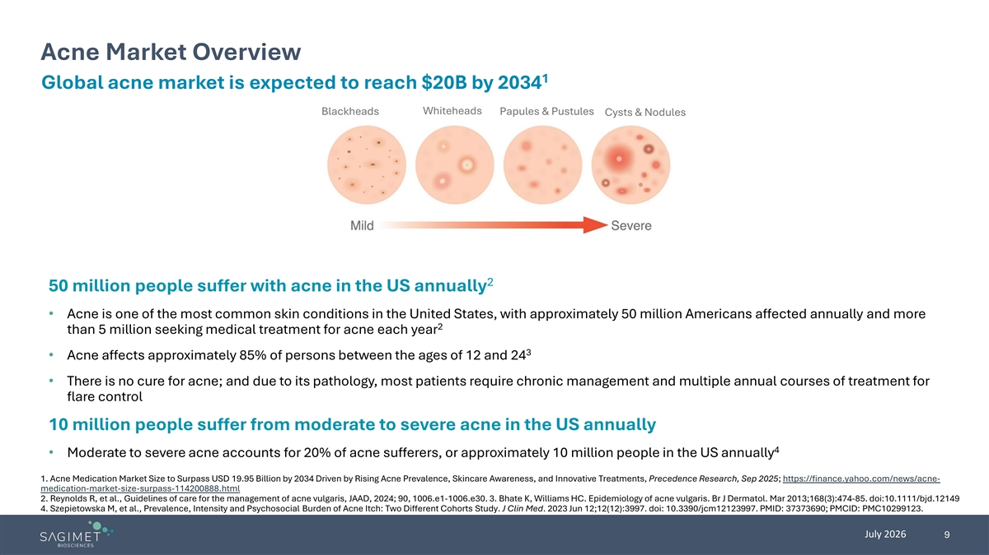
Acne Market Overview 1 Global acne market is expected to reach $20B by 2034 Whiteheads Blackheads Papules & Pustules Cysts & Nodules 2 50 million people suffer with acne in the US annually • Acne is one of the most common skin conditions in the United States, with approximately 50 million Americans affected annually and more 2 than 5 million seeking medical treatment for acne each year 3 • Acne affects approximately 85% of persons between the ages of 12 and 24 • There is no cure for acne; and due to its pathology, most patients require chronic management and multiple annual courses of treatment for flare control 10 million people suffer from moderate to severe acne in the US annually 4 • Moderate to severe acne accounts for 20% of acne sufferers, or approximately 10 million people in the US annually 1. Acne Medication Market Size to Surpass USD 19.95 Billion by 2034 Driven by Rising Acne Prevalence, Skincare Awareness, and Innovative Treatments, Precedence Research, Sep 2025; https://finance.yahoo.com/news/acne- medication-market-size-surpass-114200888.html 2. Reynolds R, et al., Guidelines of care for the management of acne vulgaris, JAAD, 2024; 90, 1006.e1-1006.e30. 3. Bhate K, Williams HC. Epidemiology of acne vulgaris. Br J Dermatol. Mar 2013;168(3):474-85. doi:10.1111/bjd.12149 4. Szepietowska M, et al., Prevalence, Intensity and Psychosocial Burden of Acne Itch: Two Different Cohorts Study. J Clin Med. 2023 Jun 12;12(12):3997. doi: 10.3390/jcm12123997. PMID: 37373690; PMCID: PMC10299123. July 2026 9

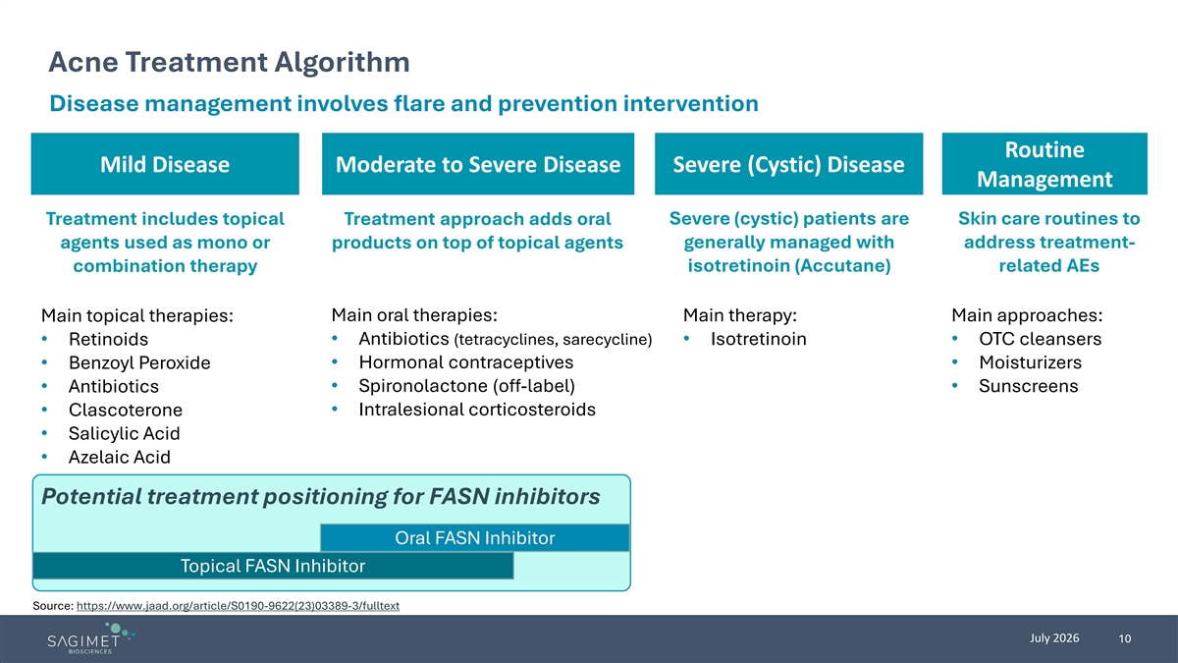
Acne Treatment Algorithm Disease management involves flare and prevention intervention Routine Mild Disease Moderate to Severe Disease Severe (Cystic) Disease Management Treatment includes topical Treatment approach adds oral Severe (cystic) patients are Skin care routines to generally managed with address treatment- agents used as mono or products on top of topical agents isotretinoin (Accutane) related AEs combination therapy Main topical therapies: Main oral therapies: Main therapy: Main approaches: • Retinoids • Antibiotics (tetracyclines, sarecycline) • Isotretinoin • OTC cleansers • Hormonal contraceptives • Moisturizers • Benzoyl Peroxide • Spironolactone (off-label) • Antibiotics • Sunscreens • Clascoterone • Intralesional corticosteroids • Salicylic Acid • Azelaic Acid Potential treatment positioning for FASN inhibitors Oral FASN Inhibitor Topical FASN Inhibitor Source: https://www.jaad.org/article/S0190-9622(23)03389-3/fulltext July 2026 10


Denifanstat’s Clinical Data in Acne

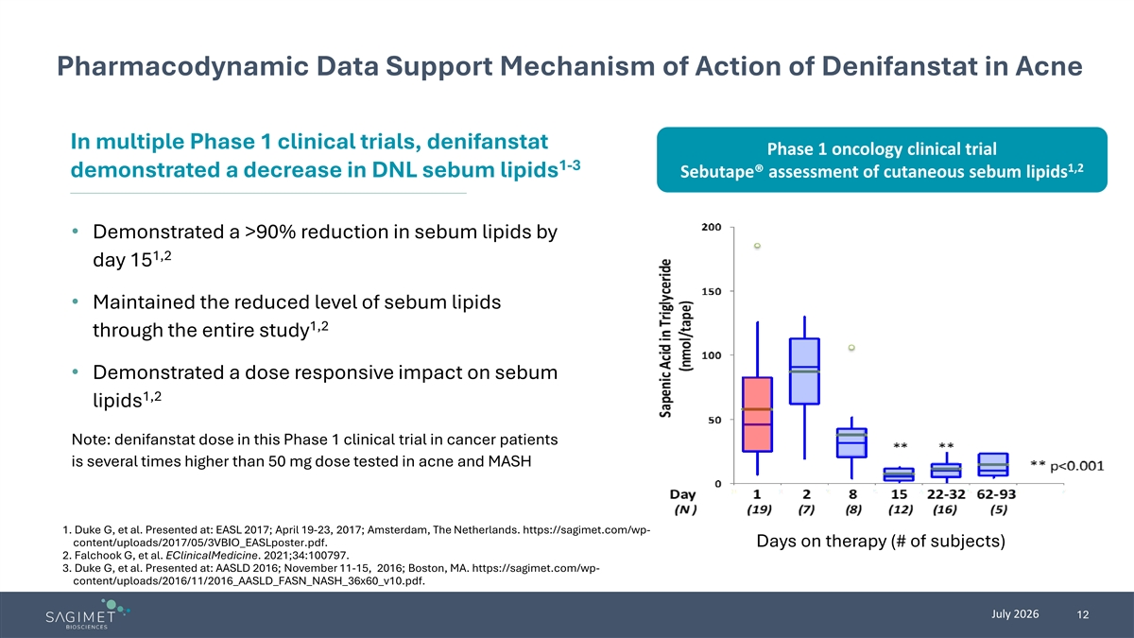
Pharmacodynamic Data Support Mechanism of Action of Denifanstat in Acne In multiple Phase 1 clinical trials, denifanstat Phase 1 oncology clinical trial 1-3 1,2 demonstrated a decrease in DNL sebum lipids Sebutape® assessment of cutaneous sebum lipids • Demonstrated a >90% reduction in sebum lipids by 1,2 day 15 • Maintained the reduced level of sebum lipids 1,2 through the entire study • Demonstrated a dose responsive impact on sebum 1,2 lipids Note: denifanstat dose in this Phase 1 clinical trial in cancer patients is several times higher than 50 mg dose tested in acne and MASH 1. Duke G, et al. Presented at: EASL 2017; April 19-23, 2017; Amsterdam, The Netherlands. https://sagimet.com/wp- content/uploads/2017/05/3VBIO_EASLposter.pdf. Days on therapy (# of subjects) 2. Falchook G, et al. EClinicalMedicine. 2021;34:100797. 3. Duke G, et al. Presented at: AASLD 2016; November 11-15, 2016; Boston, MA. https://sagimet.com/wp- content/uploads/2016/11/2016_AASLD_FASN_NASH_36x60_v10.pdf. July 2026 12

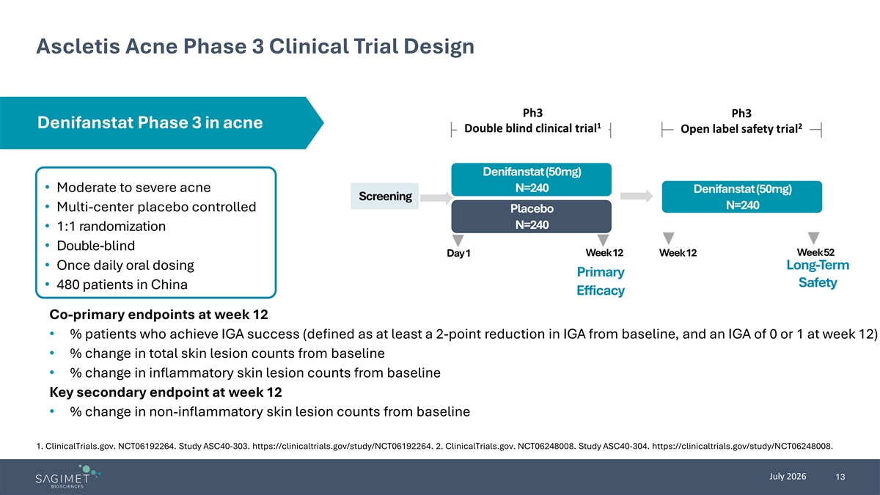
Ascletis Acne Phase 3 Clinical Trial Design Ph3 Ph3 Denifanstat Phase 3 in acne 1 2 Double blind clinical trial Open label safety trial Denifanstat (50mg) • Moderate to severe acne N=240 Denifanstat (50mg) Screening N=240 • Multi-center placebo controlled Placebo N=240 • 1:1 randomization • Double-blind Week 52 Day 1 Week 12 Week 12 • Once daily oral dosing Long-Term Primary Safety • 480 patients in China Efficacy Co-primary endpoints at week 12 • % patients who achieve IGA success (defined as at least a 2-point reduction in IGA from baseline, and an IGA of 0 or 1 at week 12) • % change in total skin lesion counts from baseline • % change in inflammatory skin lesion counts from baseline Key secondary endpoint at week 12 • % change in non-inflammatory skin lesion counts from baseline 1. ClinicalTrials.gov. NCT06192264. Study ASC40-303. https://clinicaltrials.gov/study/NCT06192264. 2. ClinicalTrials.gov. NCT06248008. Study ASC40-304. https://clinicaltrials.gov/study/NCT06248008. July 2026 13

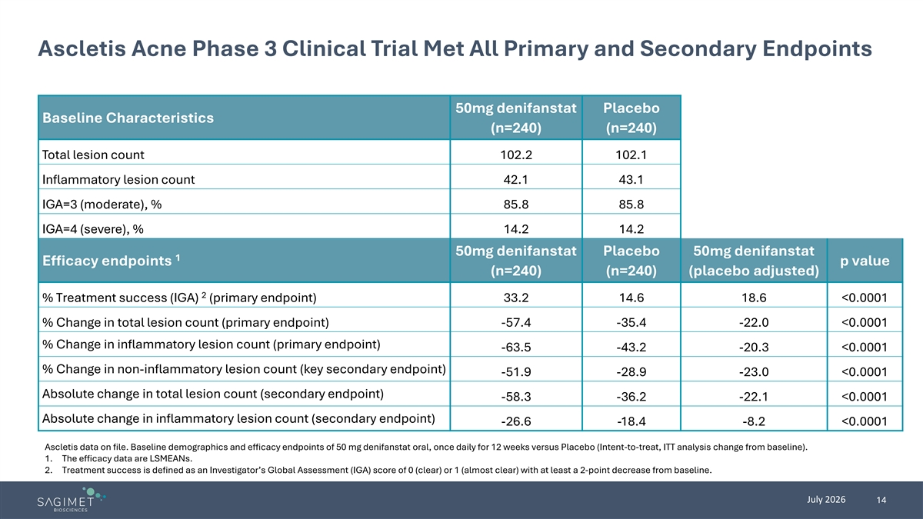
Ascletis Acne Phase 3 Clinical Trial Met All Primary and Secondary Endpoints 50mg denifanstat Placebo Baseline Characteristics (n=240) (n=240) Total lesion count 102.2 102.1 Inflammatory lesion count 42.1 43.1 IGA=3 (moderate), % 85.8 85.8 IGA=4 (severe), % 14.2 14.2 50mg denifanstat Placebo 50mg denifanstat 1 Efficacy endpoints p value (n=240) (n=240) (placebo adjusted) 2 % Treatment success (IGA) (primary endpoint) 33.2 14.6 18.6 <0.0001 % Change in total lesion count (primary endpoint) -57.4 -35.4 -22.0 <0.0001 % Change in inflammatory lesion count (primary endpoint) -63.5 -43.2 -20.3 <0.0001 % Change in non-inflammatory lesion count (key secondary endpoint) -51.9 -28.9 -23.0 <0.0001 Absolute change in total lesion count (secondary endpoint) -58.3 -36.2 -22.1 <0.0001 Absolute change in inflammatory lesion count (secondary endpoint) -26.6 -18.4 -8.2 <0.0001 Ascletis data on file. Baseline demographics and efficacy endpoints of 50 mg denifanstat oral, once daily for 12 weeks versus Placebo (Intent-to-treat, ITT analysis change from baseline). 1. The efficacy data are LSMEANs. 2. Treatment success is defined as an Investigator’s Global Assessment (IGA) score of 0 (clear) or 1 (almost clear) with at least a 2-point decrease from baseline. July 2026 14

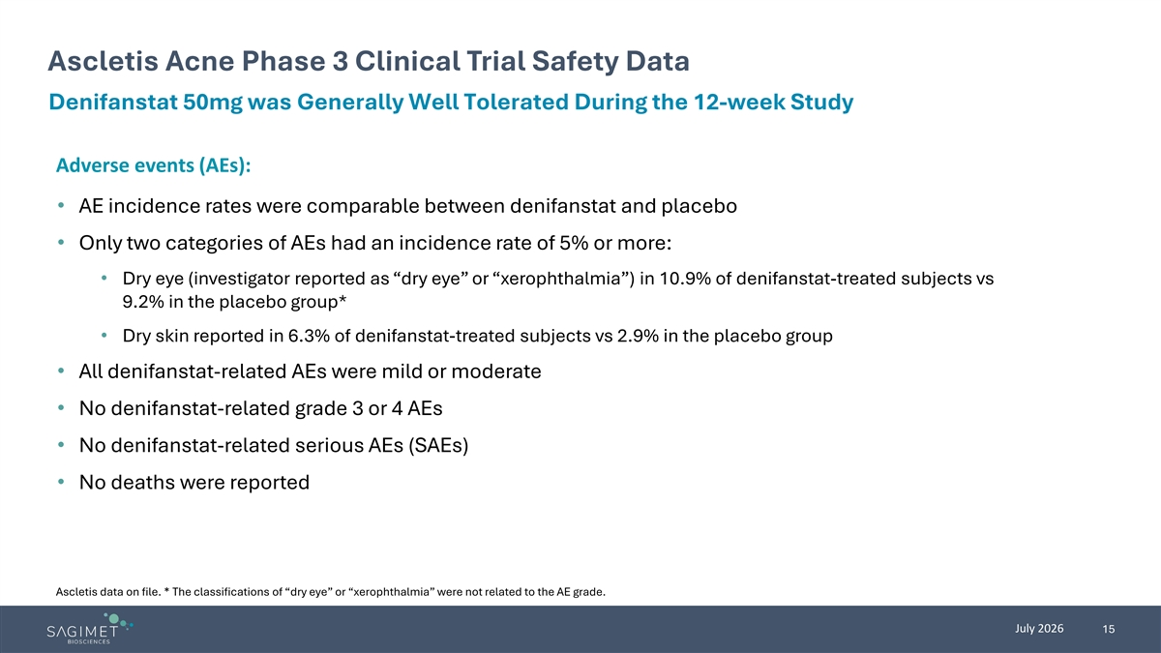
Ascletis Acne Phase 3 Clinical Trial Safety Data Denifanstat 50mg was Generally Well Tolerated During the 12-week Study Adverse events (AEs): • AE incidence rates were comparable between denifanstat and placebo • Only two categories of AEs had an incidence rate of 5% or more: • Dry eye (investigator reported as “dry eye” or “xerophthalmia”) in 10.9% of denifanstat-treated subjects vs 9.2% in the placebo group* • Dry skin reported in 6.3% of denifanstat-treated subjects vs 2.9% in the placebo group • All denifanstat-related AEs were mild or moderate • No denifanstat-related grade 3 or 4 AEs • No denifanstat-related serious AEs (SAEs) • No deaths were reported Ascletis data on file. * The classifications of “dry eye” or “xerophthalmia” were not related to the AE grade. July 2026 15

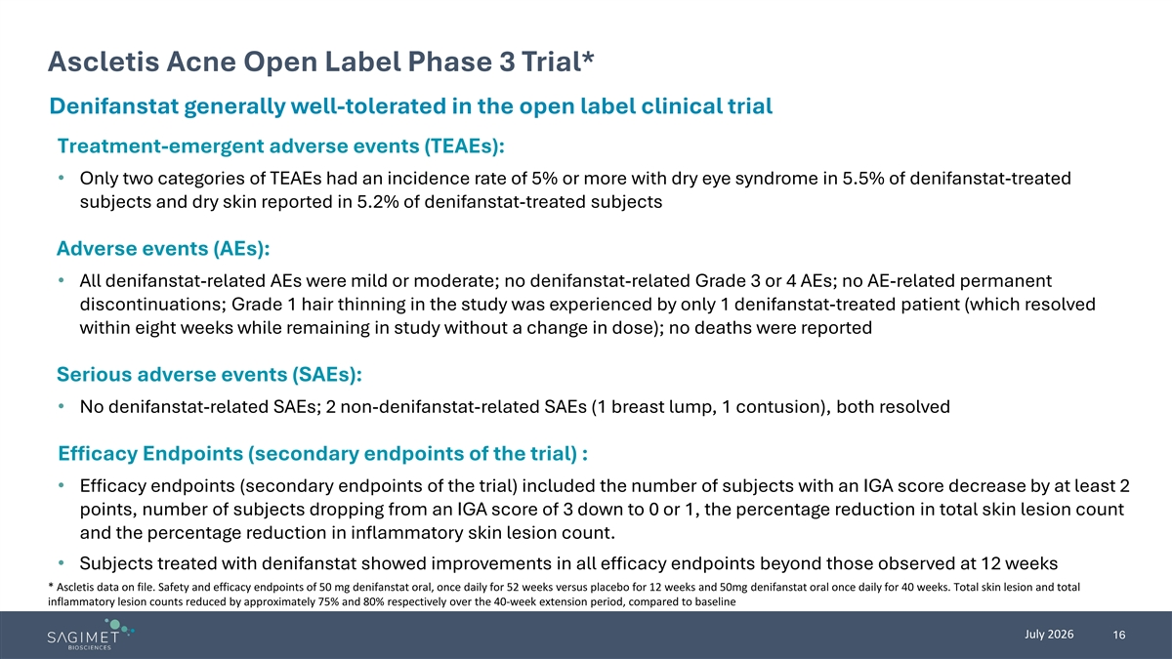
Ascletis Acne Open Label Phase 3 Trial* Denifanstat generally well-tolerated in the open label clinical trial Treatment-emergent adverse events (TEAEs): • Only two categories of TEAEs had an incidence rate of 5% or more with dry eye syndrome in 5.5% of denifanstat-treated subjects and dry skin reported in 5.2% of denifanstat-treated subjects Adverse events (AEs): • All denifanstat-related AEs were mild or moderate; no denifanstat-related Grade 3 or 4 AEs; no AE-related permanent discontinuations; Grade 1 hair thinning in the study was experienced by only 1 denifanstat-treated patient (which resolved within eight weeks while remaining in study without a change in dose); no deaths were reported Serious adverse events (SAEs): • No denifanstat-related SAEs; 2 non-denifanstat-related SAEs (1 breast lump, 1 contusion), both resolved Efficacy Endpoints (secondary endpoints of the trial) : • Efficacy endpoints (secondary endpoints of the trial) included the number of subjects with an IGA score decrease by at least 2 points, number of subjects dropping from an IGA score of 3 down to 0 or 1, the percentage reduction in total skin lesion count and the percentage reduction in inflammatory skin lesion count. • Subjects treated with denifanstat showed improvements in all efficacy endpoints beyond those observed at 12 weeks * Ascletis data on file. Safety and efficacy endpoints of 50 mg denifanstat oral, once daily for 52 weeks versus placebo for 12 weeks and 50mg denifanstat oral once daily for 40 weeks. Total skin lesion and total inflammatory lesion counts reduced by approximately 75% and 80% respectively over the 40-week extension period, compared to baseline July 2026 16


Sagimet’s Upcoming Development Programs

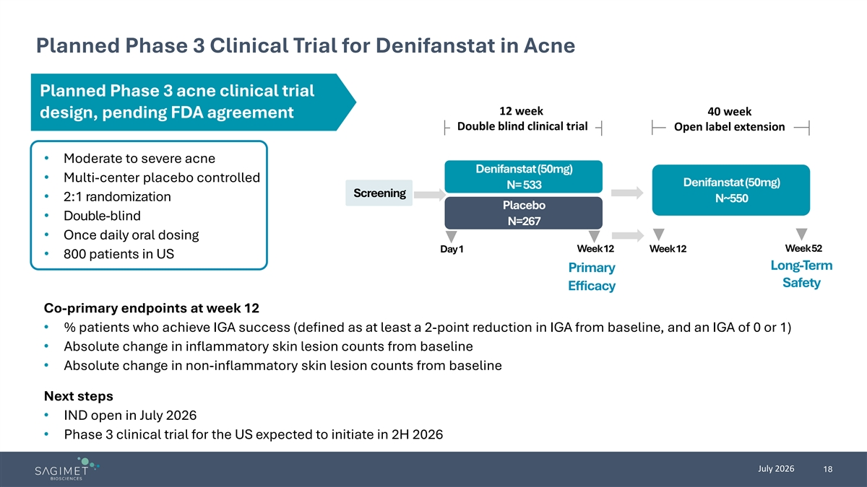
Planned Phase 3 Clinical Trial for Denifanstat in Acne Planned Phase 3 acne clinical trial 12 week 40 week design, pending FDA agreement Double blind clinical trial Open label extension • Moderate to severe acne Denifanstat (50mg) • Multi-center placebo controlled Denifanstat (50mg) N= 533 Screening • 2:1 randomization N~550 Placebo • Double-blind N=267 • Once daily oral dosing Week 52 Day 1 Week 12 Week 12 • 800 patients in US Long-Term Primary Safety Efficacy Co-primary endpoints at week 12 • % patients who achieve IGA success (defined as at least a 2-point reduction in IGA from baseline, and an IGA of 0 or 1) • Absolute change in inflammatory skin lesion counts from baseline • Absolute change in non-inflammatory skin lesion counts from baseline Next steps • IND open in July 2026 • Phase 3 clinical trial for the US expected to initiate in 2H 2026 July 2026 18

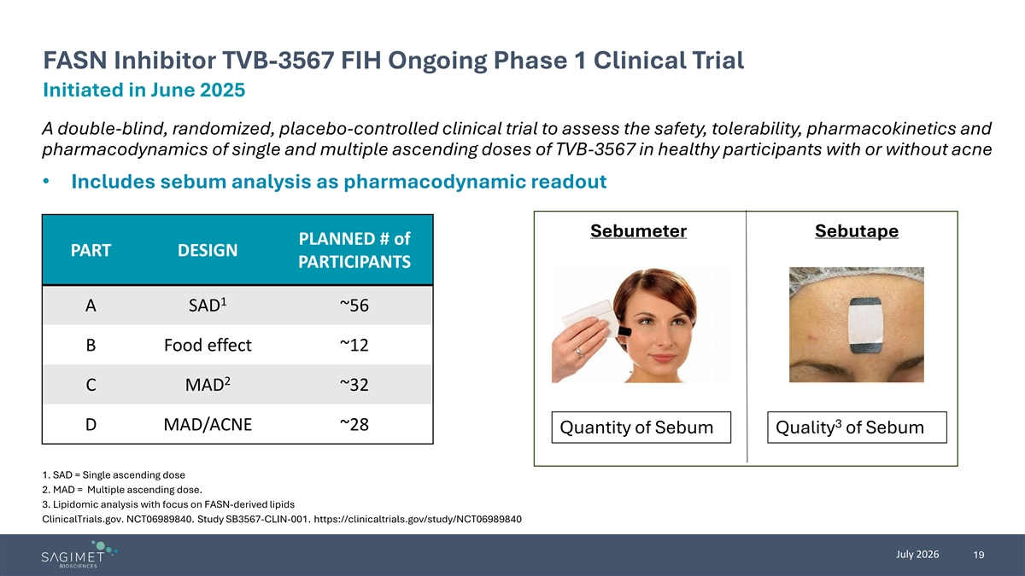
FASN Inhibitor TVB-3567 FIH Ongoing Phase 1 Clinical Trial Initiated in June 2025 A double-blind, randomized, placebo-controlled clinical trial to assess the safety, tolerability, pharmacokinetics and pharmacodynamics of single and multiple ascending doses of TVB-3567 in healthy participants with or without acne • Includes sebum analysis as pharmacodynamic readout Sebumeter Sebutape PLANNED # of PART DESIGN PARTICIPANTS 1 A SAD ~56 B Food effect ~12 2 C MAD ~32 3 D MAD/ACNE ~28 Quantity of Sebum Quality of Sebum 1. SAD = Single ascending dose 2. MAD = Multiple ascending dose. 3. Lipidomic analysis with focus on FASN-derived lipids ClinicalTrials.gov. NCT06989840. Study SB3567-CLIN-001. https://clinicaltrials.gov/study/NCT06989840 July 2026 19

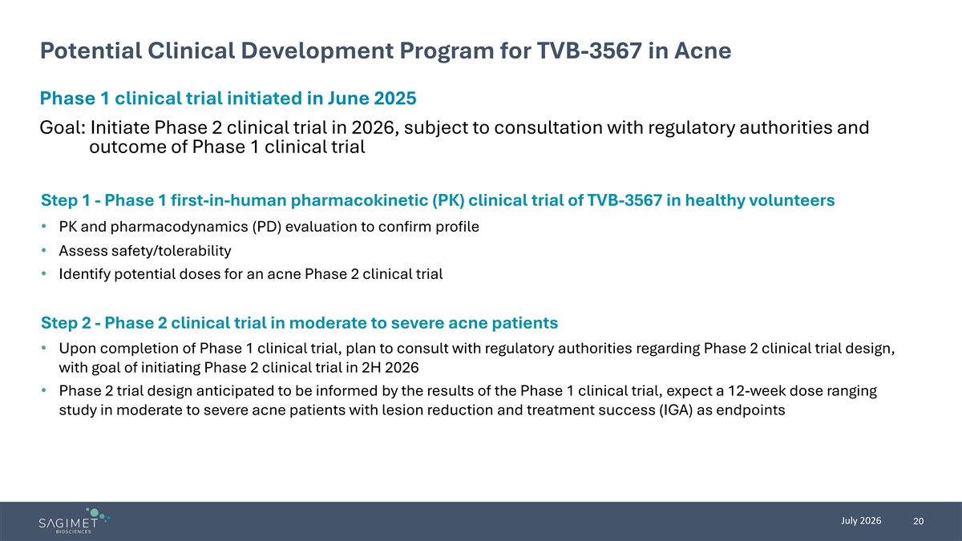
Potential Clinical Development Program for TVB-3567 in Acne Phase 1 clinical trial initiated in June 2025 Goal: Initiate Phase 2 clinical trial in 2026, subject to consultation with regulatory authorities and outcome of Phase 1 clinical trial Step 1 - Phase 1 first-in-human pharmacokinetic (PK) clinical trial of TVB-3567 in healthy volunteers • PK and pharmacodynamics (PD) evaluation to confirm profile • Assess safety/tolerability • Identify potential doses for an acne Phase 2 clinical trial Step 2 - Phase 2 clinical trial in moderate to severe acne patients • Upon completion of Phase 1 clinical trial, plan to consult with regulatory authorities regarding Phase 2 clinical trial design, with goal of initiating Phase 2 clinical trial in 2H 2026 • Phase 2 trial design anticipated to be informed by the results of the Phase 1 clinical trial, expect a 12-week dose ranging study in moderate to severe acne patients with lesion reduction and treatment success (IGA) as endpoints July 2026 20

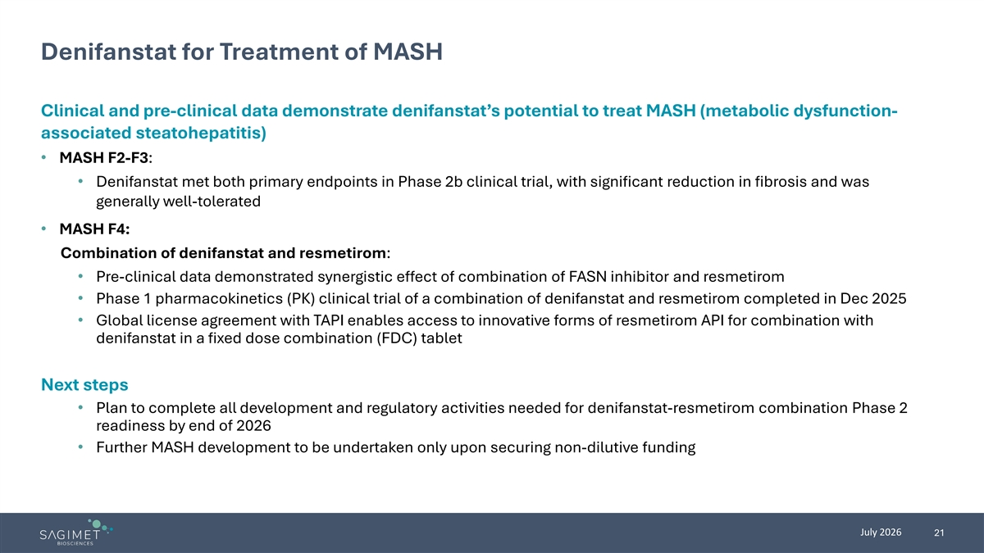
Denifanstat for Treatment of MASH Clinical and pre-clinical data demonstrate denifanstat’s potential to treat MASH (metabolic dysfunction- associated steatohepatitis) • MASH F2-F3: • Denifanstat met both primary endpoints in Phase 2b clinical trial, with significant reduction in fibrosis and was generally well-tolerated • MASH F4: Combination of denifanstat and resmetirom: • Pre-clinical data demonstrated synergistic effect of combination of FASN inhibitor and resmetirom • Phase 1 pharmacokinetics (PK) clinical trial of a combination of denifanstat and resmetirom completed in Dec 2025 • Global license agreement with TAPI enables access to innovative forms of resmetirom API for combination with denifanstat in a fixed dose combination (FDC) tablet Next steps • Plan to complete all development and regulatory activities needed for denifanstat-resmetirom combination Phase 2 readiness by end of 2026 • Further MASH development to be undertaken only upon securing non-dilutive funding July 2026 21

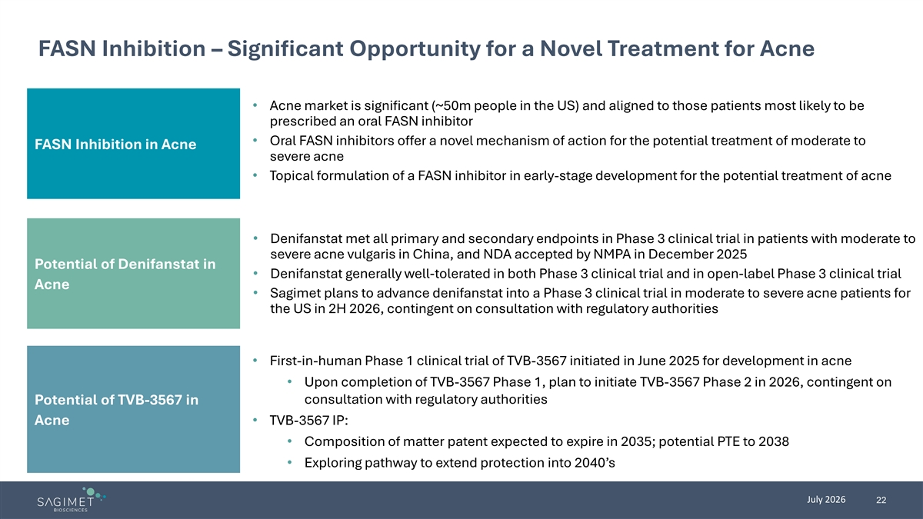
FASN Inhibition – Significant Opportunity for a Novel Treatment for Acne • Acne market is significant (~50m people in the US) and aligned to those patients most likely to be prescribed an oral FASN inhibitor • Oral FASN inhibitors offer a novel mechanism of action for the potential treatment of moderate to FASN Inhibition in Acne severe acne • Topical formulation of a FASN inhibitor in early-stage development for the potential treatment of acne • Denifanstat met all primary and secondary endpoints in Phase 3 clinical trial in patients with moderate to severe acne vulgaris in China, and NDA accepted by NMPA in December 2025 Potential of Denifanstat in • Denifanstat generally well-tolerated in both Phase 3 clinical trial and in open-label Phase 3 clinical trial Acne • Sagimet plans to advance denifanstat into a Phase 3 clinical trial in moderate to severe acne patients for the US in 2H 2026, contingent on consultation with regulatory authorities • First-in-human Phase 1 clinical trial of TVB-3567 initiated in June 2025 for development in acne • Upon completion of TVB-3567 Phase 1, plan to initiate TVB-3567 Phase 2 in 2026, contingent on consultation with regulatory authorities Potential of TVB-3567 in Acne • TVB-3567 IP: • Composition of matter patent expected to expire in 2035; potential PTE to 2038 • Exploring pathway to extend protection into 2040’s July 2026 22

