UNITED STATES
SECURITIES AND EXCHANGE COMMISSION
Washington, D.C. 20549

FORM 8-K

CURRENT REPORT
Pursuant to Section 13 or 15(d)
of the Securities Exchange Act of 1934
Date of Report (Date of earliest event reported): October 22, 2026

SAGIMET BIOSCIENCES INC.
(Exact name of registrant as specified in its charter)

Delaware |  | 001-41742 |  | 20-5991472
(State or other jurisdiction  of incorporation) |  | (Commission  File Number) |  | (I.R.S. Employer  Identification No.)
Sagimet Biosciences Inc.
950 Tower Lane, Suite 1500,
Foster City, CA 94404
(Address of principal executive offices, including zip code)
(650) 561-8600
(Registrant’s telephone number, including area code)
Not applicable
(Former Name or Former Address, if Changed Since Last Report)

Check the appropriate box below if the Form 8-K filing is intended to simultaneously satisfy the filing obligation of the registrant under any of the following provisions:

☐ | Written communications pursuant to Rule 425 under the Securities Act (17 CFR 230.425)

☐ | Soliciting material pursuant to Rule 14a-12 under the Exchange Act (17 CFR 240.14a-12)

☐ | Pre-commencement communications pursuant to Rule 14d-2(b) under the Exchange Act (17 CFR 240.14d-2(b))

☐ | Pre-commencement communications pursuant to Rule 13e-4(c) under the Exchange Act (17 CFR 240.13e-4(c))
Securities registered pursuant to Section 12(b) of the Act:

Title of each class |  | Trade  Symbol(s) |  | Name of each exchange  on which registered
Series A Common Stock, $0.0001 par value per share |  | SGMT |  | The Nasdaq Global Market
Indicate by check mark whether the registrant is an emerging growth company as defined in Rule 405 of the Securities Act of 1933 (§ 230.405 of this chapter) or Rule 12b-2 of the Securities Exchange Act of 1934 (§ 240.12b-2 of this chapter).
Emerging growth company ☒
If an emerging growth company, indicate by check mark if the registrant has elected not to use the extended transition period for complying with any new or revised financial accounting standards provided pursuant to Section 13(a) of the Exchange Act. ☐

Item 7.01 | Regulation FD Disclosure.
On October 22, 2026, Sagimet Biosciences Inc. (the “Company”) updated information reflected in a slide presentation, which is attached as Exhibit 99.1 to this Current Report on Form 8-K and is incorporated herein by reference. Representatives of the Company will use the updated presentation in various meetings with investors from time to time.
The information in Item 7.01 of this Current Report on Form 8-K, including the information set forth in Exhibit 99.1, is being furnished and shall not be deemed “filed” for purposes of Section 18 of the Securities Exchange Act of 1934, as amended (the “Exchange Act”), nor shall Exhibit 99.1 furnished herewith be deemed incorporated by reference in any filing under the Securities Act of 1933, as amended, or the Exchange Act, except as shall be expressly set forth by specific reference in such a filing.

Item 9.01 | Financial Statements and Exhibits.
(d) Exhibits

Exhibit  No. |  | Document
99.1 |  | Investor Presentation of Sagimet Biosciences Inc., dated October 22, 2026.
104 |  | Cover Page Interactive Data File (embedded within the Inline XBRL document).

SIGNATURES
Pursuant to the requirements of the Securities Exchange Act of 1934, as amended, the registrant has duly caused this report to be signed on its behalf by the undersigned hereunto duly authorized.

 |  |  |  | Sagimet Biosciences Inc.
Date: October 22, 2026 |  |  |  | By: |  | /s/ David Happel
 |  |  |  |  |  | David Happel
 |  |  |  |  |  | Chief Executive Officer

Targeting Metabolic Dysfunction with Novel Therapeutics October 2026 Exhibit 99.1

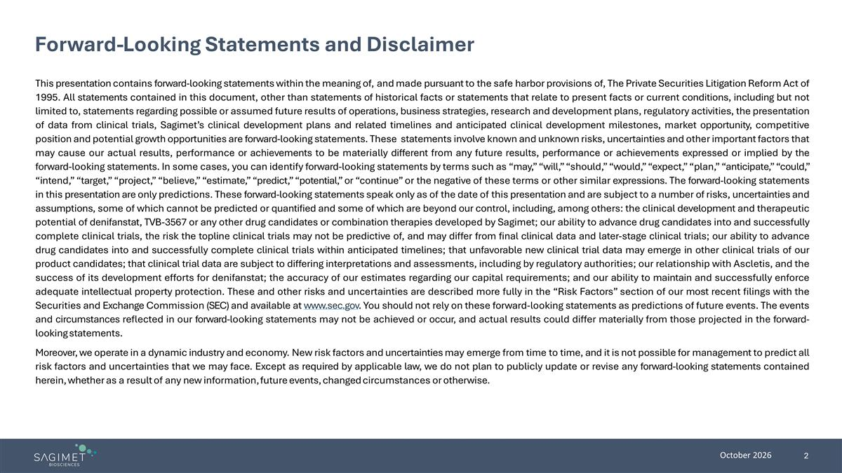
Forward-Looking Statements and Disclaimer This presentation contains forward-looking statements within the meaning of, and made pursuant to the safe harbor provisions of, The Private Securities Litigation Reform Act of 1995. All statements contained in this document, other than statements of historical facts or statements that relate to present facts or current conditions, including but not limited to, statements regarding possible or assumed future results of operations, business strategies, research and development plans, regulatory activities, the presentation of data from clinical trials, Sagimet’s clinical development plans and related timelines and anticipated clinical development milestones, market opportunity, competitive position and potential growth opportunities are forward-looking statements. These statements involve known and unknown risks, uncertainties and other important factors that may cause our actual results, performance or achievements to be materially different from any future results, performance or achievements expressed or implied by the forward-looking statements. In some cases, you can identify forward-looking statements by terms such as “may,” “will,” “should,” “would,” “expect,” “plan,” “anticipate,” “could,” “intend,” “target,” “project,” “believe,” “estimate,” “predict,” “potential,” or “continue” or the negative of these terms or other similar expressions. The forward-looking statements in this presentation are only predictions. These forward-looking statements speak only as of the date of this presentation and are subject to a number of risks, uncertainties and assumptions, some of which cannot be predicted or quantified and some of which are beyond our control, including, among others: the clinical development and therapeutic potential of denifanstat, TVB-3567 or any other drug candidates or combination therapies developed by Sagimet; our ability to advance drug candidates into and successfully complete clinical trials, the risk the topline clinical trials may not be predictive of, and may differ from final clinical data and later-stage clinical trials; our ability to advance drug candidates into and successfully complete clinical trials within anticipated timelines; that unfavorable new clinical trial data may emerge in other clinical trials of our product candidates; that clinical trial data are subject to differing interpretations and assessments, including by regulatory authorities; our relationship with Ascletis, and the success of its development efforts for denifanstat; the accuracy of our estimates regarding our capital requirements; and our ability to maintain and successfully enforce adequate intellectual property protection. These and other risks and uncertainties are described more fully in the “Risk Factors” section of our most recent filings with the Securities and Exchange Commission (SEC) and available at www.sec.gov. You should not rely on these forward-looking statements as predictions of future events. The events and circumstances reflected in our forward-looking statements may not be achieved or occur, and actual results could differ materially from those projected in the forward-looking statements. Moreover, we operate in a dynamic industry and economy. New risk factors and uncertainties may emerge from time to time, and it is not possible for management to predict all risk factors and uncertainties that we may face. Except as required by applicable law, we do not plan to publicly update or revise any forward-looking statements contained herein, whether as a result of any new information, future events, changed circumstances or otherwise.

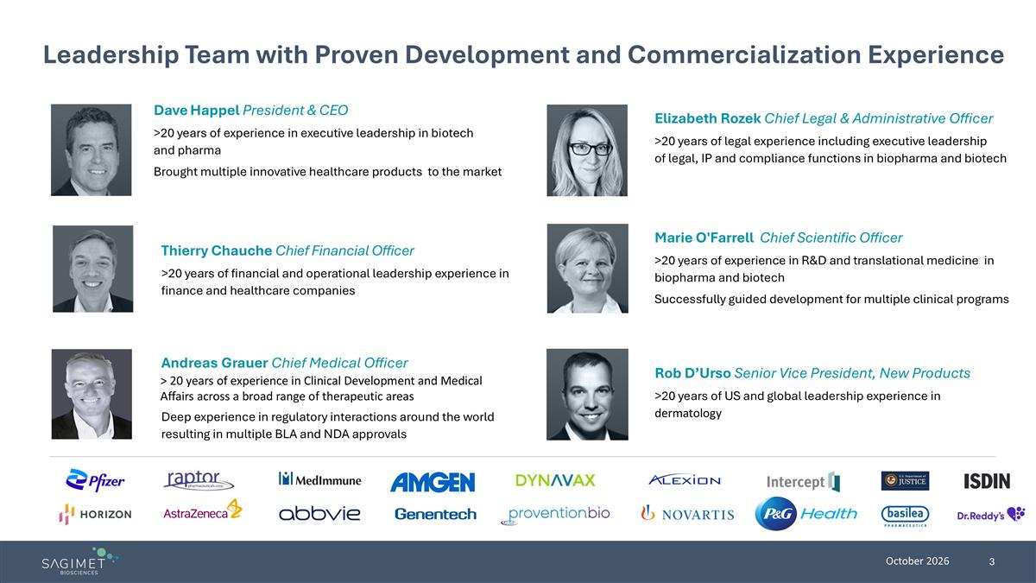
Dave Happel President & CEO >20 years of experience in executive leadership in biotech and pharma Brought multiple innovative healthcare products to the market Andreas Grauer Chief Medical Officer > 20 years of experience in Clinical Development and Medical Affairs across a broad range of therapeutic areas Deep experience in regulatory interactions around the world resulting in multiple BLA and NDA approvals Thierry Chauche Chief Financial Officer >20 years of financial and operational leadership experience in finance and healthcare companies Elizabeth Rozek Chief Legal & Administrative Officer >20 years of legal experience including executive leadership of legal, IP and compliance functions in biopharma and biotech Rob D’Urso Senior Vice President, New Products >20 years of US and global leadership experience in dermatology Marie O'Farrell Chief Scientific Officer >20 years of experience in R&D and translational medicine in biopharma and biotech Successfully guided development for multiple clinical programs Leadership Team with Proven Development and Commercialization Experience

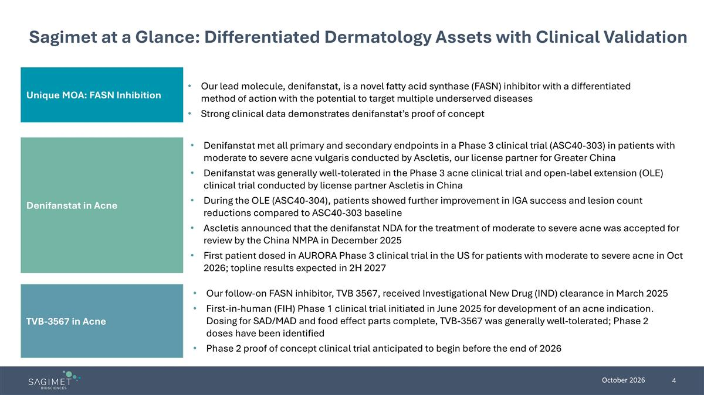
TVB-3567 in Acne Unique MOA: FASN Inhibition Sagimet at a Glance: Differentiated Dermatology Assets with Clinical Validation Our lead molecule, denifanstat, is a novel fatty acid synthase (FASN) inhibitor with a differentiated method of action with the potential to target multiple underserved diseases Strong clinical data demonstrates denifanstat’s proof of concept Denifanstat met all primary and secondary endpoints in a Phase 3 clinical trial (ASC40-303) in patients with moderate to severe acne vulgaris conducted by Ascletis, our license partner for Greater China Denifanstat was generally well-tolerated in the Phase 3 acne clinical trial and open-label extension (OLE) clinical trial conducted by license partner Ascletis in China During the OLE (ASC40-304), patients showed further improvement in IGA success and lesion count reductions compared to ASC40-303 baseline Ascletis announced that the denifanstat NDA for the treatment of moderate to severe acne was accepted for review by the China NMPA in December 2025 First patient dosed in AURORA Phase 3 clinical trial in the US for patients with moderate to severe acne in Oct 2026; topline results expected in 2H 2027 Our follow-on FASN inhibitor, TVB 3567, received Investigational New Drug (IND) clearance in March 2025 First-in-human (FIH) Phase 1 clinical trial initiated in June 2025 for development of an acne indication. Dosing for SAD/MAD and food effect parts complete, TVB-3567 was generally well-tolerated; Phase 2 doses have been identified Phase 2 proof of concept clinical trial anticipated to begin before the end of 2026 Denifanstat in Acne

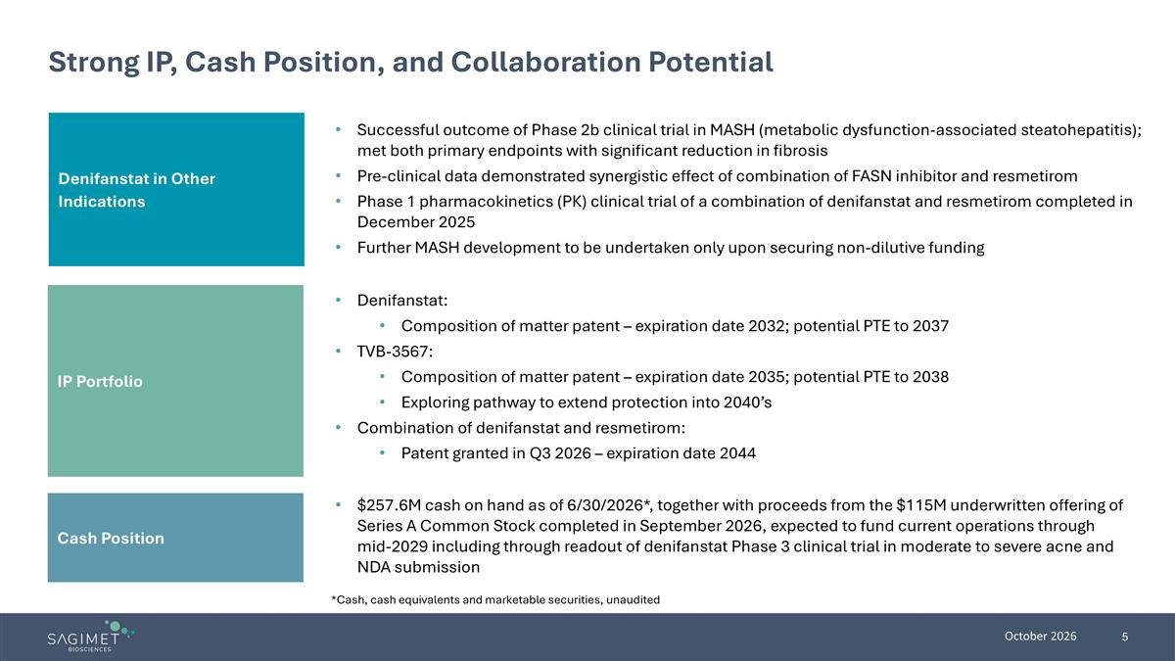
Denifanstat in Other Indications Strong IP, Cash Position, and Collaboration Potential Successful outcome of Phase 2b clinical trial in MASH (metabolic dysfunction-associated steatohepatitis); met both primary endpoints with significant reduction in fibrosis Pre-clinical data demonstrated synergistic effect of combination of FASN inhibitor and resmetirom Phase 1 pharmacokinetics (PK) clinical trial of a combination of denifanstat and resmetirom completed in December 2025 Further MASH development to be undertaken only upon securing non-dilutive funding Denifanstat: Composition of matter patent – expiration date 2032; potential PTE to 2037 TVB-3567: Composition of matter patent – expiration date 2035; potential PTE to 2038 Exploring pathway to extend protection into 2040’s Combination of denifanstat and resmetirom: Patent granted in Q3 2026 – expiration date 2044 $257.6M cash on hand as of 6/30/2026*, together with proceeds from the $115M underwritten offering of Series A Common Stock completed in September 2026, expected to fund current operations through mid-2029 including through readout of denifanstat Phase 3 clinical trial in moderate to severe acne and NDA submission *Cash, cash equivalents and marketable securities, unaudited IP Portfolio Cash Position

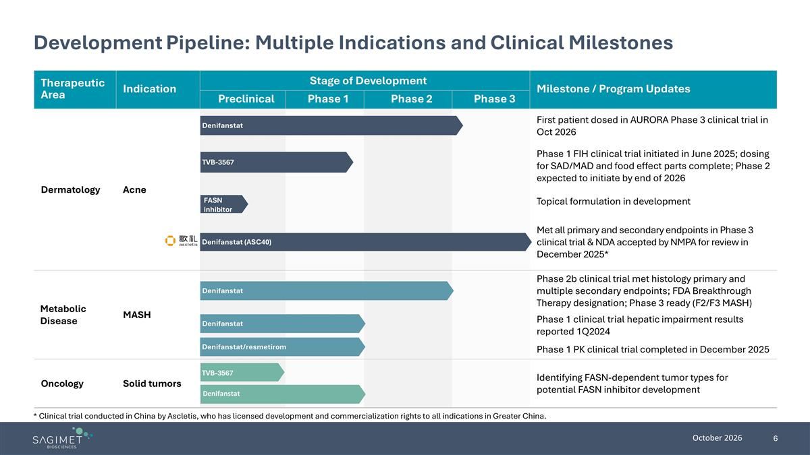
Therapeutic Area Indication Stage of Development Milestone / Program Updates Preclinical Phase 1 Phase 2 Phase 3 Dermatology Acne First patient dosed in AURORA Phase 3 clinical trial in Oct 2026 Phase 1 FIH clinical trial initiated in June 2025; dosing for SAD/MAD and food effect parts complete; Phase 2 expected to initiate by end of 2026 Topical formulation in development Met all primary and secondary endpoints in Phase 3 clinical trial & NDA accepted by NMPA for review in December 2025* Metabolic Disease MASH Phase 2b clinical trial met histology primary and multiple secondary endpoints; FDA Breakthrough Therapy designation; Phase 3 ready (F2/F3 MASH) Phase 1 clinical trial hepatic impairment results reported 1Q2024 Phase 1 PK clinical trial completed in December 2025 Oncology Solid tumors Identifying FASN-dependent tumor types for potential FASN inhibitor development Denifanstat TVB-3567 Denifanstat (ASC40) Development Pipeline: Multiple Indications and Clinical Milestones * Clinical trial conducted in China by Ascletis, who has licensed development and commercialization rights to all indications in Greater China. TVB-3567 Denifanstat FASN inhibitor Denifanstat Denifanstat Denifanstat/resmetirom


FASN Inhibition Offers Differentiated MOA in Acne

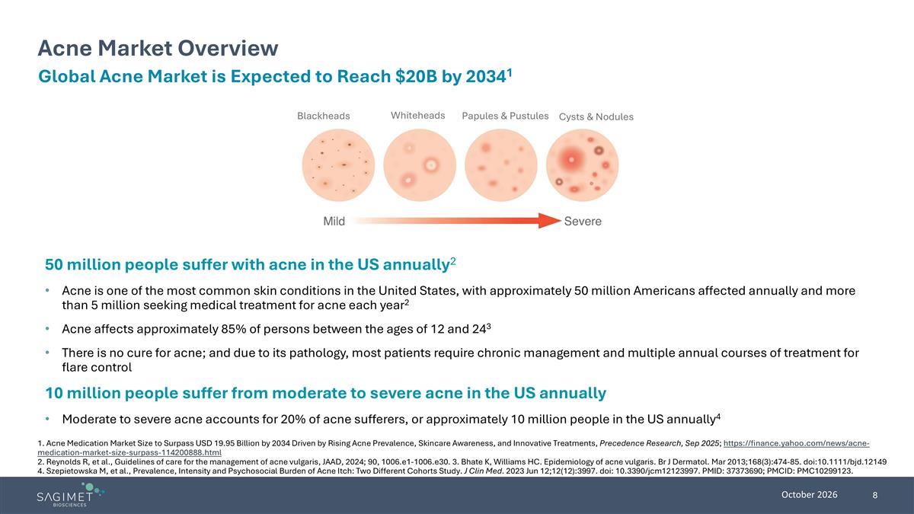
Blackheads Whiteheads Papules & Pustules Cysts & Nodules Acne Market Overview Global Acne Market is Expected to Reach $20B by 20341 50 million people suffer with acne in the US annually2 Acne is one of the most common skin conditions in the United States, with approximately 50 million Americans affected annually and more than 5 million seeking medical treatment for acne each year2 Acne affects approximately 85% of persons between the ages of 12 and 243 There is no cure for acne; and due to its pathology, most patients require chronic management and multiple annual courses of treatment for flare control 10 million people suffer from moderate to severe acne in the US annually Moderate to severe acne accounts for 20% of acne sufferers, or approximately 10 million people in the US annually4 1. Acne Medication Market Size to Surpass USD 19.95 Billion by 2034 Driven by Rising Acne Prevalence, Skincare Awareness, and Innovative Treatments, Precedence Research, Sep 2025; https://finance.yahoo.com/news/acne- medication-market-size-surpass-114200888.html 2. Reynolds R, et al., Guidelines of care for the management of acne vulgaris, JAAD, 2024; 90, 1006.e1-1006.e30. 3. Bhate K, Williams HC. Epidemiology of acne vulgaris. Br J Dermatol. Mar 2013;168(3):474-85. doi:10.1111/bjd.12149 4. Szepietowska M, et al., Prevalence, Intensity and Psychosocial Burden of Acne Itch: Two Different Cohorts Study. J Clin Med. 2023 Jun 12;12(12):3997. doi: 10.3390/jcm12123997. PMID: 37373690; PMCID: PMC10299123.

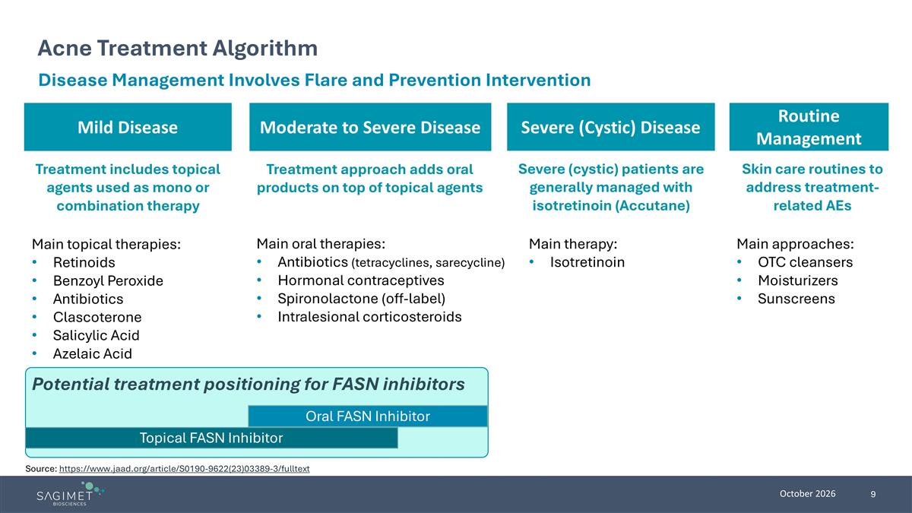
Moderate to Severe Disease Mild Disease Acne Treatment Algorithm Disease Management Involves Flare and Prevention Intervention Treatment includes topical agents used as mono or combination therapy Main topical therapies: Retinoids Benzoyl Peroxide Antibiotics Clascoterone Salicylic Acid Azelaic Acid Treatment approach adds oral products on top of topical agents Main oral therapies: Antibiotics (tetracyclines, sarecycline) Hormonal contraceptives Spironolactone (off-label) Intralesional corticosteroids Severe (cystic) patients are generally managed with isotretinoin (Accutane) Main therapy: Isotretinoin Severe (Cystic) Disease Oral FASN Inhibitor Topical FASN Inhibitor Potential treatment positioning for FASN inhibitors Source: https://www.jaad.org/article/S0190-9622(23)03389-3/fulltext Routine Management Main approaches: OTC cleansers Moisturizers Sunscreens Skin care routines to address treatment-related AEs

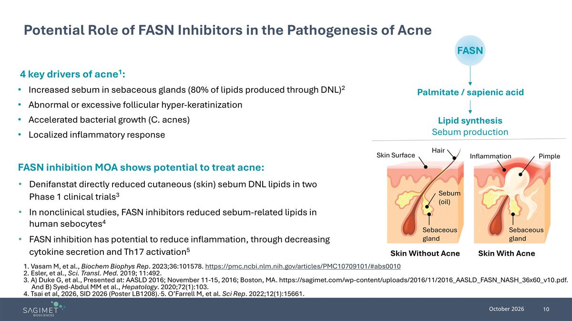
4 key drivers of acne1: Increased sebum in sebaceous glands (80% of lipids produced through DNL)2 Abnormal or excessive follicular hyper-keratinization Accelerated bacterial growth (C. acnes) Localized inflammatory response Potential Role of FASN Inhibitors in the Pathogenesis of Acne 1. Vasam M, et al., Biochem Biophys Rep. 2023;36:101578. https://pmc.ncbi.nlm.nih.gov/articles/PMC10709101/#abs0010 2. Esler, et al., Sci. Transl. Med. 2019; 11:492. 3. A) Duke G, et al., Presented at: AASLD 2016; November 11-15, 2016; Boston, MA. https://sagimet.com/wp-content/uploads/2016/11/2016_AASLD_FASN_NASH_36x60_v10.pdf. And B) Syed-Abdul MM et al., Hepatology. 2020;72(1):103. 4. Tsai et al, 2026, SID 2026 (Poster LB1208). 5. O’Farrell M, et al. Sci Rep. 2022;12(1):15661. FASN Palmitate / sapienic acid Lipid synthesis Sebum production Hair Skin Surface Sebum (oil) Inflammation Sebaceous gland Skin With Acne Skin Without Acne Pimple Sebaceous gland FASN inhibition MOA shows potential to treat acne: Denifanstat directly reduced cutaneous (skin) sebum DNL lipids in two Phase 1 clinical trials3 In nonclinical studies, FASN inhibitors reduced sebum-related lipids in human sebocytes4 FASN inhibition has potential to reduce inflammation, through decreasing cytokine secretion and Th17 activation5

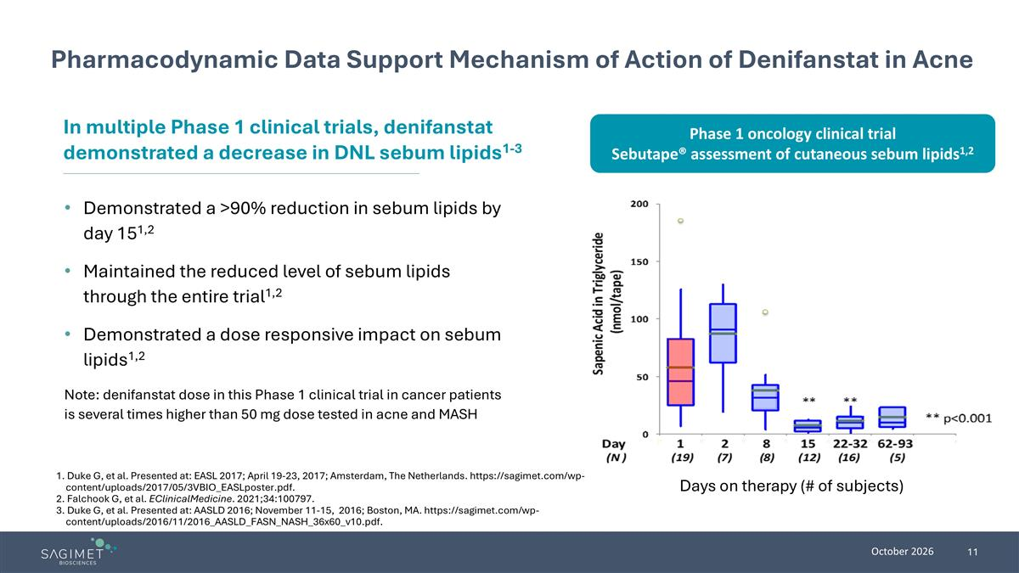
Pharmacodynamic Data Support Mechanism of Action of Denifanstat in Acne Demonstrated a >90% reduction in sebum lipids by day 151,2 Maintained the reduced level of sebum lipids through the entire trial1,2 Demonstrated a dose responsive impact on sebum lipids1,2 Note: denifanstat dose in this Phase 1 clinical trial in cancer patients is several times higher than 50 mg dose tested in acne and MASH In multiple Phase 1 clinical trials, denifanstat demonstrated a decrease in DNL sebum lipids1-3 1. Duke G, et al. Presented at: EASL 2017; April 19-23, 2017; Amsterdam, The Netherlands. https://sagimet.com/wp-content/uploads/2017/05/3VBIO_EASLposter.pdf. 2. Falchook G, et al. EClinicalMedicine. 2021;34:100797. 3. Duke G, et al. Presented at: AASLD 2016; November 11-15, 2016; Boston, MA. https://sagimet.com/wp-content/uploads/2016/11/2016_AASLD_FASN_NASH_36x60_v10.pdf. Days on therapy (# of subjects) Phase 1 oncology clinical trial Sebutape® assessment of cutaneous sebum lipids1,2


Denifanstat’s Clinical Data in Acne

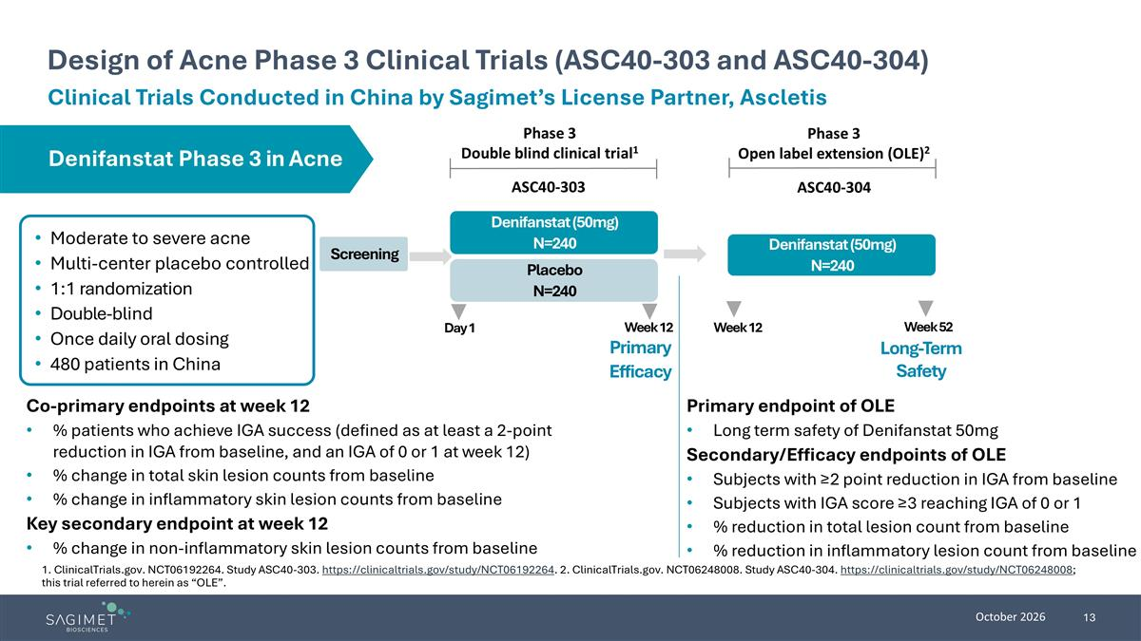
Design of Acne Phase 3 Clinical Trials (ASC40-303 and ASC40-304) Moderate to severe acne Multi-center placebo controlled 1:1 randomization Double-blind Once daily oral dosing 480 patients in China Co-primary endpoints at week 12 % patients who achieve IGA success (defined as at least a 2-point reduction in IGA from baseline, and an IGA of 0 or 1 at week 12) % change in total skin lesion counts from baseline % change in inflammatory skin lesion counts from baseline Key secondary endpoint at week 12 % change in non-inflammatory skin lesion counts from baseline Screening Placebo N=240 Denifanstat (50mg) N=240 Day 1 Week 12 Primary Efficacy Denifanstat (50mg) N=240 Phase 3 Double blind clinical trial1 Week 12 Week 52 Denifanstat Phase 3 in Acne 1. ClinicalTrials.gov. NCT06192264. Study ASC40-303. https://clinicaltrials.gov/study/NCT06192264. 2. ClinicalTrials.gov. NCT06248008. Study ASC40-304. https://clinicaltrials.gov/study/NCT06248008; this trial referred to herein as “OLE”. Phase 3 Open label extension (OLE)2 Long-Term Safety Primary endpoint of OLE Long term safety of Denifanstat 50mg Secondary/Efficacy endpoints of OLE Subjects with ≥2 point reduction in IGA from baseline Subjects with IGA score ≥3 reaching IGA of 0 or 1 % reduction in total lesion count from baseline % reduction in inflammatory lesion count from baseline ASC40-303 ASC40-304 Clinical Trials Conducted in China by Sagimet’s License Partner, Ascletis

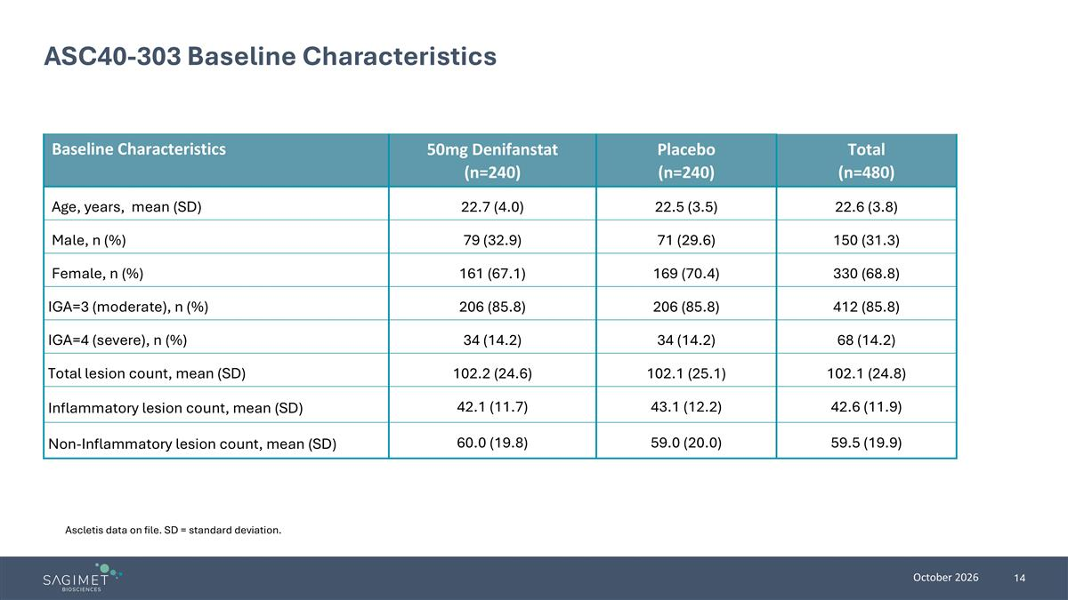
ASC40-303 Baseline Characteristics Baseline Characteristics 50mg Denifanstat (n=240) Placebo (n=240) Total (n=480) Age, years, mean (SD) 22.7 (4.0) 22.5 (3.5) 22.6 (3.8) Male, n (%) 79 (32.9) 71 (29.6) 150 (31.3) Female, n (%) 161 (67.1) 169 (70.4) 330 (68.8) IGA=3 (moderate), n (%) 206 (85.8) 206 (85.8) 412 (85.8) IGA=4 (severe), n (%) 34 (14.2) 34 (14.2) 68 (14.2) Total lesion count, mean (SD) 102.2 (24.6) 102.1 (25.1) 102.1 (24.8) Inflammatory lesion count, mean (SD) 42.1 (11.7) 43.1 (12.2) 42.6 (11.9) Non-Inflammatory lesion count, mean (SD) 60.0 (19.8) 59.0 (20.0) 59.5 (19.9) Ascletis data on file. SD = standard deviation.

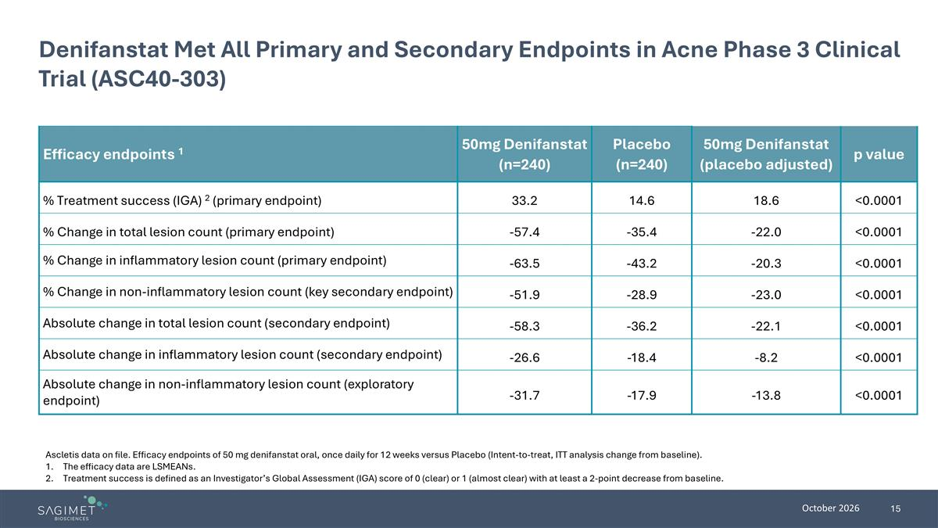
Denifanstat Met All Primary and Secondary Endpoints in Acne Phase 3 Clinical Trial (ASC40-303) Efficacy endpoints 1 50mg Denifanstat (n=240) Placebo (n=240) 50mg Denifanstat (placebo adjusted) p value % Treatment success (IGA) 2 (primary endpoint) 33.2 14.6 18.6 <0.0001 % Change in total lesion count (primary endpoint) -57.4 -35.4 -22.0 <0.0001 % Change in inflammatory lesion count (primary endpoint) -63.5 -43.2 -20.3 <0.0001 % Change in non-inflammatory lesion count (key secondary endpoint) -51.9 -28.9 -23.0 <0.0001 Absolute change in total lesion count (secondary endpoint) -58.3 -36.2 -22.1 <0.0001 Absolute change in inflammatory lesion count (secondary endpoint) -26.6 -18.4 -8.2 <0.0001 Absolute change in non-inflammatory lesion count (exploratory endpoint) -31.7 -17.9 -13.8 <0.0001 Ascletis data on file. Efficacy endpoints of 50 mg denifanstat oral, once daily for 12 weeks versus Placebo (Intent-to-treat, ITT analysis change from baseline). The efficacy data are LSMEANs. Treatment success is defined as an Investigator’s Global Assessment (IGA) score of 0 (clear) or 1 (almost clear) with at least a 2-point decrease from baseline.

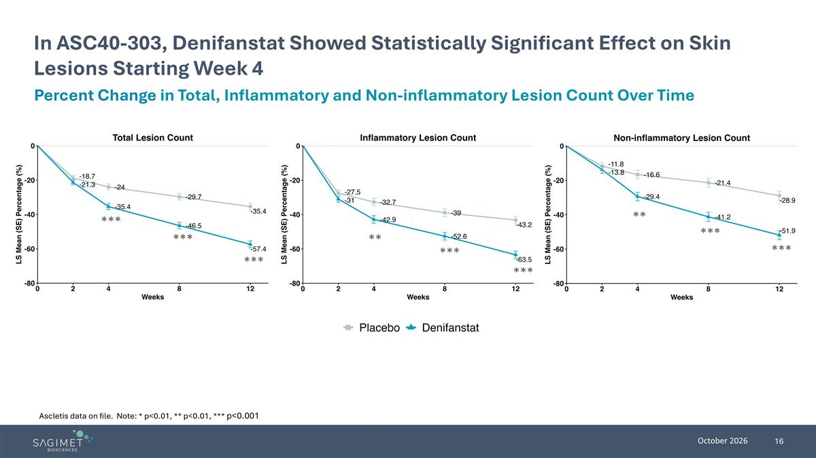
In ASC40-303, Denifanstat Showed Statistically Significant Effect on Skin Lesions Starting Week 4 Percent Change in Total, Inflammatory and Non-inflammatory Lesion Count Over Time ** *** *** ** *** *** *** *** *** Ascletis data on file. Note: * p<0.01, ** p<0.01, *** p<0.001

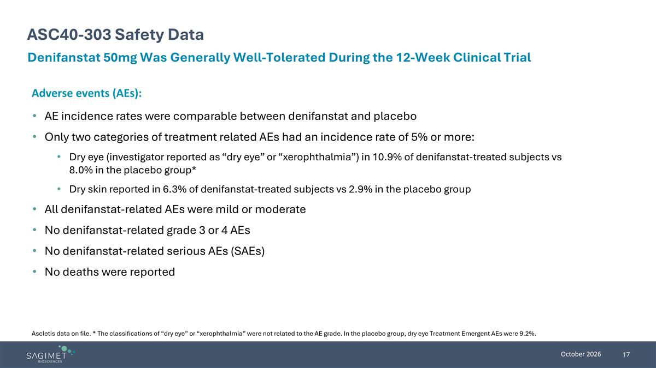
ASC40-303 Safety Data Denifanstat 50mg Was Generally Well-Tolerated During the 12-Week Clinical Trial Adverse events (AEs): AE incidence rates were comparable between denifanstat and placebo Only two categories of treatment related AEs had an incidence rate of 5% or more: Dry eye (investigator reported as “dry eye” or “xerophthalmia”) in 10.9% of denifanstat-treated subjects vs 8.0% in the placebo group* Dry skin reported in 6.3% of denifanstat-treated subjects vs 2.9% in the placebo group All denifanstat-related AEs were mild or moderate No denifanstat-related grade 3 or 4 AEs No denifanstat-related serious AEs (SAEs) No deaths were reported Ascletis data on file. * The classifications of “dry eye” or “xerophthalmia” were not related to the AE grade. In the placebo group, dry eye Treatment Emergent AEs were 9.2%.

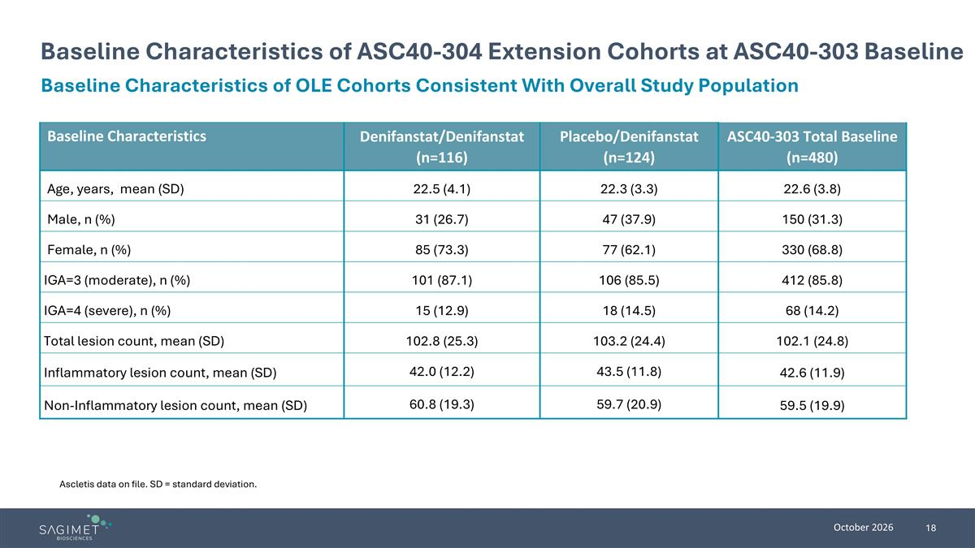
Baseline Characteristics of ASC40-304 Extension Cohorts at ASC40-303 Baseline Baseline Characteristics Denifanstat/Denifanstat (n=116) Placebo/Denifanstat (n=124) ASC40-303 Total Baseline (n=480) Age, years, mean (SD) 22.5 (4.1) 22.3 (3.3) 22.6 (3.8) Male, n (%) 31 (26.7) 47 (37.9) 150 (31.3) Female, n (%) 85 (73.3) 77 (62.1) 330 (68.8) IGA=3 (moderate), n (%) 101 (87.1) 106 (85.5) 412 (85.8) IGA=4 (severe), n (%) 15 (12.9) 18 (14.5) 68 (14.2) Total lesion count, mean (SD) 102.8 (25.3) 103.2 (24.4) 102.1 (24.8) Inflammatory lesion count, mean (SD) 42.0 (12.2) 43.5 (11.8) 42.6 (11.9) Non-Inflammatory lesion count, mean (SD) 60.8 (19.3) 59.7 (20.9) 59.5 (19.9) Ascletis data on file. SD = standard deviation. Baseline Characteristics of OLE Cohorts Consistent With Overall Study Population

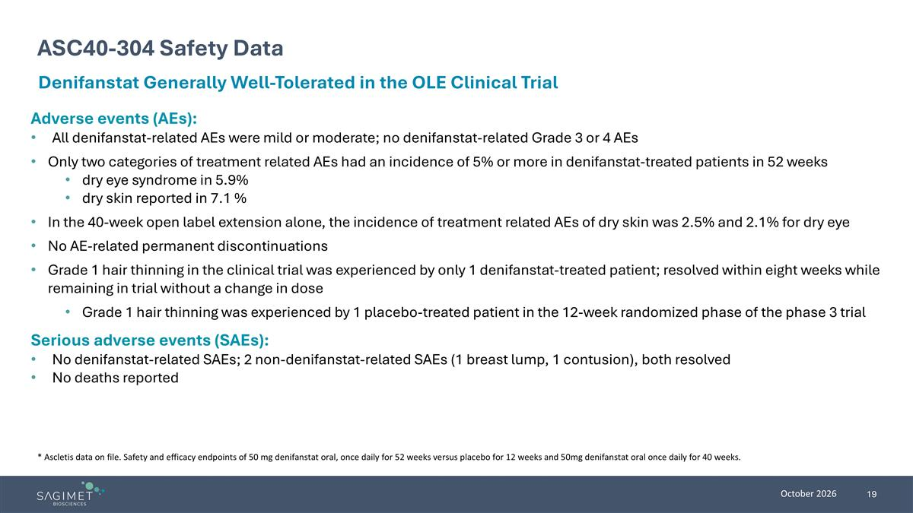
ASC40-304 Safety Data Denifanstat Generally Well-Tolerated in the OLE Clinical Trial * Ascletis data on file. Safety and efficacy endpoints of 50 mg denifanstat oral, once daily for 52 weeks versus placebo for 12 weeks and 50mg denifanstat oral once daily for 40 weeks. Adverse events (AEs): All denifanstat-related AEs were mild or moderate; no denifanstat-related Grade 3 or 4 AEs Only two categories of treatment related AEs had an incidence of 5% or more in denifanstat-treated patients in 52 weeks dry eye syndrome in 5.9% dry skin reported in 7.1 % In the 40-week open label extension alone, the incidence of treatment related AEs of dry skin was 2.5% and 2.1% for dry eye No AE-related permanent discontinuations Grade 1 hair thinning in the clinical trial was experienced by only 1 denifanstat-treated patient; resolved within eight weeks while remaining in trial without a change in dose Grade 1 hair thinning was experienced by 1 placebo-treated patient in the 12-week randomized phase of the phase 3 trial Serious adverse events (SAEs): No denifanstat-related SAEs; 2 non-denifanstat-related SAEs (1 breast lump, 1 contusion), both resolved No deaths reported

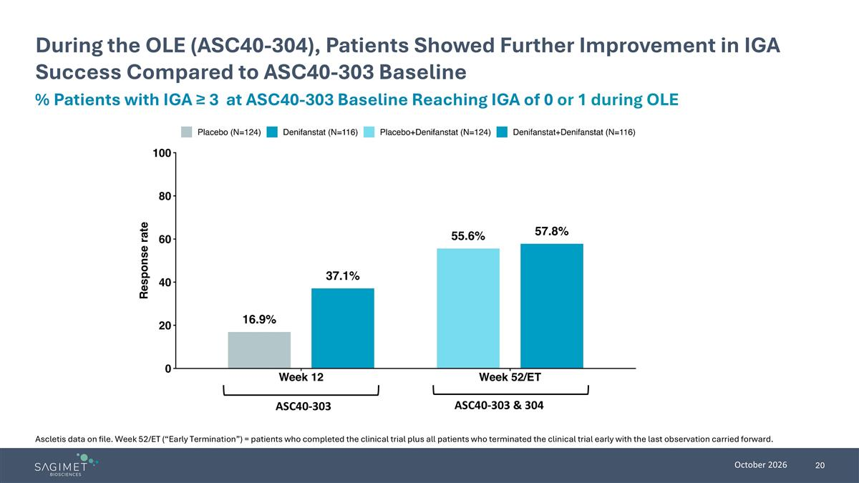
During the OLE (ASC40-304), Patients Showed Further Improvement in IGA Success Compared to ASC40-303 Baseline % Patients with IGA ≥ 3 at ASC40-303 Baseline Reaching IGA of 0 or 1 during OLE ASC40-303 ASC40-303 & 304 Ascletis data on file. Week 52/ET (“Early Termination”) = patients who completed the clinical trial plus all patients who terminated the clinical trial early with the last observation carried forward.

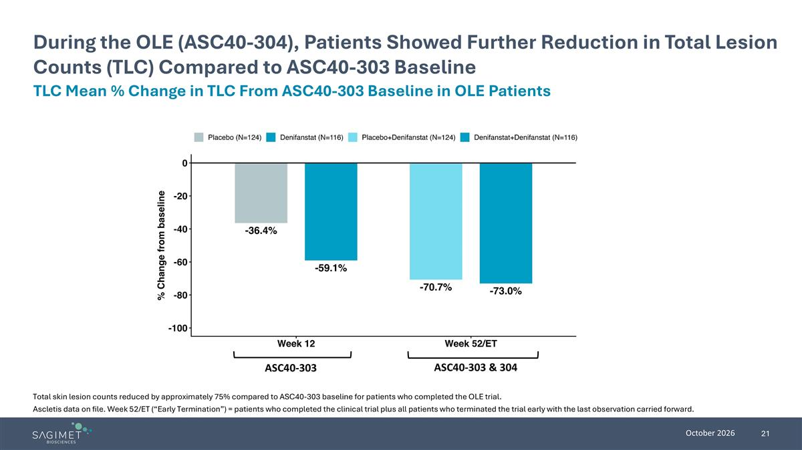
Ascletis data on file. Week 52/ET (“Early Termination”) = patients who completed the clinical trial plus all patients who terminated the trial early with the last observation carried forward. During the OLE (ASC40-304), Patients Showed Further Reduction in Total Lesion Counts (TLC) Compared to ASC40-303 Baseline TLC Mean % Change in TLC From ASC40-303 Baseline in OLE Patients ASC40-303 ASC40-303 & 304 Total skin lesion counts reduced by approximately 75% compared to ASC40-303 baseline for patients who completed the OLE trial.

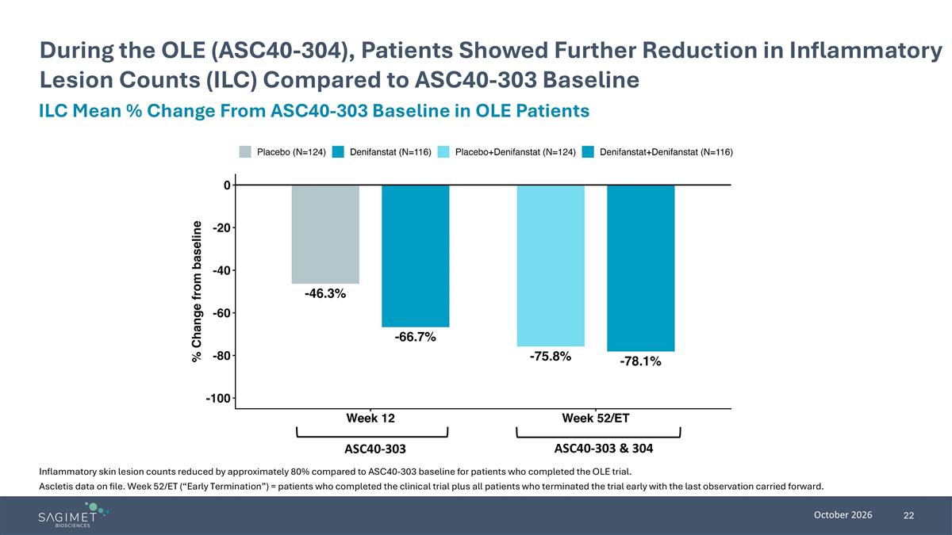
During the OLE (ASC40-304), Patients Showed Further Reduction in Inflammatory Lesion Counts (ILC) Compared to ASC40-303 Baseline ILC Mean % Change From ASC40-303 Baseline in OLE Patients ASC40-303 ASC40-303 & 304 Ascletis data on file. Week 52/ET (“Early Termination”) = patients who completed the clinical trial plus all patients who terminated the trial early with the last observation carried forward. Inflammatory skin lesion counts reduced by approximately 80% compared to ASC40-303 baseline for patients who completed the OLE trial.

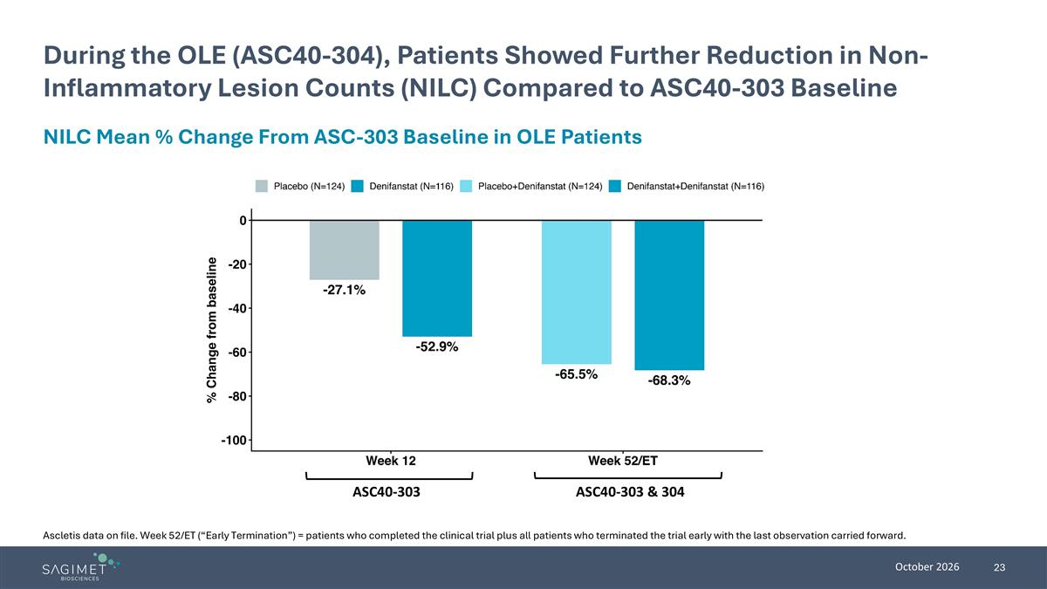
During the OLE (ASC40-304), Patients Showed Further Reduction in Non-Inflammatory Lesion Counts (NILC) Compared to ASC40-303 Baseline NILC Mean % Change From ASC-303 Baseline in OLE Patients ASC40-303 ASC40-303 & 304 Ascletis data on file. Week 52/ET (“Early Termination”) = patients who completed the clinical trial plus all patients who terminated the trial early with the last observation carried forward.

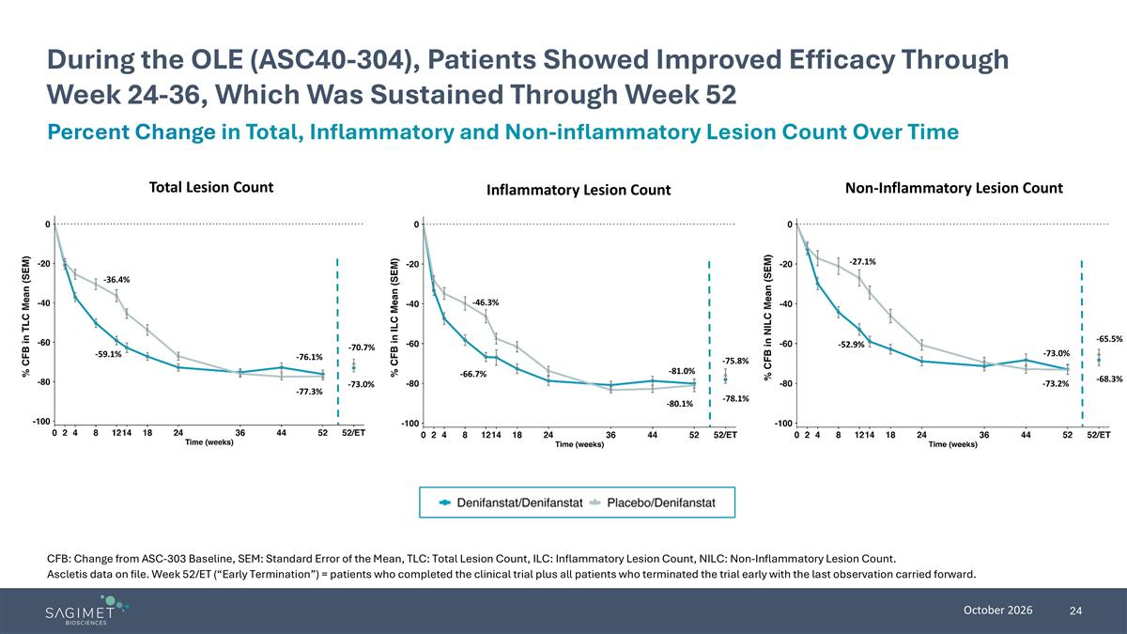
During the OLE (ASC40-304), Patients Showed Improved Efficacy Through Week 24-36, Which Was Sustained Through Week 52 Ascletis data on file. Week 52/ET (“Early Termination”) = patients who completed the clinical trial plus all patients who terminated the trial early with the last observation carried forward. CFB: Change from ASC-303 Baseline, SEM: Standard Error of the Mean, TLC: Total Lesion Count, ILC: Inflammatory Lesion Count, NILC: Non-Inflammatory Lesion Count. Total Lesion Count Inflammatory Lesion Count Non-Inflammatory Lesion Count -78.1% -75.8% -81.0% -80.1% -46.3% -66.7% -70.7% -73.0% -77.3% -76.1% -59.1% -36.4% -73.0% -73.2% -52.9% -27.1% -65.5% -68.3% Percent Change in Total, Inflammatory and Non-inflammatory Lesion Count Over Time

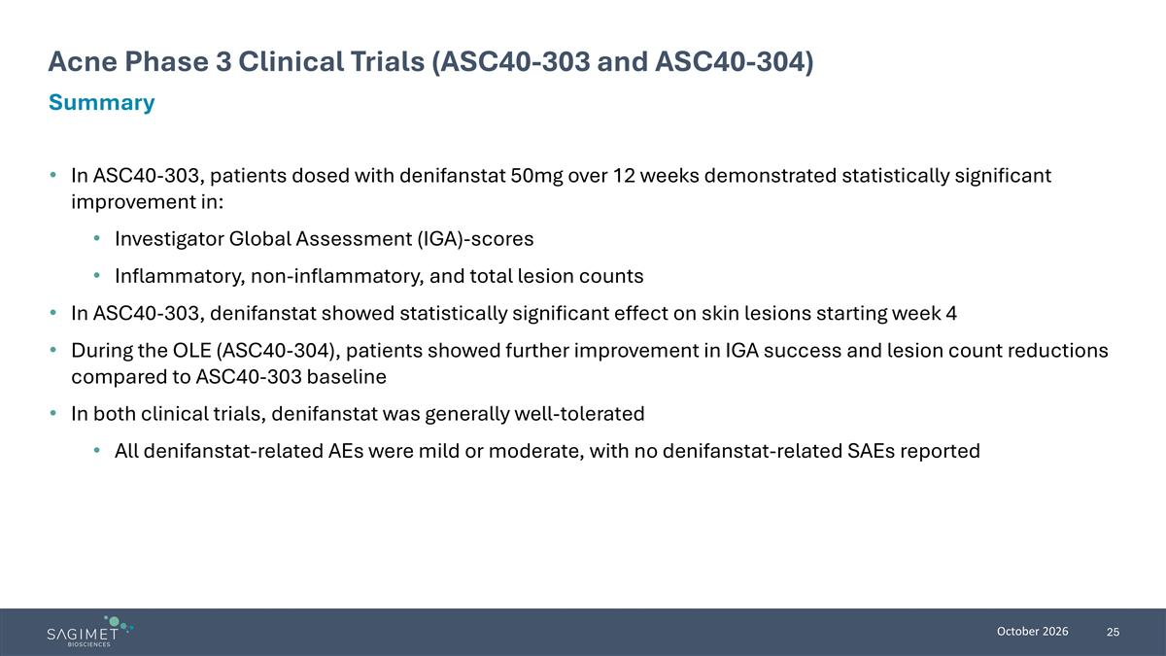
In ASC40-303, patients dosed with denifanstat 50mg over 12 weeks demonstrated statistically significant improvement in: Investigator Global Assessment (IGA)-scores Inflammatory, non-inflammatory, and total lesion counts In ASC40-303, denifanstat showed statistically significant effect on skin lesions starting week 4 During the OLE (ASC40-304), patients showed further improvement in IGA success and lesion count reductions compared to ASC40-303 baseline In both clinical trials, denifanstat was generally well-tolerated All denifanstat-related AEs were mild or moderate, with no denifanstat-related SAEs reported Acne Phase 3 Clinical Trials (ASC40-303 and ASC40-304) Summary


Sagimet’s Development Programs

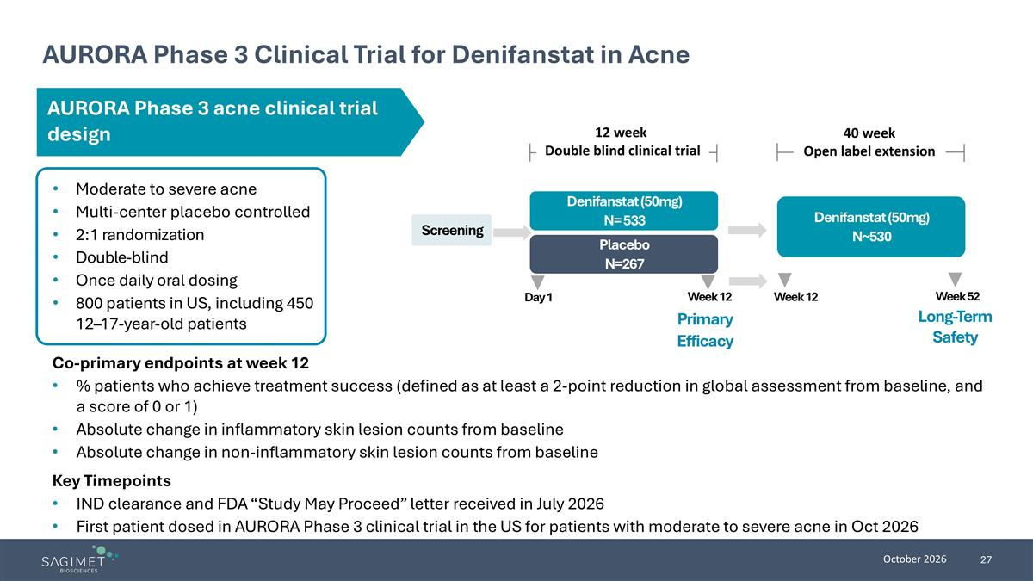
AURORA Phase 3 Clinical Trial for Denifanstat in Acne Moderate to severe acne Multi-center placebo controlled 2:1 randomization Double-blind Once daily oral dosing 800 patients in US, including 450 12–17-year-old patients Co-primary endpoints at week 12 % patients who achieve treatment success (defined as at least a 2-point reduction in global assessment from baseline, and a score of 0 or 1) Absolute change in inflammatory skin lesion counts from baseline Absolute change in non-inflammatory skin lesion counts from baseline Key Timepoints IND clearance and FDA “Study May Proceed” letter received in July 2026 First patient dosed in AURORA Phase 3 clinical trial in the US for patients with moderate to severe acne in Oct 2026 Screening Placebo N=267 Denifanstat (50mg) N= 533 Day 1 Week 12 Primary Efficacy Denifanstat (50mg) N~530 Long-Term Safety 12 week Double blind clinical trial 40 week Open label extension Week 12 Week 52 AURORA Phase 3 acne clinical trial design

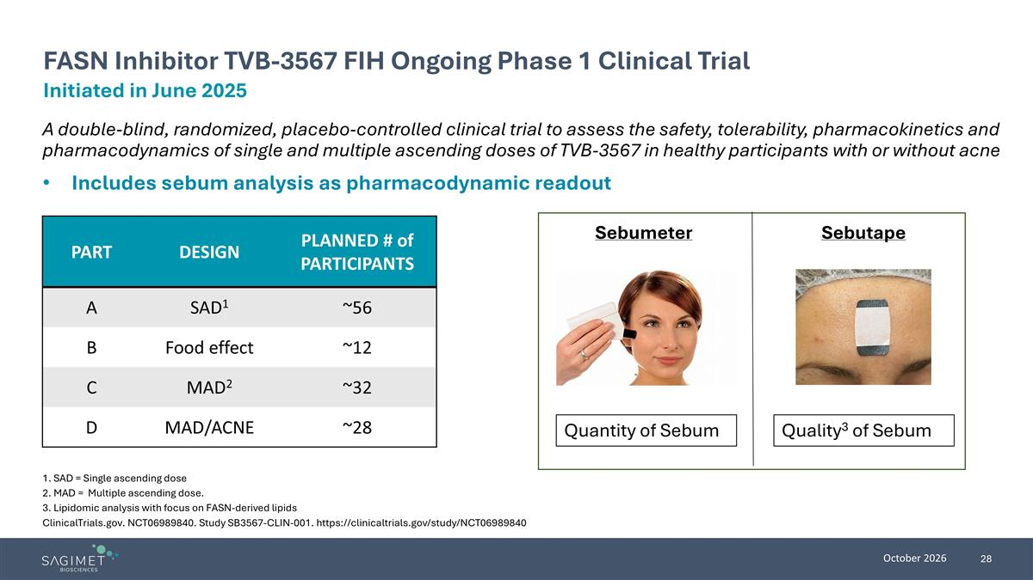
A double-blind, randomized, placebo-controlled clinical trial to assess the safety, tolerability, pharmacokinetics and pharmacodynamics of single and multiple ascending doses of TVB-3567 in healthy participants with or without acne Includes sebum analysis as pharmacodynamic readout 1. SAD = Single ascending dose 2. MAD = Multiple ascending dose. 3. Lipidomic analysis with focus on FASN-derived lipids ClinicalTrials.gov. NCT06989840. Study SB3567-CLIN-001. https://clinicaltrials.gov/study/NCT06989840 Initiated in June 2025 FASN Inhibitor TVB-3567 FIH Ongoing Phase 1 Clinical Trial Sebutape Sebumeter Quantity of Sebum Quality3 of Sebum PART DESIGN PLANNED # of PARTICIPANTS A SAD1 ~56 B Food effect ~12 C MAD2 ~32 D MAD/ACNE ~28

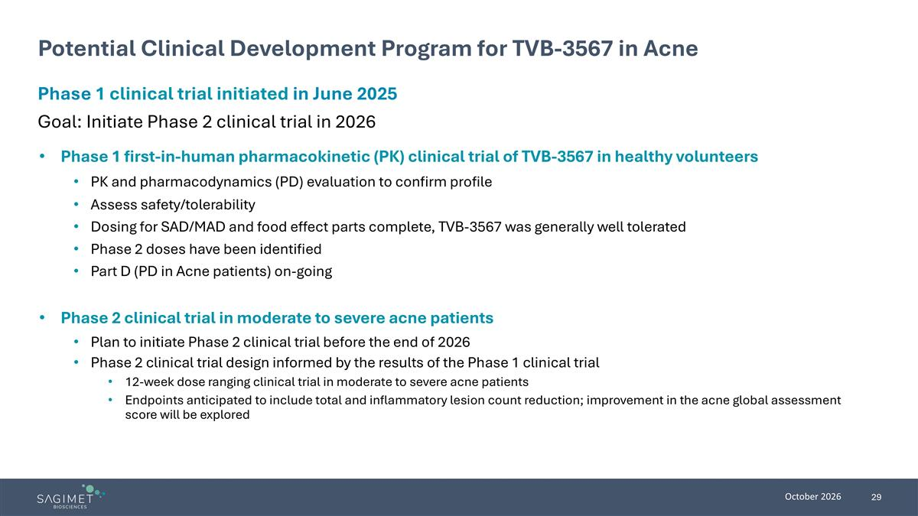
Potential Clinical Development Program for TVB-3567 in Acne Phase 1 first-in-human pharmacokinetic (PK) clinical trial of TVB-3567 in healthy volunteers PK and pharmacodynamics (PD) evaluation to confirm profile Assess safety/tolerability Dosing for SAD/MAD and food effect parts complete, TVB-3567 was generally well tolerated Phase 2 doses have been identified Part D (PD in Acne patients) on-going Phase 2 clinical trial in moderate to severe acne patients Plan to initiate Phase 2 clinical trial before the end of 2026 Phase 2 clinical trial design informed by the results of the Phase 1 clinical trial 12-week dose ranging clinical trial in moderate to severe acne patients Endpoints anticipated to include total and inflammatory lesion count reduction; improvement in the acne global assessment score will be explored Phase 1 clinical trial initiated in June 2025 Goal: Initiate Phase 2 clinical trial in 2026

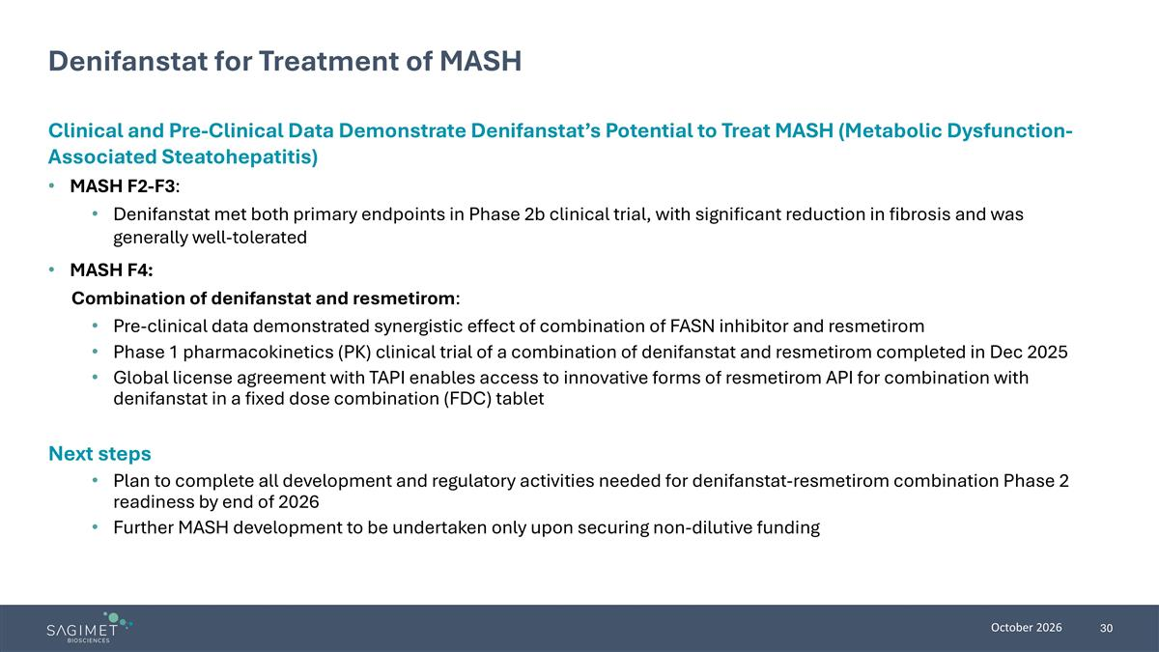
Denifanstat for Treatment of MASH Clinical and Pre-Clinical Data Demonstrate Denifanstat’s Potential to Treat MASH (Metabolic Dysfunction-Associated Steatohepatitis) MASH F2-F3: Denifanstat met both primary endpoints in Phase 2b clinical trial, with significant reduction in fibrosis and was generally well-tolerated MASH F4: Combination of denifanstat and resmetirom: Pre-clinical data demonstrated synergistic effect of combination of FASN inhibitor and resmetirom Phase 1 pharmacokinetics (PK) clinical trial of a combination of denifanstat and resmetirom completed in Dec 2025 Global license agreement with TAPI enables access to innovative forms of resmetirom API for combination with denifanstat in a fixed dose combination (FDC) tablet Next steps Plan to complete all development and regulatory activities needed for denifanstat-resmetirom combination Phase 2 readiness by end of 2026 Further MASH development to be undertaken only upon securing non-dilutive funding

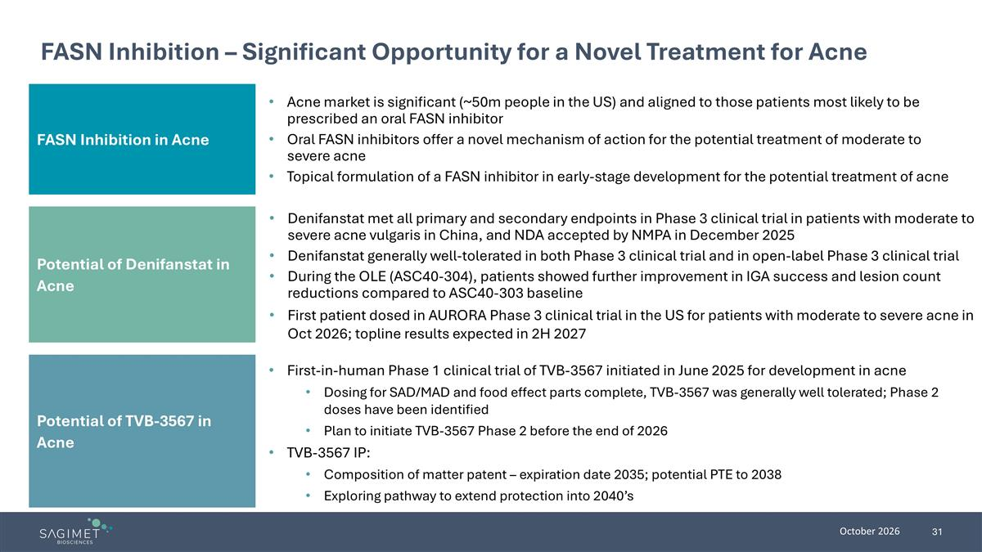
FASN Inhibition – Significant Opportunity for a Novel Treatment for Acne FASN Inhibition in Acne Potential of TVB-3567 in Acne Acne market is significant (~50m people in the US) and aligned to those patients most likely to be prescribed an oral FASN inhibitor Oral FASN inhibitors offer a novel mechanism of action for the potential treatment of moderate to severe acne Topical formulation of a FASN inhibitor in early-stage development for the potential treatment of acne First-in-human Phase 1 clinical trial of TVB-3567 initiated in June 2025 for development in acne Dosing for SAD/MAD and food effect parts complete, TVB-3567 was generally well tolerated; Phase 2 doses have been identified Plan to initiate TVB-3567 Phase 2 before the end of 2026 TVB-3567 IP: Composition of matter patent – expiration date 2035; potential PTE to 2038 Exploring pathway to extend protection into 2040’s Potential of Denifanstat in Acne Denifanstat met all primary and secondary endpoints in Phase 3 clinical trial in patients with moderate to severe acne vulgaris in China, and NDA accepted by NMPA in December 2025 Denifanstat generally well-tolerated in both Phase 3 clinical trial and in open-label Phase 3 clinical trial During the OLE (ASC40-304), patients showed further improvement in IGA success and lesion count reductions compared to ASC40-303 baseline First patient dosed in AURORA Phase 3 clinical trial in the US for patients with moderate to severe acne in Oct 2026; topline results expected in 2H 2027

