UNITED STATES
SECURITIES AND EXCHANGE COMMISSION
Washington, D.C. 20549

FORM 8-K

CURRENT REPORT
Pursuant to Section 13 or 15(d)
of the Securities Exchange Act of 1934
Date of Report (Date of earliest event reported): September 30, 2026

SAGIMET BIOSCIENCES INC.
(Exact name of registrant as specified in its charter)

Delaware |  | 001-41742 |  | 20-5991472
(State or other jurisdiction  of incorporation) |  | (Commission  File Number) |  | (I.R.S. Employer  Identification No.)
Sagimet Biosciences Inc.
950 Tower Lane, Suite 1500,
Foster City, CA 94404
(Address of principal executive offices, including zip code)
(650) 561-8600
(Registrant’s telephone number, including area code)
Not applicable
(Former Name or Former Address, if Changed Since Last Report)

Check the appropriate box below if the Form 8-K filing is intended to simultaneously satisfy the filing obligation of the registrant under any of the following provisions:

☐ | Written communications pursuant to Rule 425 under the Securities Act (17 CFR 230.425)

☐ | Soliciting material pursuant to Rule 14a-12 under the Exchange Act (17 CFR 240.14a-12)

☐ | Pre-commencement communications pursuant to Rule 14d-2(b) under the Exchange Act (17 CFR 240.14d-2(b))

☐ | Pre-commencement communications pursuant to Rule 13e-4(c) under the Exchange Act (17 CFR 240.13e-4(c))
Securities registered pursuant to Section 12(b) of the Act:

Title of each class |  | Trade  Symbol(s) |  | Name of each exchange  on which registered
Series A Common Stock, $0.0001 par value per share |  | SGMT |  | The Nasdaq Global Market
Indicate by check mark whether the registrant is an emerging growth company as defined in Rule 405 of the Securities Act of 1933 (§ 230.405 of this chapter) or Rule 12b-2 of the Securities Exchange Act of 1934 (§ 240.12b-2 of this chapter).
Emerging growth company ☒
If an emerging growth company, indicate by check mark if the registrant has elected not to use the extended transition period for complying with any new or revised financial accounting standards provided pursuant to Section 13(a) of the Exchange Act. ☐

Item 7.01 | Regulation FD Disclosure.
On September 30, 2026, Sagimet Biosciences Inc. (the “Company”) updated information reflected in a slide presentation, which is attached as Exhibit 99.1 to this Current Report on Form 8-K and is incorporated herein by reference. Representatives of the Company will use the updated presentation in various meetings with investors from time to time.
The information in Item 7.01 of this Current Report on Form 8-K, including the information set forth in Exhibit 99.1, is being furnished and shall not be deemed “filed” for purposes of Section 18 of the Securities Exchange Act of 1934, as amended (the “Exchange Act”), nor shall Exhibit 99.1 furnished herewith be deemed incorporated by reference in any filing under the Securities Act of 1933, as amended, or the Exchange Act, except as shall be expressly set forth by specific reference in such a filing.

Item 8.01 | Other Events.
Press Release
On September 30, 2026, the Company issued a press release announcing positive 52-week results from the Phase 3 ASC40-304 open-label extension clinical trial of denifanstat in patients with moderate to severe acne vulgaris, conducted by license partner Ascletis BioScience Co. Ltd. in China. The full text of the press release is filed as Exhibit 99.2 to this Current Report on Form 8-K and incorporated herein by reference.
At-the-Market Offering Prospectus Supplement Termination
Effective September 30, 2026, the Company suspended and terminated the prospectus supplement (the “ATM Prospectus Supplement”) related to the Company’s Series A common stock, par value $0.0001 per share (the “Common Stock”), issuable pursuant to the terms of a Sales Agreement, dated August 14, 2025, by and between the Company and Leerink Partners LLC (the “Sales Agreement”). As a result, the Company will not make any sales of the Company’s Common Stock pursuant to the Sales Agreement unless and until a new prospectus, prospectus supplement or a new registration statement is filed. Other than the termination of the ATM Prospectus Supplement, the Sales Agreement remains in full force and effect.

Item 9.01 | Financial Statements and Exhibits.
(d) Exhibits

Exhibit  No. |  | Document
99.1 |  | Investor Presentation of Sagimet Biosciences Inc., dated September 30, 2026.
99.2 |  | Press Release of Sagimet Biosciences Inc., dated September 30, 2026.
104 |  | Cover Page Interactive Data File (embedded within the Inline XBRL document).

SIGNATURES
Pursuant to the requirements of the Securities Exchange Act of 1934, as amended, the registrant has duly caused this report to be signed on its behalf by the undersigned hereunto duly authorized.

 |  |  |  | Sagimet Biosciences Inc.
Date: September 30, 2026 |  |  |  | By: |  | /s/ David Happel
 |  |  |  |  |  | David Happel
 |  |  |  |  |  | Chief Executive Officer
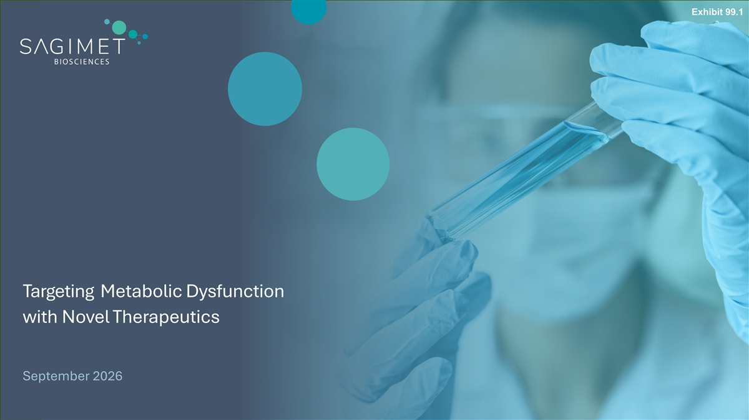
Exhibit 99.1 Targeting Metabolic Dysfunction with Novel Therapeutics September 2026

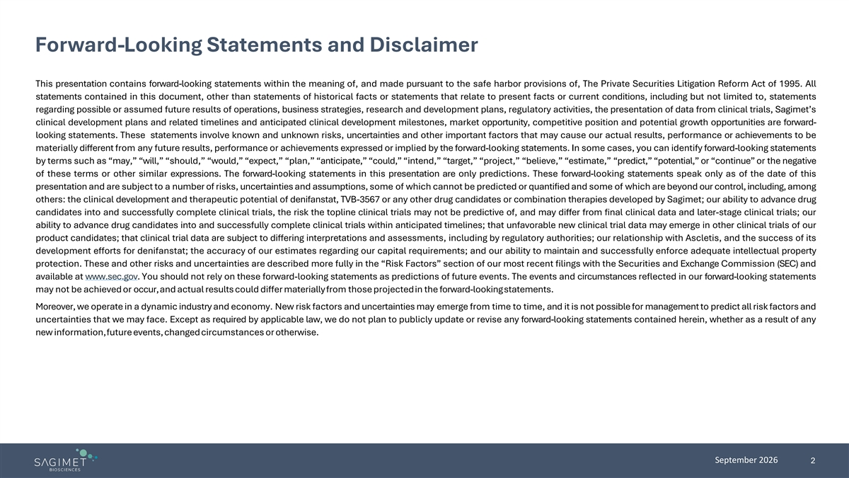
Forward-Looking Statements and Disclaimer This presentation contains forward-looking statements within the meaning of, and made pursuant to the safe harbor provisions of, The Private Securities Litigation Reform Act of 1995. All statements contained in this document, other than statements of historical facts or statements that relate to present facts or current conditions, including but not limited to, statements regarding possible or assumed future results of operations, business strategies, research and development plans, regulatory activities, the presentation of data from clinical trials, Sagimet’s clinical development plans and related timelines and anticipated clinical development milestones, market opportunity, competitive position and potential growth opportunities are forward- looking statements. These statements involve known and unknown risks, uncertainties and other important factors that may cause our actual results, performance or achievements to be materially different from any future results, performance or achievements expressed or implied by the forward-looking statements. In some cases, you can identify forward-looking statements by terms such as “may,” “will,” “should,” “would,” “expect,” “plan,” “anticipate,” “could,” “intend,” “target,” “project,” “believe,” “estimate,” “predict,” “potential,” or “continue” or the negative of these terms or other similar expressions. The forward-looking statements in this presentation are only predictions. These forward-looking statements speak only as of the date of this presentation and are subject to a number of risks, uncertainties and assumptions, some of which cannot be predicted or quantified and some of which are beyond our control, including, among others: the clinical development and therapeutic potential of denifanstat, TVB-3567 or any other drug candidates or combination therapies developed by Sagimet; our ability to advance drug candidates into and successfully complete clinical trials, the risk the topline clinical trials may not be predictive of, and may differ from final clinical data and later-stage clinical trials; our ability to advance drug candidates into and successfully complete clinical trials within anticipated timelines; that unfavorable new clinical trial data may emerge in other clinical trials of our product candidates; that clinical trial data are subject to differing interpretations and assessments, including by regulatory authorities; our relationship with Ascletis, and the success of its development efforts for denifanstat; the accuracy of our estimates regarding our capital requirements; and our ability to maintain and successfully enforce adequate intellectual property protection. These and other risks and uncertainties are described more fully in the “Risk Factors” section of our most recent filings with the Securities and Exchange Commission (SEC) and available at www.sec.gov. You should not rely on these forward-looking statements as predictions of future events. The events and circumstances reflected in our forward-looking statements may not be achieved or occur, and actual results could differ materially from those projected in the forward-looking statements. Moreover, we operate in a dynamic industry and economy. New risk factors and uncertainties may emerge from time to time, and it is not possible for management to predict all risk factors and uncertainties that we may face. Except as required by applicable law, we do not plan to publicly update or revise any forward-looking statements contained herein, whether as a result of any new information, future events, changed circumstances or otherwise. September 2026 2

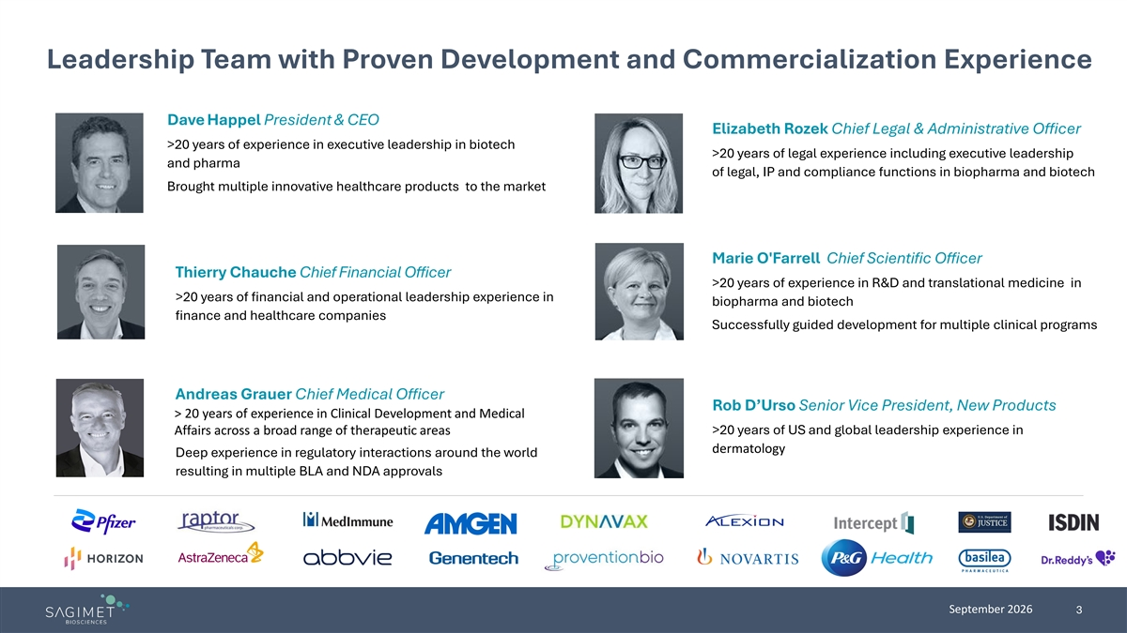
Leadership Team with Proven Development and Commercialization Experience Dave Happel President & CEO Elizabeth Rozek Chief Legal & Administrative Officer >20 years of experience in executive leadership in biotech >20 years of legal experience including executive leadership and pharma of legal, IP and compliance functions in biopharma and biotech Brought multiple innovative healthcare products to the market Marie O'Farrell Chief Scientific Officer Thierry Chauche Chief Financial Officer >20 years of experience in R&D and translational medicine in >20 years of financial and operational leadership experience in biopharma and biotech finance and healthcare companies Successfully guided development for multiple clinical programs Andreas Grauer Chief Medical Officer Rob D’Urso Senior Vice President, New Products > 20 years of experience in Clinical Development and Medical Affairs across a broad range of therapeutic areas >20 years of US and global leadership experience in dermatology Deep experience in regulatory interactions around the world resulting in multiple BLA and NDA approvals September 2026 3

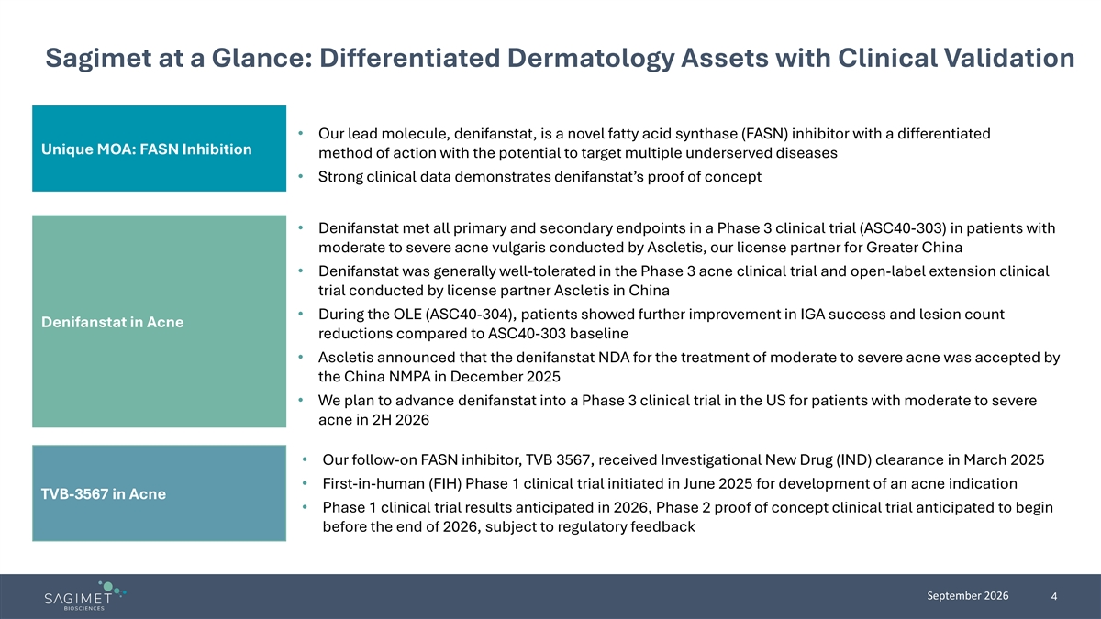
Sagimet at a Glance: Differentiated Dermatology Assets with Clinical Validation • Our lead molecule, denifanstat, is a novel fatty acid synthase (FASN) inhibitor with a differentiated Unique MOA: FASN Inhibition method of action with the potential to target multiple underserved diseases • Strong clinical data demonstrates denifanstat’s proof of concept • Denifanstat met all primary and secondary endpoints in a Phase 3 clinical trial (ASC40-303) in patients with moderate to severe acne vulgaris conducted by Ascletis, our license partner for Greater China • Denifanstat was generally well-tolerated in the Phase 3 acne clinical trial and open-label extension clinical trial conducted by license partner Ascletis in China • During the OLE (ASC40-304), patients showed further improvement in IGA success and lesion count Denifanstat in Acne reductions compared to ASC40-303 baseline • Ascletis announced that the denifanstat NDA for the treatment of moderate to severe acne was accepted by the China NMPA in December 2025 • We plan to advance denifanstat into a Phase 3 clinical trial in the US for patients with moderate to severe acne in 2H 2026 • Our follow-on FASN inhibitor, TVB 3567, received Investigational New Drug (IND) clearance in March 2025 • First-in-human (FIH) Phase 1 clinical trial initiated in June 2025 for development of an acne indication TVB-3567 in Acne • Phase 1 clinical trial results anticipated in 2026, Phase 2 proof of concept clinical trial anticipated to begin before the end of 2026, subject to regulatory feedback September 2026 4

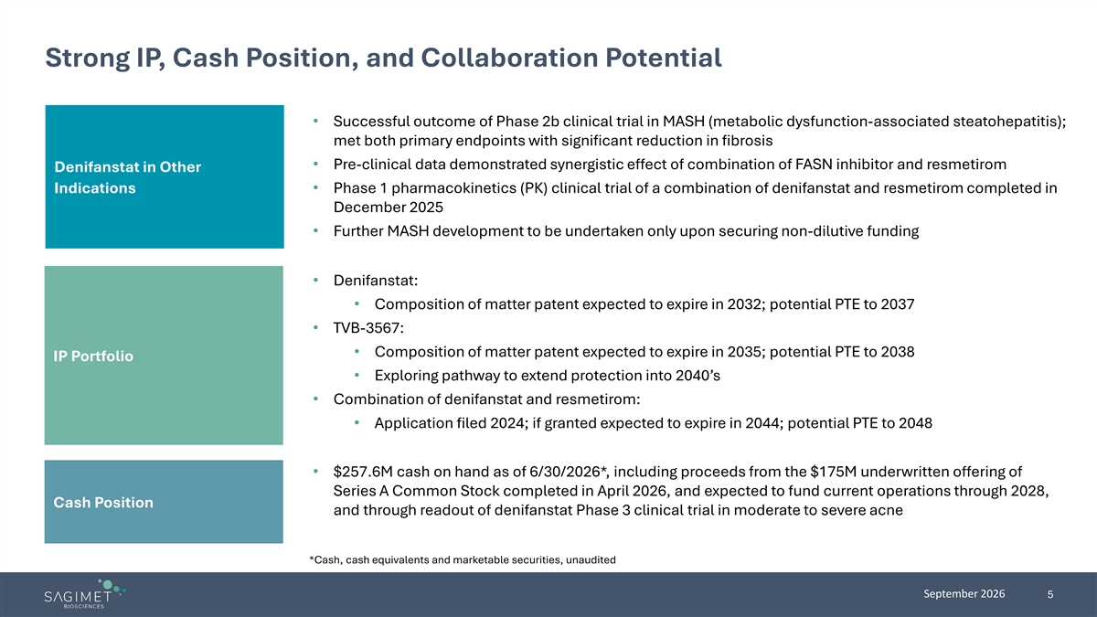
Strong IP, Cash Position, and Collaboration Potential • Successful outcome of Phase 2b clinical trial in MASH (metabolic dysfunction-associated steatohepatitis); met both primary endpoints with significant reduction in fibrosis • Pre-clinical data demonstrated synergistic effect of combination of FASN inhibitor and resmetirom Denifanstat in Other Indications • Phase 1 pharmacokinetics (PK) clinical trial of a combination of denifanstat and resmetirom completed in December 2025 • Further MASH development to be undertaken only upon securing non-dilutive funding • Denifanstat: • Composition of matter patent expected to expire in 2032; potential PTE to 2037 • TVB-3567: • Composition of matter patent expected to expire in 2035; potential PTE to 2038 IP Portfolio • Exploring pathway to extend protection into 2040’s • Combination of denifanstat and resmetirom: • Application filed 2024; if granted expected to expire in 2044; potential PTE to 2048 • $257.6M cash on hand as of 6/30/2026*, including proceeds from the $175M underwritten offering of Series A Common Stock completed in April 2026, and expected to fund current operations through 2028, Cash Position and through readout of denifanstat Phase 3 clinical trial in moderate to severe acne *Cash, cash equivalents and marketable securities, unaudited September 2026 5

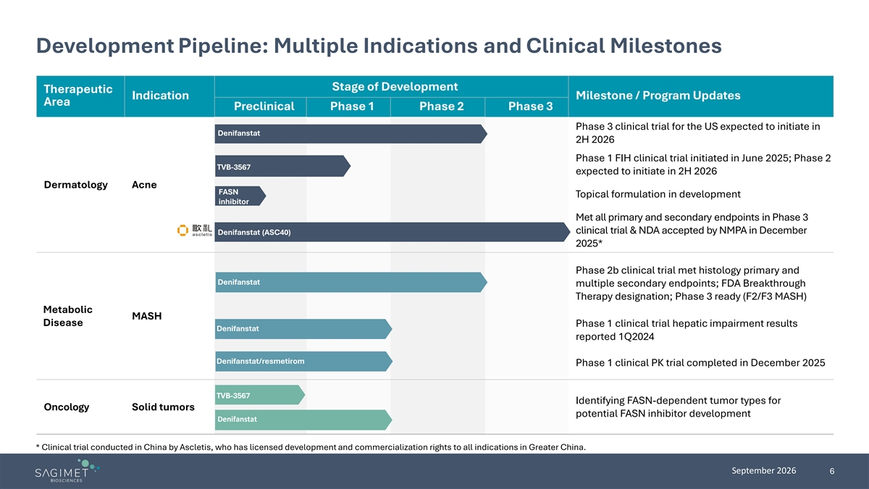
Development Pipeline: Multiple Indications and Clinical Milestones Stage of Development Therapeutic Indication Milestone / Program Updates Area Preclinical Phase 1 Phase 2 Phase 3 Phase 3 clinical trial for the US expected to initiate in Denifanstat 2H 2026 Phase 1 FIH clinical trial initiated in June 2025; Phase 2 TVB-3567 expected to initiate in 2H 2026 Dermatology Acne FASN Topical formulation in development inhibitor Met all primary and secondary endpoints in Phase 3 clinical trial & NDA accepted by NMPA in December Denifanstat (ASC40) 2025* Phase 2b clinical trial met histology primary and Denifanstat multiple secondary endpoints; FDA Breakthrough Therapy designation; Phase 3 ready (F2/F3 MASH) Metabolic MASH Disease Phase 1 clinical trial hepatic impairment results Denifanstat reported 1Q2024 Denifanstat/resmetirom Phase 1 clinical PK trial completed in December 2025 TVB-3567 Identifying FASN-dependent tumor types for Oncology Solid tumors potential FASN inhibitor development Denifanstat * Clinical trial conducted in China by Ascletis, who has licensed development and commercialization rights to all indications in Greater China. September 2026 6


FASN Inhibition Offers Differentiated MOA in Acne

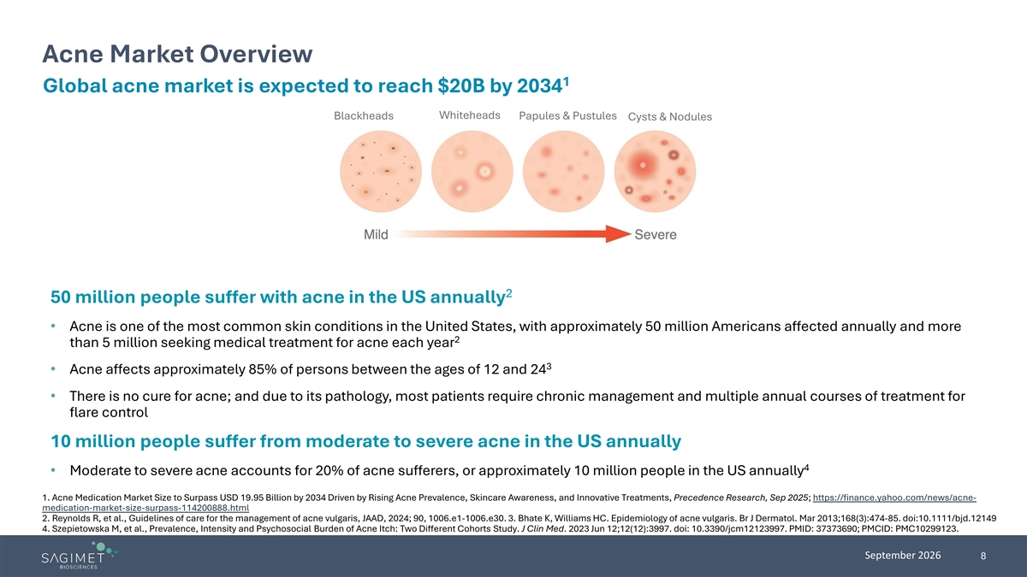
Acne Market Overview 1 Global acne market is expected to reach $20B by 2034 Whiteheads Blackheads Papules & Pustules Cysts & Nodules 2 50 million people suffer with acne in the US annually • Acne is one of the most common skin conditions in the United States, with approximately 50 million Americans affected annually and more 2 than 5 million seeking medical treatment for acne each year 3 • Acne affects approximately 85% of persons between the ages of 12 and 24 • There is no cure for acne; and due to its pathology, most patients require chronic management and multiple annual courses of treatment for flare control 10 million people suffer from moderate to severe acne in the US annually 4 • Moderate to severe acne accounts for 20% of acne sufferers, or approximately 10 million people in the US annually 1. Acne Medication Market Size to Surpass USD 19.95 Billion by 2034 Driven by Rising Acne Prevalence, Skincare Awareness, and Innovative Treatments, Precedence Research, Sep 2025; https://finance.yahoo.com/news/acne- medication-market-size-surpass-114200888.html 2. Reynolds R, et al., Guidelines of care for the management of acne vulgaris, JAAD, 2024; 90, 1006.e1-1006.e30. 3. Bhate K, Williams HC. Epidemiology of acne vulgaris. Br J Dermatol. Mar 2013;168(3):474-85. doi:10.1111/bjd.12149 4. Szepietowska M, et al., Prevalence, Intensity and Psychosocial Burden of Acne Itch: Two Different Cohorts Study. J Clin Med. 2023 Jun 12;12(12):3997. doi: 10.3390/jcm12123997. PMID: 37373690; PMCID: PMC10299123. September 2026 8

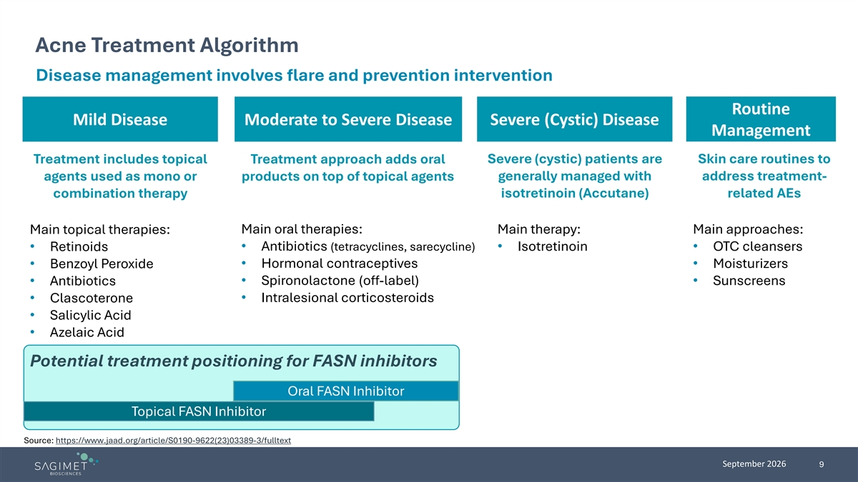
Acne Treatment Algorithm Disease management involves flare and prevention intervention Routine Mild Disease Moderate to Severe Disease Severe (Cystic) Disease Management Treatment includes topical Treatment approach adds oral Severe (cystic) patients are Skin care routines to generally managed with address treatment- agents used as mono or products on top of topical agents isotretinoin (Accutane) related AEs combination therapy Main topical therapies: Main oral therapies: Main therapy: Main approaches: • Retinoids • Antibiotics (tetracyclines, sarecycline) • Isotretinoin • OTC cleansers • Hormonal contraceptives • Moisturizers • Benzoyl Peroxide • Spironolactone (off-label) • Antibiotics • Sunscreens • Clascoterone • Intralesional corticosteroids • Salicylic Acid • Azelaic Acid Potential treatment positioning for FASN inhibitors Oral FASN Inhibitor Topical FASN Inhibitor Source: https://www.jaad.org/article/S0190-9622(23)03389-3/fulltext September 2026 9


Denifanstat’s Clinical Data in Acne

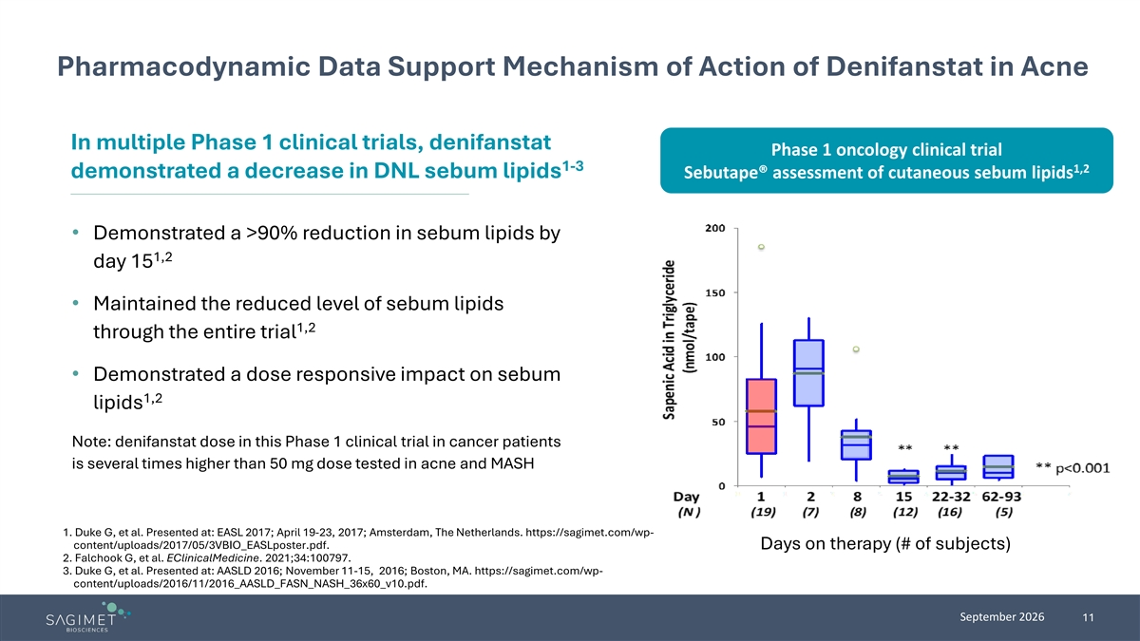
Pharmacodynamic Data Support Mechanism of Action of Denifanstat in Acne In multiple Phase 1 clinical trials, denifanstat Phase 1 oncology clinical trial 1-3 1,2 demonstrated a decrease in DNL sebum lipids Sebutape® assessment of cutaneous sebum lipids • Demonstrated a >90% reduction in sebum lipids by 1,2 day 15 • Maintained the reduced level of sebum lipids 1,2 through the entire trial • Demonstrated a dose responsive impact on sebum 1,2 lipids Note: denifanstat dose in this Phase 1 clinical trial in cancer patients is several times higher than 50 mg dose tested in acne and MASH 1. Duke G, et al. Presented at: EASL 2017; April 19-23, 2017; Amsterdam, The Netherlands. https://sagimet.com/wp- content/uploads/2017/05/3VBIO_EASLposter.pdf. Days on therapy (# of subjects) 2. Falchook G, et al. EClinicalMedicine. 2021;34:100797. 3. Duke G, et al. Presented at: AASLD 2016; November 11-15, 2016; Boston, MA. https://sagimet.com/wp- content/uploads/2016/11/2016_AASLD_FASN_NASH_36x60_v10.pdf. September 2026 11

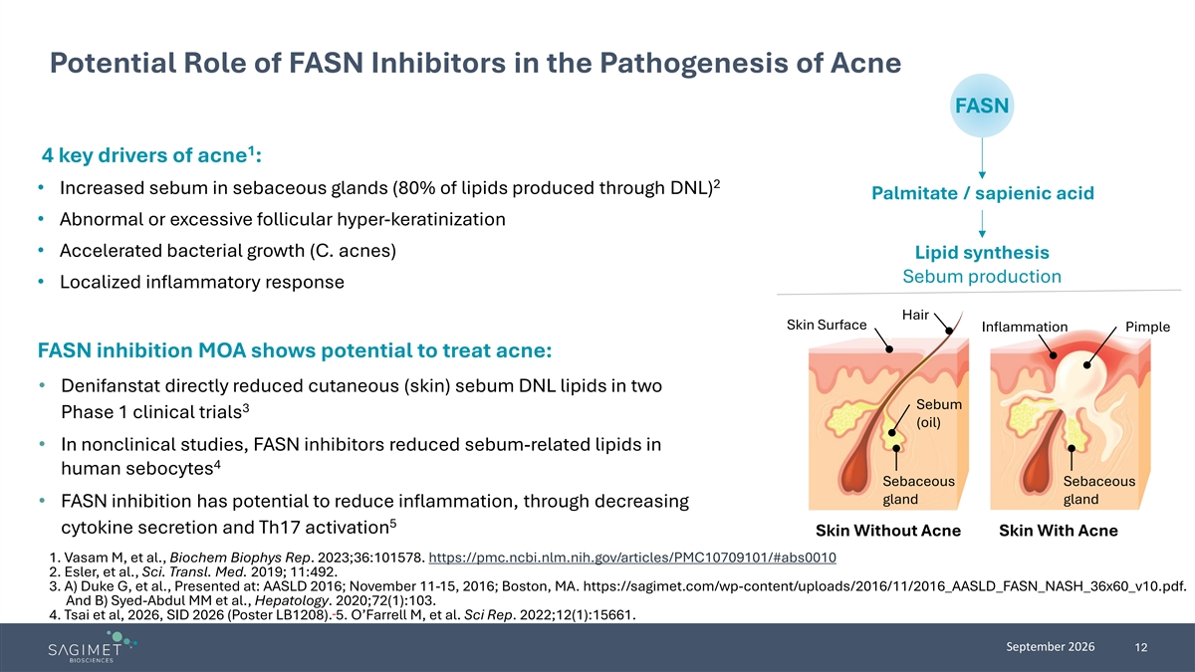
Potential Role of FASN Inhibitors in the Pathogenesis of Acne FASN 1 4 key drivers of acne : 2 • Increased sebum in sebaceous glands (80% of lipids produced through DNL) Palmitate / sapienic acid • Abnormal or excessive follicular hyper-keratinization • Accelerated bacterial growth (C. acnes) Lipid synthesis Sebum production • Localized inflammatory response Hair Skin Surface Inflammation Pimple FASN inhibition MOA shows potential to treat acne: • Denifanstat directly reduced cutaneous (skin) sebum DNL lipids in two Sebum 3 Phase 1 clinical trials (oil) • In nonclinical studies, FASN inhibitors reduced sebum-related lipids in 4 human sebocytes Sebaceous Sebaceous gland gland • FASN inhibition has potential to reduce inflammation, through decreasing 5 cytokine secretion and Th17 activation Skin Without Acne Skin With Acne 1. Vasam M, et al., Biochem Biophys Rep. 2023;36:101578. https://pmc.ncbi.nlm.nih.gov/articles/PMC10709101/#abs0010 2. Esler, et al., Sci. Transl. Med. 2019; 11:492. 3. A) Duke G, et al., Presented at: AASLD 2016; November 11-15, 2016; Boston, MA. https://sagimet.com/wp-content/uploads/2016/11/2016_AASLD_FASN_NASH_36x60_v10.pdf. And B) Syed-Abdul MM et al., Hepatology. 2020;72(1):103. 4. Tsai et al, 2026, SID 2026 (Poster LB1208). 5. O’Farrell M, et al. Sci Rep. 2022;12(1):15661. September 2026 12

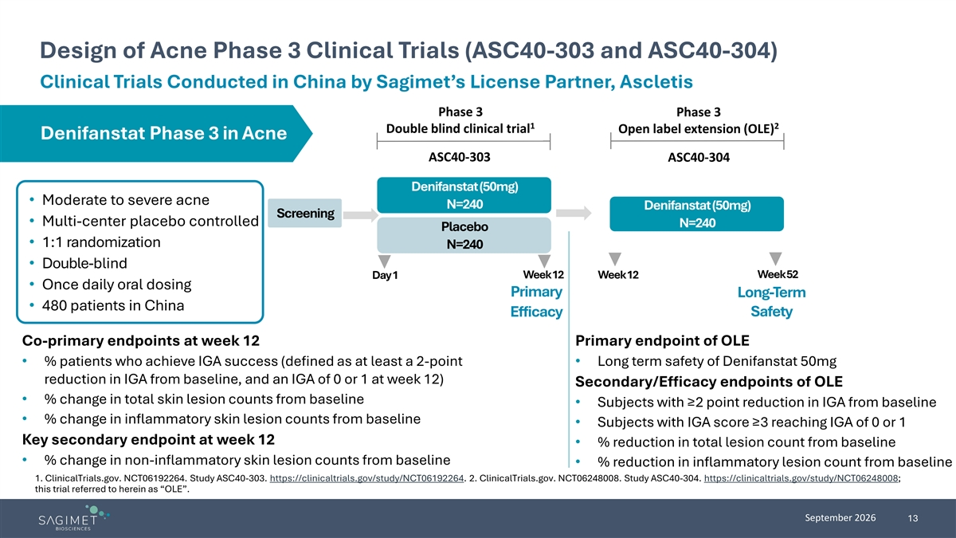
Design of Acne Phase 3 Clinical Trials (ASC40-303 and ASC40-304) Clinical Trials Conducted in China by Sagimet’s License Partner, Ascletis Phase 3 Phase 3 1 2 Double blind clinical trial Open label extension (OLE) Denifanstat Phase 3 in Acne ASC40-303 ASC40-304 Denifanstat (50mg) • Moderate to severe acne N=240 Denifanstat (50mg) Screening • Multi-center placebo controlled N=240 Placebo • 1:1 randomization N=240 • Double-blind Week 52 Day 1 Week 12 Week 12 • Once daily oral dosing Primary Long-Term • 480 patients in China Efficacy Safety Co-primary endpoints at week 12 Primary endpoint of OLE • % patients who achieve IGA success (defined as at least a 2-point • Long term safety of Denifanstat 50mg reduction in IGA from baseline, and an IGA of 0 or 1 at week 12) Secondary/Efficacy endpoints of OLE • % change in total skin lesion counts from baseline • Subjects with ≥2 point reduction in IGA from baseline • % change in inflammatory skin lesion counts from baseline • Subjects with IGA score ≥3 reaching IGA of 0 or 1 Key secondary endpoint at week 12 • % reduction in total lesion count from baseline • % change in non-inflammatory skin lesion counts from baseline • % reduction in inflammatory lesion count from baseline 1. ClinicalTrials.gov. NCT06192264. Study ASC40-303. https://clinicaltrials.gov/study/NCT06192264. 2. ClinicalTrials.gov. NCT06248008. Study ASC40-304. https://clinicaltrials.gov/study/NCT06248008; this trial referred to herein as “OLE”. September 2026 13

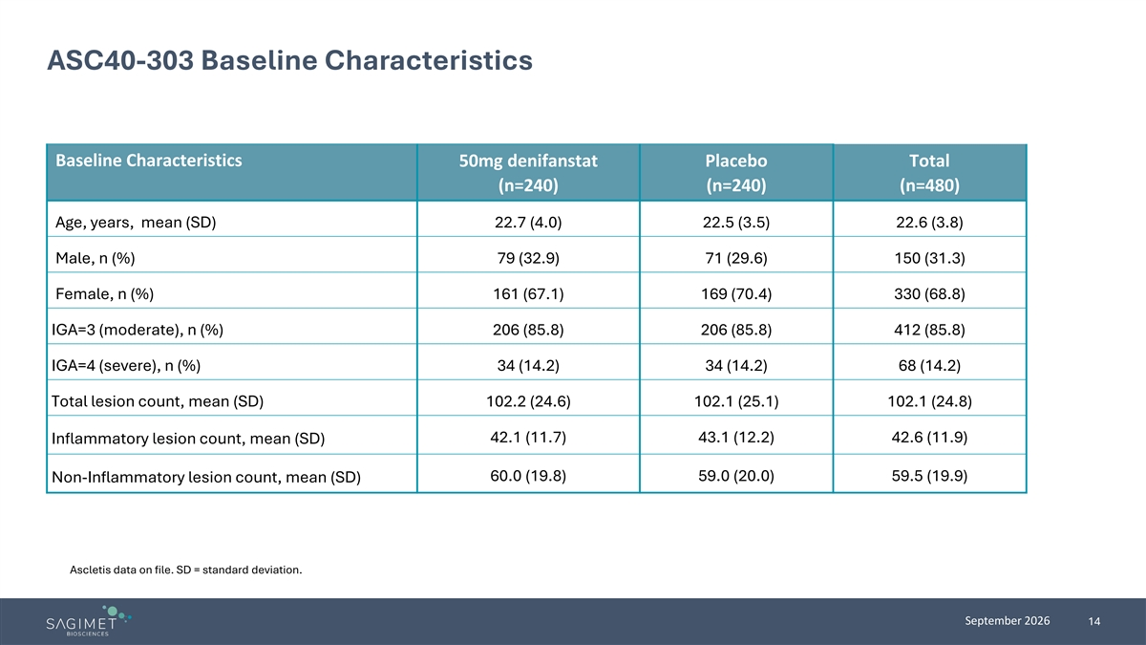
ASC40-303 Baseline Characteristics Baseline Characteristics 50mg denifanstat Placebo Total (n=240) (n=240) (n=480) Age, years, mean (SD) 22.7 (4.0) 22.5 (3.5) 22.6 (3.8) Male, n (%) 79 (32.9) 71 (29.6) 150 (31.3) Female, n (%) 161 (67.1) 169 (70.4) 330 (68.8) IGA=3 (moderate), n (%) 206 (85.8) 206 (85.8) 412 (85.8) IGA=4 (severe), n (%) 34 (14.2) 34 (14.2) 68 (14.2) Total lesion count, mean (SD) 102.2 (24.6) 102.1 (25.1) 102.1 (24.8) 42.1 (11.7) 43.1 (12.2) 42.6 (11.9) Inflammatory lesion count, mean (SD) 60.0 (19.8) 59.0 (20.0) 59.5 (19.9) Non-Inflammatory lesion count, mean (SD) Ascletis data on file. SD = standard deviation. September 2026 14

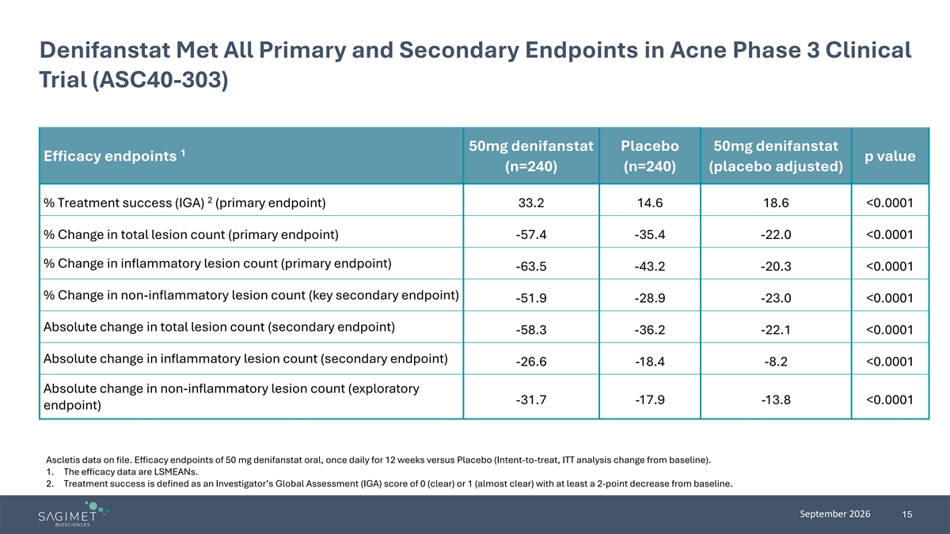
Denifanstat Met All Primary and Secondary Endpoints in Acne Phase 3 Clinical Trial (ASC40-303) 50mg denifanstat Placebo 50mg denifanstat 1 Efficacy endpoints p value (n=240) (n=240) (placebo adjusted) 2 % Treatment success (IGA) (primary endpoint) 33.2 14.6 18.6 <0.0001 % Change in total lesion count (primary endpoint) -57.4 -35.4 -22.0 <0.0001 % Change in inflammatory lesion count (primary endpoint) -63.5 -43.2 -20.3 <0.0001 % Change in non-inflammatory lesion count (key secondary endpoint) -51.9 -28.9 -23.0 <0.0001 Absolute change in total lesion count (secondary endpoint) -58.3 -36.2 -22.1 <0.0001 Absolute change in inflammatory lesion count (secondary endpoint) -26.6 -18.4 -8.2 <0.0001 Absolute change in non-inflammatory lesion count (exploratory -31.7 -17.9 -13.8 <0.0001 endpoint) Ascletis data on file. Efficacy endpoints of 50 mg denifanstat oral, once daily for 12 weeks versus Placebo (Intent-to-treat, ITT analysis change from baseline). 1. The efficacy data are LSMEANs. 2. Treatment success is defined as an Investigator’s Global Assessment (IGA) score of 0 (clear) or 1 (almost clear) with at least a 2-point decrease from baseline. September 2026 15

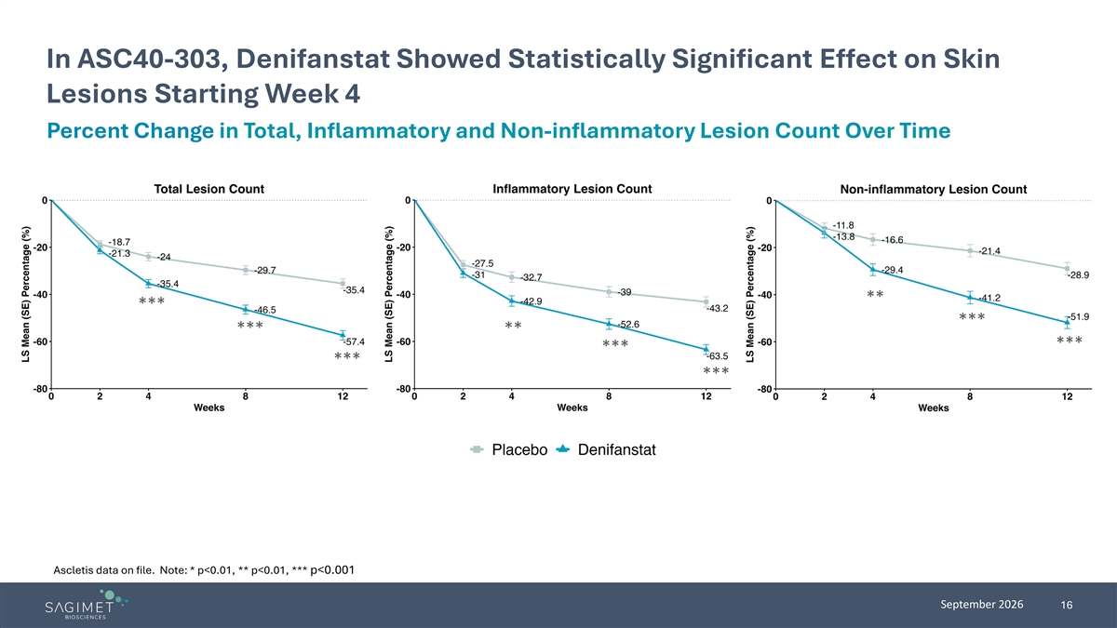
In ASC40-303, Denifanstat Showed Statistically Significant Effect on Skin Lesions Starting Week 4 Percent Change in Total, Inflammatory and Non-inflammatory Lesion Count Over Time ** *** *** *** ** *** *** *** *** Ascletis data on file. Note: * p<0.01, ** p<0.01, *** p<0.001 September 2026 16

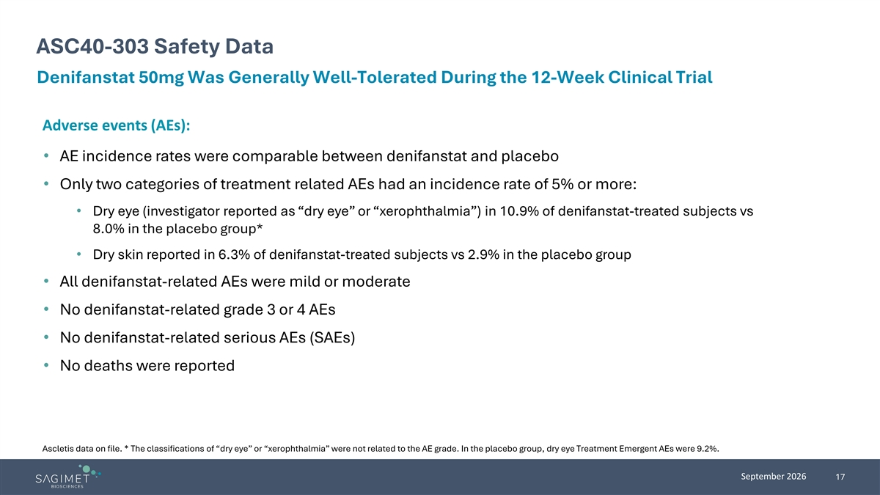
ASC40-303 Safety Data Denifanstat 50mg Was Generally Well-Tolerated During the 12-Week Clinical Trial Adverse events (AEs): • AE incidence rates were comparable between denifanstat and placebo • Only two categories of treatment related AEs had an incidence rate of 5% or more: • Dry eye (investigator reported as “dry eye” or “xerophthalmia”) in 10.9% of denifanstat-treated subjects vs 8.0% in the placebo group* • Dry skin reported in 6.3% of denifanstat-treated subjects vs 2.9% in the placebo group • All denifanstat-related AEs were mild or moderate • No denifanstat-related grade 3 or 4 AEs • No denifanstat-related serious AEs (SAEs) • No deaths were reported Ascletis data on file. * The classifications of “dry eye” or “xerophthalmia” were not related to the AE grade. In the placebo group, dry eye Treatment Emergent AEs were 9.2%. September 2026 17

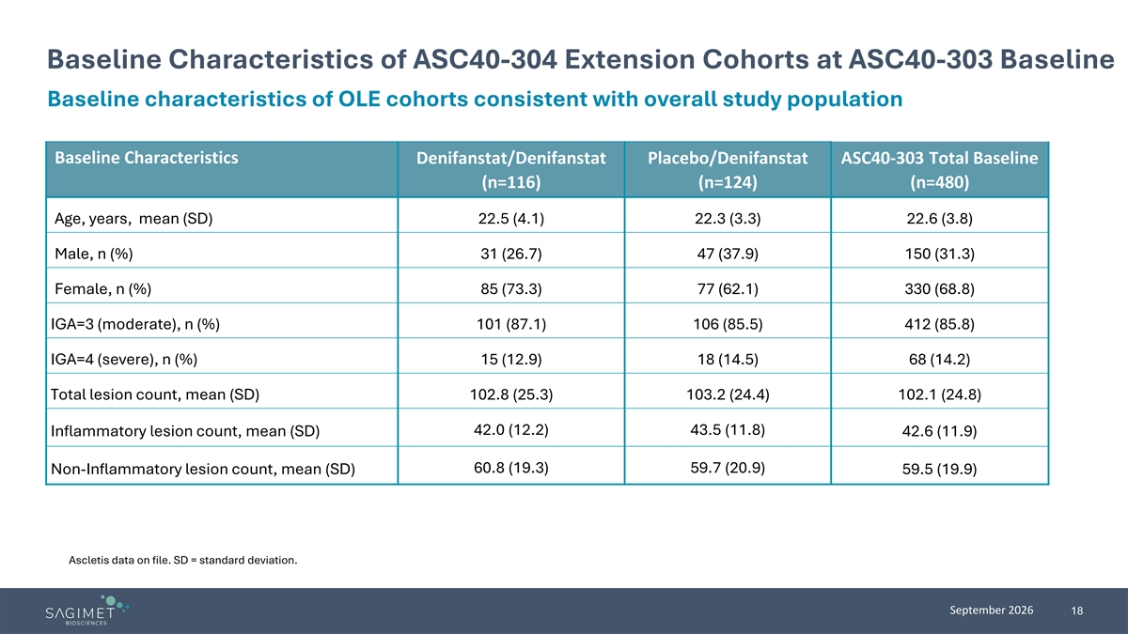
Baseline Characteristics of ASC40-304 Extension Cohorts at ASC40-303 Baseline Baseline characteristics of OLE cohorts consistent with overall study population Baseline Characteristics Denifanstat/Denifanstat Placebo/Denifanstat ASC40-303 Total Baseline (n=116) (n=124) (n=480) Age, years, mean (SD) 22.5 (4.1) 22.3 (3.3) 22.6 (3.8) Male, n (%) 31 (26.7) 47 (37.9) 150 (31.3) Female, n (%) 85 (73.3) 77 (62.1) 330 (68.8) IGA=3 (moderate), n (%) 101 (87.1) 106 (85.5) 412 (85.8) IGA=4 (severe), n (%) 15 (12.9) 18 (14.5) 68 (14.2) Total lesion count, mean (SD) 102.8 (25.3) 103.2 (24.4) 102.1 (24.8) 42.0 (12.2) 43.5 (11.8) Inflammatory lesion count, mean (SD) 42.6 (11.9) 60.8 (19.3) 59.7 (20.9) Non-Inflammatory lesion count, mean (SD) 59.5 (19.9) Ascletis data on file. SD = standard deviation. September 2026 18

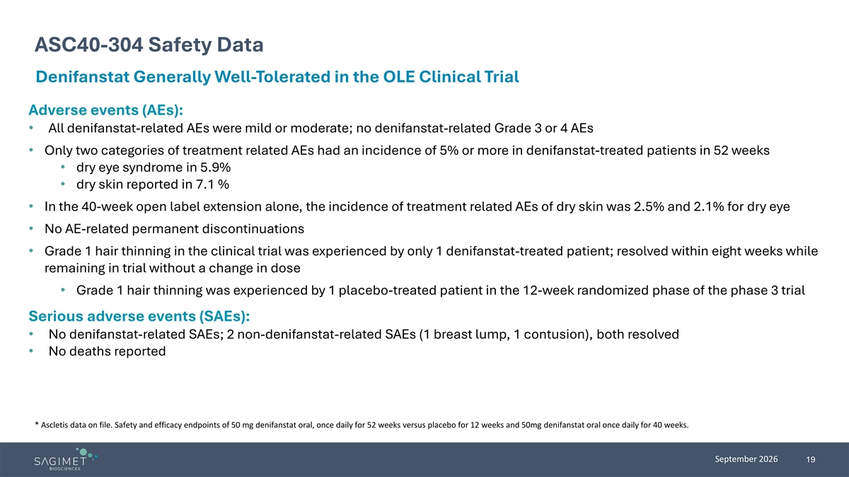
ASC40-304 Safety Data Denifanstat Generally Well-Tolerated in the OLE Clinical Trial Adverse events (AEs): • All denifanstat-related AEs were mild or moderate; no denifanstat-related Grade 3 or 4 AEs • Only two categories of treatment related AEs had an incidence of 5% or more in denifanstat-treated patients in 52 weeks • dry eye syndrome in 5.9% • dry skin reported in 7.1 % • In the 40-week open label extension alone, the incidence of treatment related AEs of dry skin was 2.5% and 2.1% for dry eye • No AE-related permanent discontinuations • Grade 1 hair thinning in the clinical trial was experienced by only 1 denifanstat-treated patient; resolved within eight weeks while remaining in trial without a change in dose • Grade 1 hair thinning was experienced by 1 placebo-treated patient in the 12-week randomized phase of the phase 3 trial Serious adverse events (SAEs): • No denifanstat-related SAEs; 2 non-denifanstat-related SAEs (1 breast lump, 1 contusion), both resolved • No deaths reported * Ascletis data on file. Safety and efficacy endpoints of 50 mg denifanstat oral, once daily for 52 weeks versus placebo for 12 weeks and 50mg denifanstat oral once daily for 40 weeks. September 2026 19

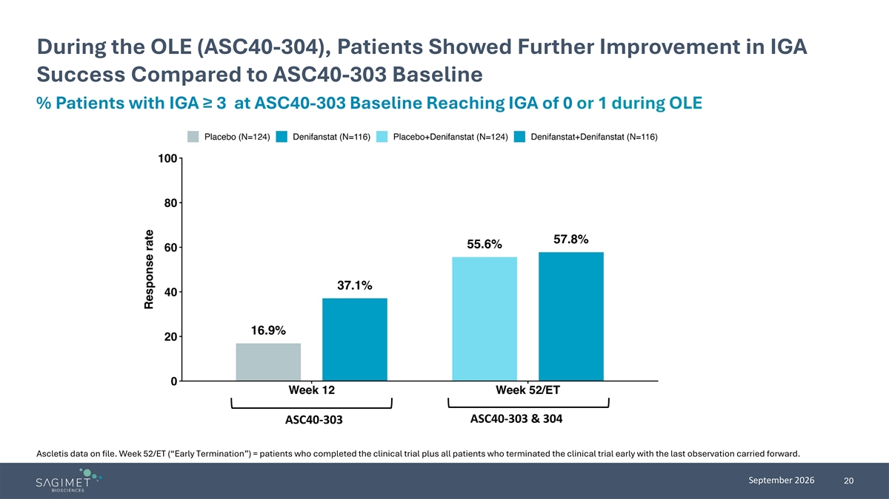
During the OLE (ASC40-304), Patients Showed Further Improvement in IGA Success Compared to ASC40-303 Baseline % Patients with IGA ≥ 3 at ASC40-303 Baseline Reaching IGA of 0 or 1 during OLE ASC40-303 & 304 ASC40-303 Ascletis data on file. Week 52/ET (“Early Termination”) = patients who completed the clinical trial plus all patients who terminated the clinical trial early with the last observation carried forward. September 2026 20

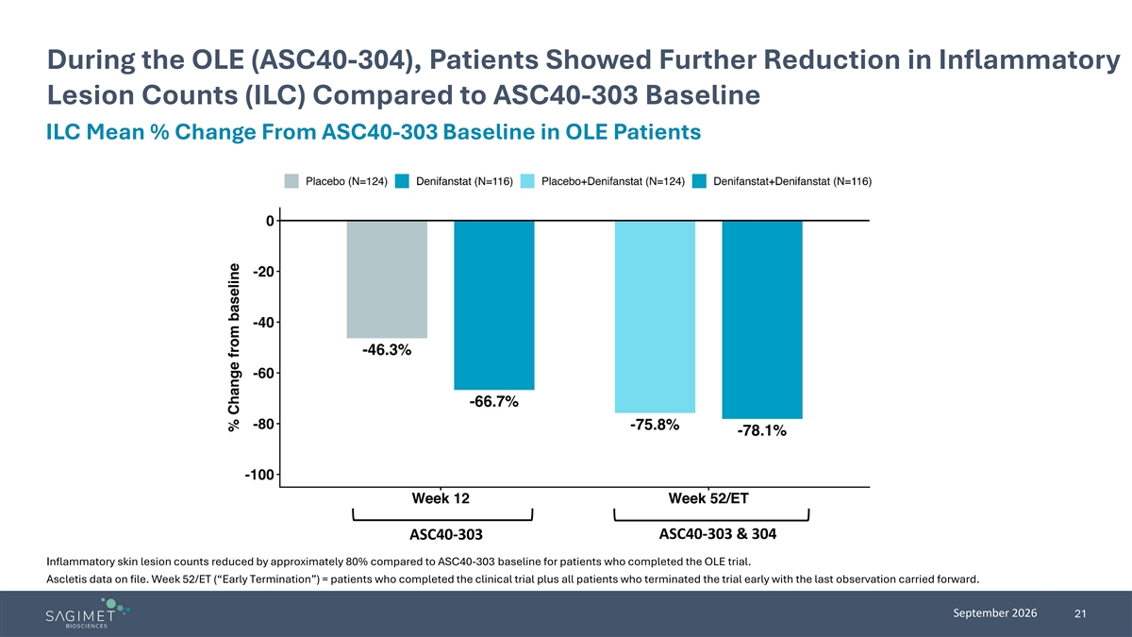
During the OLE (ASC40-304), Patients Showed Further Reduction in Inflammatory Lesion Counts (ILC) Compared to ASC40-303 Baseline ILC Mean % Change From ASC40-303 Baseline in OLE Patients ASC40-303 & 304 ASC40-303 Inflammatory skin lesion counts reduced by approximately 80% compared to ASC40-303 baseline for patients who completed the OLE trial. Ascletis data on file. Week 52/ET (“Early Termination”) = patients who completed the clinical trial plus all patients who terminated the trial early with the last observation carried forward. September 2026 21

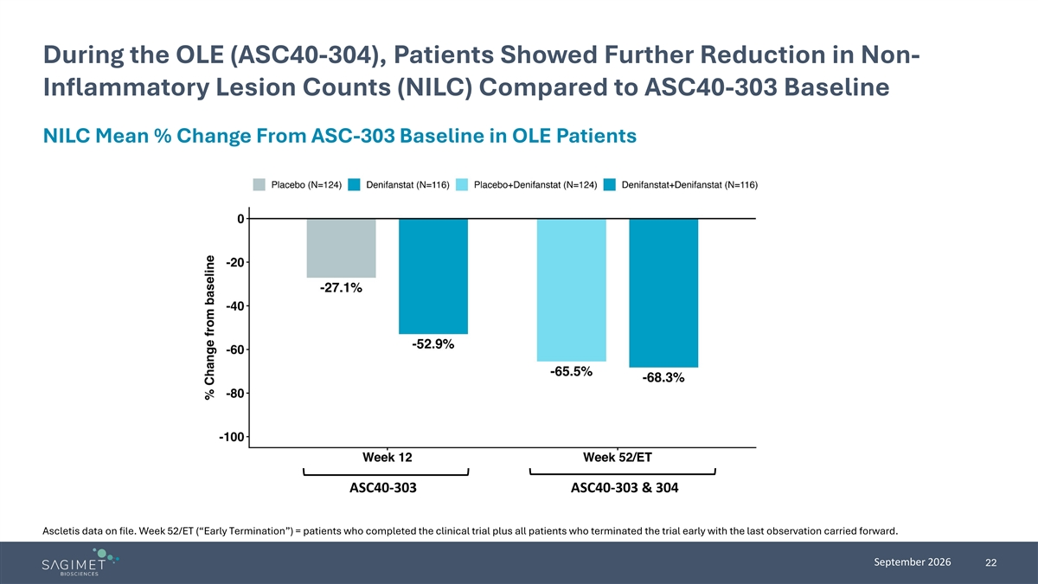
During the OLE (ASC40-304), Patients Showed Further Reduction in Non- Inflammatory Lesion Counts (NILC) Compared to ASC40-303 Baseline NILC Mean % Change From ASC-303 Baseline in OLE Patients ASC40-303 ASC40-303 & 304 Ascletis data on file. Week 52/ET (“Early Termination”) = patients who completed the clinical trial plus all patients who terminated the trial early with the last observation carried forward. September 2026 22

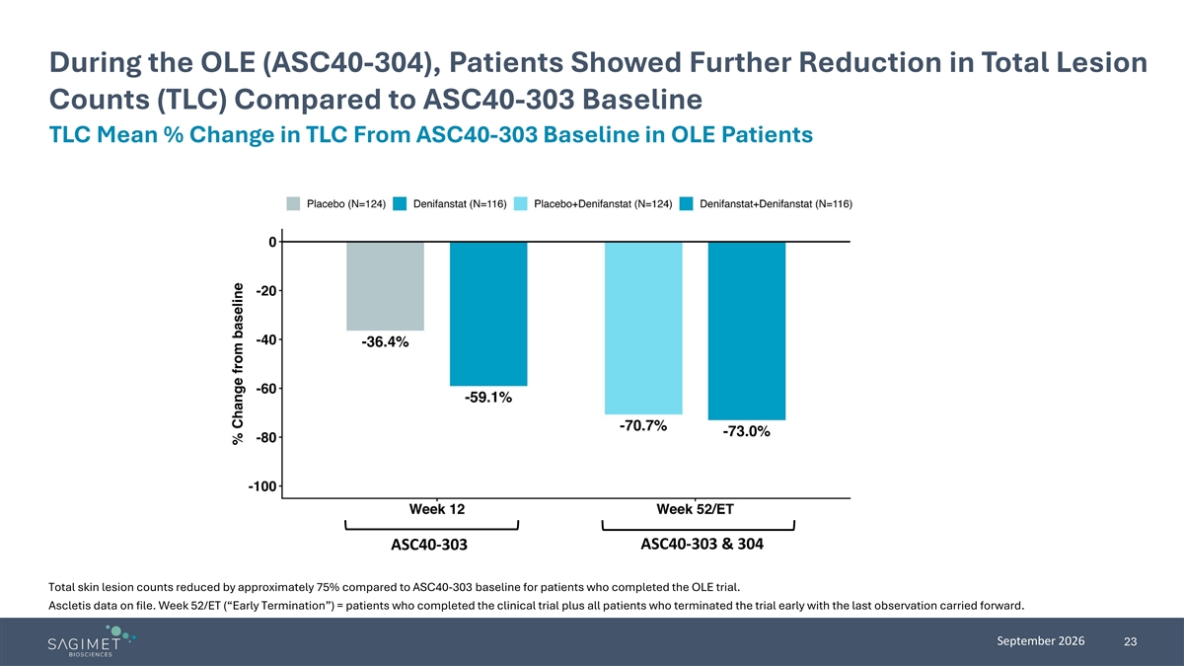
During the OLE (ASC40-304), Patients Showed Further Reduction in Total Lesion Counts (TLC) Compared to ASC40-303 Baseline TLC Mean % Change in TLC From ASC40-303 Baseline in OLE Patients ASC40-303 & 304 ASC40-303 Total skin lesion counts reduced by approximately 75% compared to ASC40-303 baseline for patients who completed the OLE trial. Ascletis data on file. Week 52/ET (“Early Termination”) = patients who completed the clinical trial plus all patients who terminated the trial early with the last observation carried forward. September 2026 23

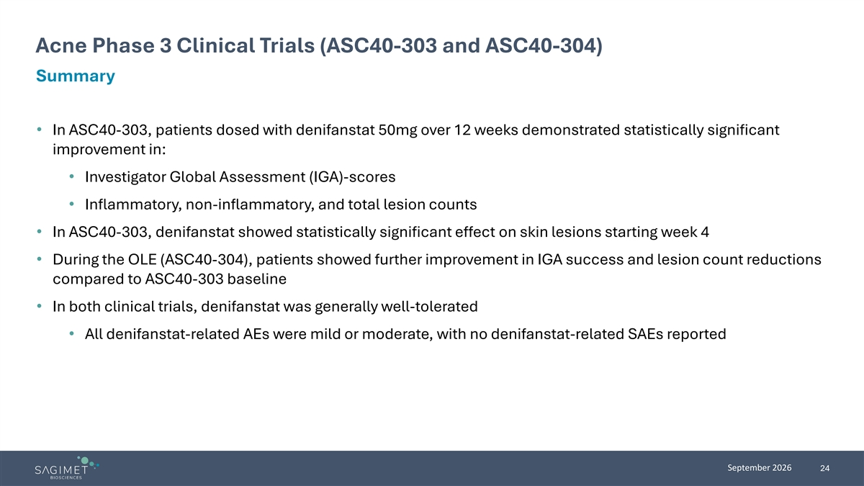
Acne Phase 3 Clinical Trials (ASC40-303 and ASC40-304) Summary • In ASC40-303, patients dosed with denifanstat 50mg over 12 weeks demonstrated statistically significant improvement in: • Investigator Global Assessment (IGA)-scores • Inflammatory, non-inflammatory, and total lesion counts • In ASC40-303, denifanstat showed statistically significant effect on skin lesions starting week 4 • During the OLE (ASC40-304), patients showed further improvement in IGA success and lesion count reductions compared to ASC40-303 baseline • In both clinical trials, denifanstat was generally well-tolerated • All denifanstat-related AEs were mild or moderate, with no denifanstat-related SAEs reported September 2026 24


Sagimet’s Development Programs

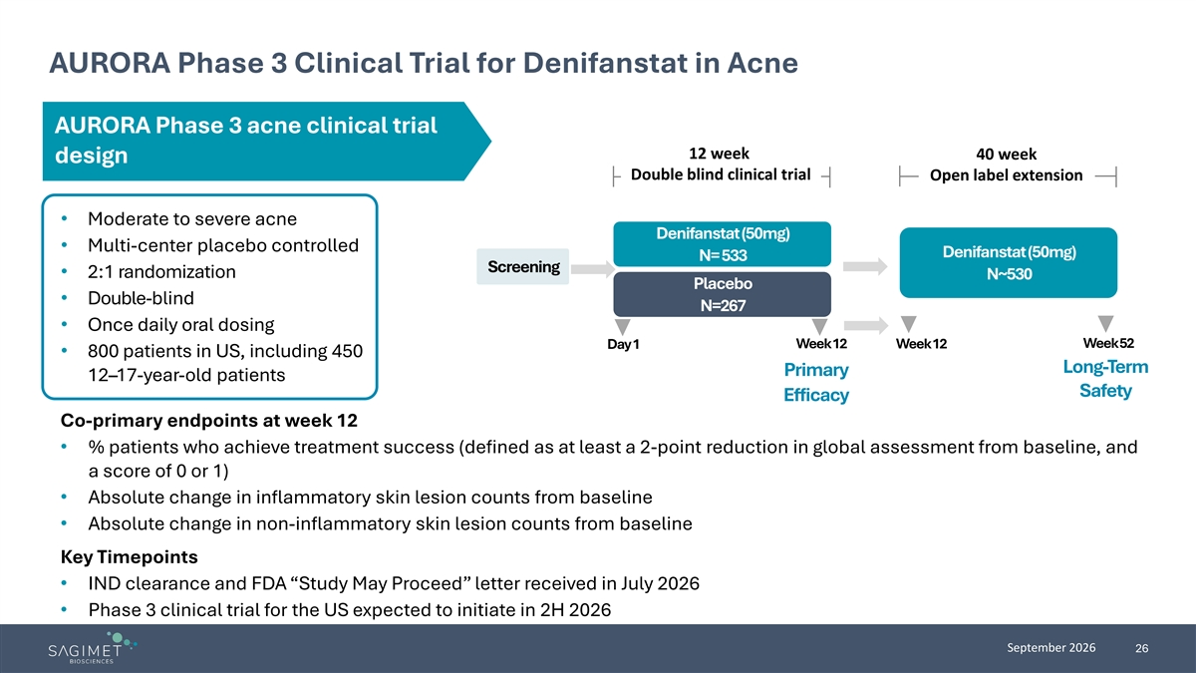
AURORA Phase 3 Clinical Trial for Denifanstat in Acne AURORA Phase 3 acne clinical trial 12 week 40 week design Double blind clinical trial Open label extension • Moderate to severe acne Denifanstat (50mg) • Multi-center placebo controlled Denifanstat (50mg) N= 533 Screening • 2:1 randomization N~530 Placebo • Double-blind N=267 • Once daily oral dosing Week 52 Day 1 Week 12 Week 12 • 800 patients in US, including 450 Long-Term Primary 12–17-year-old patients Safety Efficacy Co-primary endpoints at week 12 • % patients who achieve treatment success (defined as at least a 2-point reduction in global assessment from baseline, and a score of 0 or 1) • Absolute change in inflammatory skin lesion counts from baseline • Absolute change in non-inflammatory skin lesion counts from baseline Key Timepoints • IND clearance and FDA “Study May Proceed” letter received in July 2026 • Phase 3 clinical trial for the US expected to initiate in 2H 2026 September 2026 26

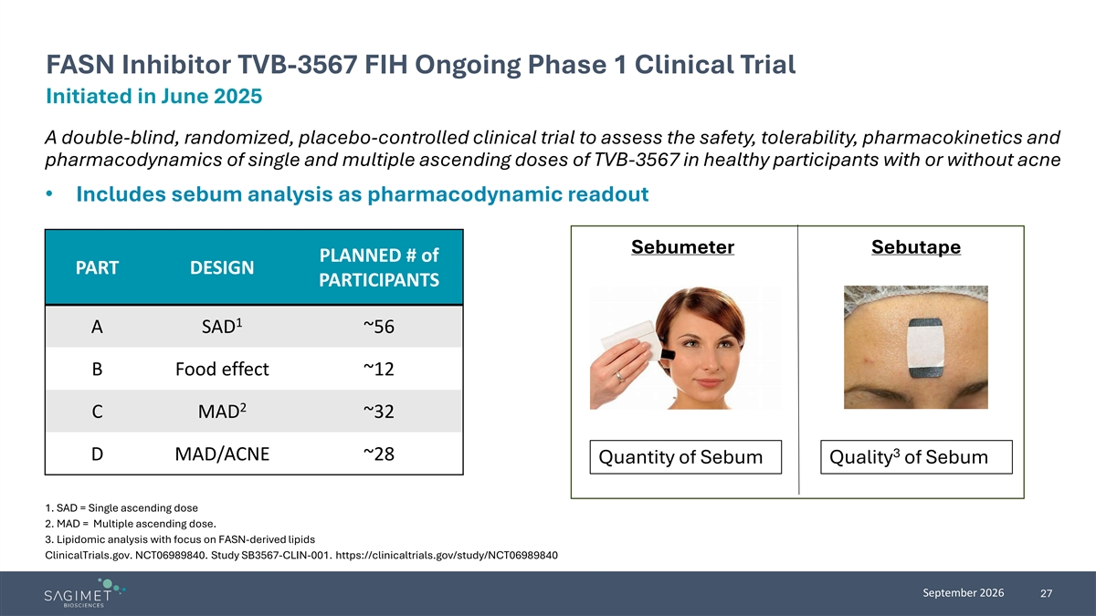
FASN Inhibitor TVB-3567 FIH Ongoing Phase 1 Clinical Trial Initiated in June 2025 A double-blind, randomized, placebo-controlled clinical trial to assess the safety, tolerability, pharmacokinetics and pharmacodynamics of single and multiple ascending doses of TVB-3567 in healthy participants with or without acne • Includes sebum analysis as pharmacodynamic readout Sebumeter Sebutape PLANNED # of PART DESIGN PARTICIPANTS 1 A SAD ~56 B Food effect ~12 2 C MAD ~32 3 D MAD/ACNE ~28 Quantity of Sebum Quality of Sebum 1. SAD = Single ascending dose 2. MAD = Multiple ascending dose. 3. Lipidomic analysis with focus on FASN-derived lipids ClinicalTrials.gov. NCT06989840. Study SB3567-CLIN-001. https://clinicaltrials.gov/study/NCT06989840 September 2026 27

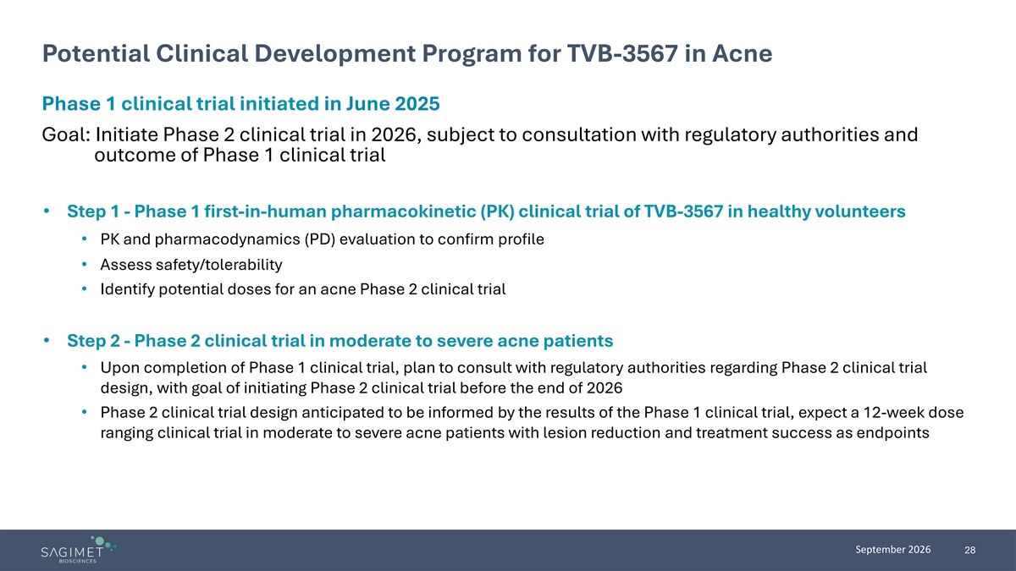
Potential Clinical Development Program for TVB-3567 in Acne Phase 1 clinical trial initiated in June 2025 Goal: Initiate Phase 2 clinical trial in 2026, subject to consultation with regulatory authorities and outcome of Phase 1 clinical trial • Step 1 - Phase 1 first-in-human pharmacokinetic (PK) clinical trial of TVB-3567 in healthy volunteers • PK and pharmacodynamics (PD) evaluation to confirm profile • Assess safety/tolerability • Identify potential doses for an acne Phase 2 clinical trial • Step 2 - Phase 2 clinical trial in moderate to severe acne patients • Upon completion of Phase 1 clinical trial, plan to consult with regulatory authorities regarding Phase 2 clinical trial design, with goal of initiating Phase 2 clinical trial before the end of 2026 • Phase 2 clinical trial design anticipated to be informed by the results of the Phase 1 clinical trial, expect a 12-week dose ranging clinical trial in moderate to severe acne patients with lesion reduction and treatment success as endpoints September 2026 28

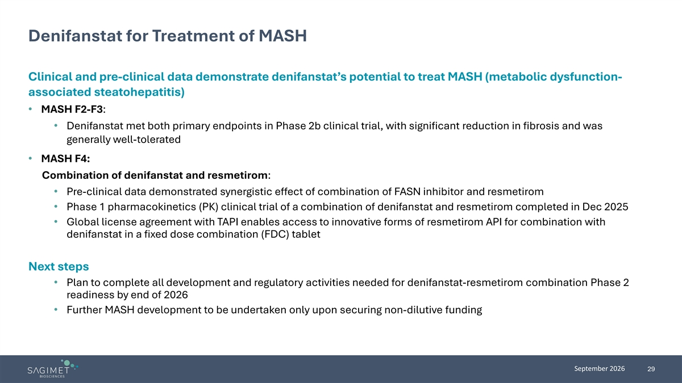
Denifanstat for Treatment of MASH Clinical and pre-clinical data demonstrate denifanstat’s potential to treat MASH (metabolic dysfunction- associated steatohepatitis) • MASH F2-F3: • Denifanstat met both primary endpoints in Phase 2b clinical trial, with significant reduction in fibrosis and was generally well-tolerated • MASH F4: Combination of denifanstat and resmetirom: • Pre-clinical data demonstrated synergistic effect of combination of FASN inhibitor and resmetirom • Phase 1 pharmacokinetics (PK) clinical trial of a combination of denifanstat and resmetirom completed in Dec 2025 • Global license agreement with TAPI enables access to innovative forms of resmetirom API for combination with denifanstat in a fixed dose combination (FDC) tablet Next steps • Plan to complete all development and regulatory activities needed for denifanstat-resmetirom combination Phase 2 readiness by end of 2026 • Further MASH development to be undertaken only upon securing non-dilutive funding September 2026 29

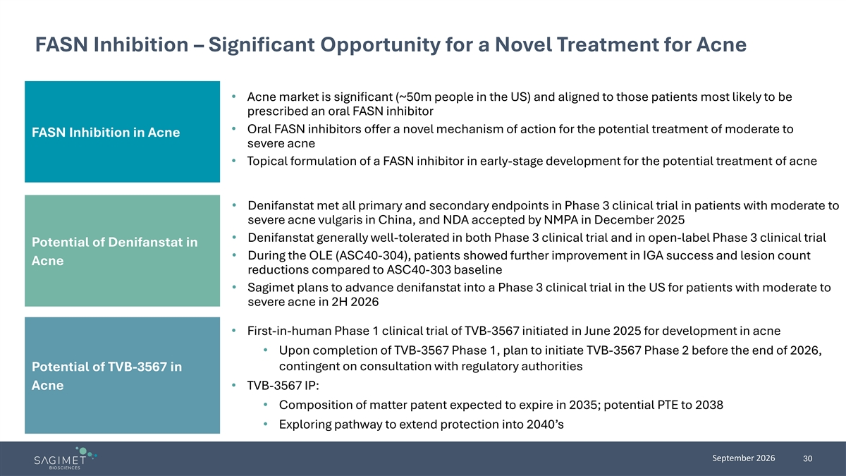
FASN Inhibition – Significant Opportunity for a Novel Treatment for Acne • Acne market is significant (~50m people in the US) and aligned to those patients most likely to be prescribed an oral FASN inhibitor • Oral FASN inhibitors offer a novel mechanism of action for the potential treatment of moderate to FASN Inhibition in Acne severe acne • Topical formulation of a FASN inhibitor in early-stage development for the potential treatment of acne • Denifanstat met all primary and secondary endpoints in Phase 3 clinical trial in patients with moderate to severe acne vulgaris in China, and NDA accepted by NMPA in December 2025 • Denifanstat generally well-tolerated in both Phase 3 clinical trial and in open-label Phase 3 clinical trial Potential of Denifanstat in • During the OLE (ASC40-304), patients showed further improvement in IGA success and lesion count Acne reductions compared to ASC40-303 baseline • Sagimet plans to advance denifanstat into a Phase 3 clinical trial in the US for patients with moderate to severe acne in 2H 2026 • First-in-human Phase 1 clinical trial of TVB-3567 initiated in June 2025 for development in acne • Upon completion of TVB-3567 Phase 1, plan to initiate TVB-3567 Phase 2 before the end of 2026, contingent on consultation with regulatory authorities Potential of TVB-3567 in Acne • TVB-3567 IP: • Composition of matter patent expected to expire in 2035; potential PTE to 2038 • Exploring pathway to extend protection into 2040’s September 2026 30
Exhibit 99.2


Sagimet Announces Positive Full 52-Week Results from License Partner Ascletis’ Phase 3 Open-Label Extension Clinical Trial of Denifanstat in Acne Presented at EADV 2026

 |  |  | In the Phase 3 open-label extension clinical trial (OLE), patients with moderate to severe acne received denifanstat for up to 52 weeks, including prior placebo patients

 |  |  | Denifanstat showed progressive and sustained improvements across all efficacy endpoints in the OLE, including Investigator’s Global Assessment (IGA), success with a response rate of 57%, 72% reduction in total lesions, and 77% reduction in inflammatory lesions, and was generally well-tolerated, with no adverse event-related permanent discontinuations

 |  |  | Patient screening for AURORA U.S. Phase 3 clinical trial expected to begin in October 2026

 |  |  | Sagimet to host a KOL event and webcast, September 30, 2026 at 1 PM ET
FOSTER CITY, Calif., September 30, 2026 (GLOBE NEWSWIRE) — Sagimet Biosciences Inc. (Nasdaq: SGMT), a clinical-stage biopharmaceutical company developing novel therapeutics targeting dysfunctional metabolic and fibrotic pathways, today announced positive 52-week results from the Phase 3 ASC40-304 OLE clinical trial of denifanstat in patients with moderate to severe acne vulgaris, conducted by license partner Ascletis BioScience Co. Ltd. (Ascletis) in China. The results were presented at the European Academy of Dermatology and Venereology Congress (EADV 2026) in Vienna by Ascletis. Denifanstat is a once-daily oral small molecule fatty acid synthase (FASN) inhibitor being developed by Ascletis as ASC40 in China where it holds an exclusive license to denifanstat, and by Sagimet in the rest of the world.
The Phase 3 OLE clinical trial, ASC40-304, evaluated the long-term safety of denifanstat in patients with moderate to severe acne vulgaris who were previously enrolled in the 12-week randomized, double-blind, placebo-controlled Phase 3 ASC40-303 clinical trial, conducted in China by Ascletis. 240 patients rolled over into the OLE trial, for a total trial duration of up to 52 weeks. 116 of those patients had received denifanstat, and 124 patients had received placebo in the original 12-week double-blind ASC40-303 trial. Primary endpoints evaluated safety, and secondary endpoints evaluated efficacy, including reduction in IGA from baseline and reduction in total lesion count and inflammatory lesion count from baseline.

Phase 3 Open-Label Extension Results
The baseline characteristics of the OLE cohorts were consistent with the overall study population, as shown below:
Baseline Characteristics of ASC40-304 OLE Cohorts at ASC40-303 Baseline

Baseline Characteristics |  | ASC40-304  Denifanstat/Denifanstat  (n=116) |  | ASC40-304  Placebo/Denifanstat  (n=124) |  | ASC40-303  Total (n=480)
Age, years, mean (SD) |  | 22.5 (4.1) |  | 22.3 (3.3) |  | 22.6 (3.8)
Male, n (%) |  | 31 (26.7) |  | 47 (37.9) |  | 150 (31.3)
Female, n (%) |  | 85 (73.3) |  | 77 (62.1) |  | 330 (68.8)
IGA=3 (moderate), n (%) |  | 101 (87.1) |  | 106 (85.5) |  | 412 (85.8)
IGA=4 (severe), n (%) |  | 15 (12.9) |  | 18 (14.5) |  | 68 (14.2)
Total lesion count, mean (SD) |  | 102.8 (25.3) |  | 103.2 (24.4) |  | 102.1 (24.8)
Inflammatory lesion count, mean (SD) |  | 42.0 (12.2) |  | 43.5 (11.8) |  | 42.6 (11.9)
Non-Inflammatory lesion count, mean (SD) |  | 60.8 (19.3) |  | 59.7 (20.9) |  | 59.5 (19.9)
Treatment success was defined as at least a 2-point reduction from baseline in Investigator’s Global Assessment (IGA) score with a score of 0 (clear) or 1 (almost clear). At the end of the trial, treatment success rates and mean percentage changes, compared to the ASC40-303 baseline, were:

Efficacy Endpoints |  | Denifanstat 12wk /  Denifanstat 40wk  (n=116) |  | Placebo 12wk /  Denifanstat 40wk  (n=124) |  | Total (n=240)
Treatment success rate |  | 57.8% |  | 55.6% |  | 56.7%
Mean % change in total lesion count |  | -73.0% |  | -70.7% |  | -71.8%
Mean % change in inflammatory lesion count |  | -78.1% |  | -75.8% |  | -76.9%
Mean % change in non-inflammatory lesion count |  | -68.3% |  | -65.5% |  | -66.9%
Note: Total skin lesion counts and inflammatory skin lesion counts reduced by approximately 75% and 80%, respectively, compared to ASC40-303 baseline for patients who completed the OLE trial.
Denifanstat was generally well-tolerated in the OLE with patients receiving up to 52 weeks of exposure, with no permanent discontinuations of study drug due to adverse events and no drug-related serious adverse events among patients treated with denifanstat. Only two categories of treatment-related adverse events had an incidence of more than 5% over the 52-week period: dry skin in 7.1% and dry eye in 5.9%.

“The positive results presented today at EADV reinforce our confidence in denifanstat as we prepare to begin patient screening for our U.S. AURORA Phase 3 clinical trial in October, with first patient enrollment expected shortly thereafter,” said David Happel, Chief Executive Officer of Sagimet. “Annually approximately ten million people in the U.S. live with moderate to severe acne. Denifanstat, if approved, could offer a convenient, once-daily oral medication for this underserved patient population, and would be the first oral treatment with a novel mechanism of action approved for acne in more than forty years.”
“The open-label extension trial provides important data to support our AURORA Phase 3 program,” said Andreas Grauer, MD, Chief Medical Officer of Sagimet. “It is particularly encouraging that patients continued to improve with longer treatment, and denifanstat remained generally well-tolerated through the open-label extension trial, with exposure to denifanstat up to 52 weeks. Notably, patients who crossed over from placebo achieved treatment success rates similar to those treated with denifanstat from the start. Together, these results provide meaningful long-term experience with the 50 mg denifanstat dose we are taking forward in AURORA.”
Virtual Key Opinion Leader Conference Call Information
Sagimet Biosciences will host a virtual KOL event with Julie Harper, MD, Founding Director and past President of the American Acne and Rosacea Society on September 30, 2026 at 1 PM ET.
Dr. Harper will join company management for a review of the 52-week data from license partner Ascletis’ Phase 3 open-label extension clinical trial of denifanstat in moderate to severe acne vulgaris in China and an update on the company’s planned U.S. Phase 3 AURORA clinical trial of denifanstat for the treatment of moderate to severe acne. Live webcast available: LINK
About the Ascletis Phase 3 Clinical Trial and Open-Label Extension
ASC40-303 (NCT06192264) was a randomized, double-blind, placebo-controlled 12-week Phase 3 clinical trial of denifanstat in 480 patients with moderate to severe acne vulgaris, conducted in China by Ascletis. Patients were randomized 1:1 to denifanstat 50 mg or placebo once daily. Denifanstat met all primary and secondary endpoints and was generally well-tolerated.
ASC40-304 (NCT06248008) was a multi-center, open-label Phase 3 extension evaluating the long-term safety of denifanstat in patients with moderate to severe acne vulgaris who were previously enrolled in the double-blind, randomized, placebo-controlled 12-week Phase 3 ASC40-303 trial. This open-label Phase 3 trial enrolled 240 subjects that received oral denifanstat 50 mg once daily for up to 40 weeks. Subjects who were originally randomized to denifanstat in ASC40-303 trial had a total of up to 52 weeks of denifanstat exposure. Primary endpoints evaluated safety, and secondary endpoints evaluated efficacy, including reduction in IGA from baseline and reduction in total lesion count and inflammatory lesion count from baseline for up to 52 weeks of denifanstat treatment. Denifanstat was generally well-tolerated. Subjects treated with denifanstat showed improvements in all efficacy endpoints (secondary endpoints of the trial) beyond those observed at 12 weeks.

About the AURORA Phase 3 Clinical Trial
The AURORA multi-center, randomized, double-blind, placebo-controlled Phase 3 clinical trial of denifanstat in moderate to severe acne is intended to enroll approximately 800 U.S. patients aged 12 years and older, of which 450 are expected to be adolescents aged 12 to 17 years. Patients will be randomized 2:1 to receive denifanstat 50 mg or placebo once daily for 12 weeks. The trial will have three co-primary endpoints that will be assessed at week 12: the proportion of patients achieving treatment success in a global assessment score, defined as at least a 2-point reduction from baseline with a score of 0 (clear) or 1 (almost clear); absolute change in inflammatory skin lesion counts from baseline; and absolute change in non-inflammatory skin lesion counts from baseline. A subset of approximately 530 patients completing the double-blind period will be eligible to enter a 40-week open-label extension evaluating the long-term safety of denifanstat.
About Denifanstat
Denifanstat is an oral, once-daily FASN inhibitor in development for the treatment of moderate to severe acne. In trials conducted by Sagimet’s license partner, Ascletis BioScience Co. Ltd. (Ascletis) in China, denifanstat met all primary and secondary endpoints in a 12 week randomized, double-blind Phase 3 clinical trial in moderate to severe acne vulgaris and was generally well-tolerated and showed improvements in all efficacy endpoints measured at 52 weeks (secondary endpoints of the trial) in an open-label extension clinical trial evaluating denifanstat’s long-term safety in patients with moderate to severe acne. Denifanstat is being developed by Ascletis as ASC40 for acne in China and by Sagimet in the rest of world.
About Acne
Acne is one of the most common skin conditions in the U.S., with approximately 50 million Americans affected annually and more than 5 million seeking medical treatment for acne each year. Acne affects around 85% of persons between the ages of 12 and 24. Moderate to severe acne accounts for 20% of acne sufferers, or approximately 10 million people in the U.S. annually. There is no cure for acne, and due to its pathology, most patients require chronic management and multiple annual courses of treatment for flare control.
About Sagimet Biosciences
Sagimet is a clinical-stage biopharmaceutical company developing novel FASN inhibitors designed to target dysfunctional metabolic and fibrotic pathways in conditions resulting from the overproduction of the fatty acid, palmitate. FASN is a regulator of lipid synthesis, a key pathway implicated in multiple diseases, such as acne, MASH and certain FASN-dependent tumor types. For additional information about Sagimet, please visit www.sagimet.com.
Forward-Looking Statements
This press release contains forward-looking statements within the meaning of, and made pursuant to the safe harbor provisions of, The Private Securities Litigation Reform Act of 1995. All statements contained in this press release, other than statements of historical facts or statements that relate to present facts or current conditions, including but not limited to, statements regarding the expected timing of the presentation of data from ongoing clinical trials, Sagimet’s clinical development plans and related timelines and anticipated development milestones, are forward-looking statements. These statements involve known and unknown risks, uncertainties and other important factors that may cause Sagimet’s actual results, performance or achievements to be materially different from any future results, performance or achievements expressed or implied by the forward-looking statements. In some

cases, these statements can be identified by terms such as “may,” “might,” “will,” “should,” “expect,” “plan,” “aim,” “seek,” “anticipate,” “could,” “intend,” “target,” “project,” “contemplate,” “believe,” “estimate,” “predict,” “forecast,” “potential” or “continue” or the negative of these terms or other similar expressions. The forward-looking statements in this press release are only predictions. Sagimet has based these forward-looking statements largely on its current expectations and projections about future events and financial trends that Sagimet believes may affect its business, financial condition and results of operations. These forward-looking statements speak only as of the date of this press release and are subject to a number of risks, uncertainties and assumptions, some of which cannot be predicted or quantified and some of which are beyond Sagimet’s control, including, among others: the clinical development and therapeutic potential of denifanstat, TVB-3567 or any other drug candidates or combination therapies developed by Sagimet; Sagimet’s ability to advance drug candidates into and successfully complete clinical trials within anticipated timelines; Sagimet’s relationship with Ascletis, and the success of its development and registration efforts for denifanstat; the accuracy of Sagimet’s estimates regarding its capital requirements and Sagimet’s ability to maintain and successfully enforce adequate intellectual property protection. These and other risks and uncertainties are described more fully in the “Risk Factors” section of Sagimet’s most recent filings with the Securities and Exchange Commission and available at www.sec.gov. You should not rely on these forward-looking statements as predictions of future events. The events and circumstances reflected in these forward-looking statements may not be achieved or occur, and actual results could differ materially from those projected in the forward-looking statements. Moreover, Sagimet operates in a dynamic industry and economy. New risk factors and uncertainties may emerge from time to time, and it is not possible for management to predict all risk factors and uncertainties that Sagimet may face. Except as required by applicable law, Sagimet does not plan to publicly update or revise any forward-looking statements contained herein, whether as a result of any new information, future events, changed circumstances or otherwise.
Investor Contact:
Joyce Allaire
LifeSci Advisors
JAllaire@LifeSciAdvisors.com
Media Contact:
Maggie Whitney
LifeSci Communications
mwhitney@lifescicomms.com

